Deliverable D10.2
Identification and specification of "NGH-Ph.1" prototypes to be built
v0.6 - december 14, 2012

Abstract

This deliverable presents the different prototypes to be built within the TF10 of the ENGINES project for further evaluation of a ”NGH-Phase 1” transmission by TF11. After a definition of the target "NGH Phase 1" features, the document gives for each prototype, the type to be developed (either a software IP block or a complete hardware and software equipment), the interfaces with other prototypes in a DVB-T2 chain, and the preliminary DVB-NGH features supported by the prototype.

Table of Content
1 Introduction 5
2 Definitions 6
3 Prototype 1: TeamCast DVB-T2 modulator 7
3.1 General description 7
3.2 Interfaces 7
3.2.1 Inputs 7
3.2.2 Outputs 8
3.2.3 Control and monitoring 8
3.3 Supported T2 modes and features 8
4 Prototype 2 : Thomson Broadcast DVB-T2 modulator 10
4.1 General description 10
4.2 Interfaces 10
4.2.1 Inputs 10
4.2.2 Outputs 10
4.2.3 Control and monitoring 10
4.3 Supported T2 modes and features 10
5 Prototype 3 : Thomson Broadcast DVB-T2 transmitter 12
5.1 General description 12
5.2 Interfaces 13
5.2.1 General Specifications 13
5.2.2 Inputs 13
5.2.3 Outputs 13
5.3 Other general specifications 13
5.3.1 Power Supply 13
5.3.2 Environmental Compliance 14
6 Prototype 4: Mier DVB-T2 transmitter. 15
6.1 General description 15
6.2 Driver unit interfaces 15
6.2.1 Inputs 15
6.2.2 Outputs 16
6.2.3 Control interfaces. 16
6.3 Power unit interfaces 16
6.3.1 Inputs 16
6.3.2 Outputs 17
6.3.3 Control interfaces. 17
6.3.4 Control and monitoring. 17
6.4 Supported T2 modes and features. 17
7 Prototype 5: Mier DVB-T2 gapfiller. 18
7.1 General description. 18
7.2 Down-converter interfaces. 18
7.2.1 Inputs. 18
7.2.2 Outputs 18
7.2.3 Control interfaces. 19
7.3 Up-converter interfaces. 19
7.3.1 Inputs. 19
7.3.2 Outputs 19
7.3.3 Control interfaces. 20
7.3.4 Control and monitoring 20
8 Prototype 6: LA SALLE DVB-T2 Gateway 21
8.1 General description 21
8.2 Features 21
8.3 Supported modes 21
8.3.1 Single PLP – VV500 21
8.3.2 Multiple PLP – VV413 21
8.3.3 Multiple PLP – VV400 21
8.4 Interfaces 22
8.4.1 Inputs 22
8.4.2 Outputs 22
8.5 HW specifications 22
9 Prototype 7: MERCE SC-OFDM Evaluation Platform 24
9.1 General description 24
9.1.1 HEP Central Unit 25
9.1.2 Transmitter (HEP Tx) 27
9.1.3 Receiver (HEP Rx) 29
9.2 Transmitter 29
9.2.1 Inputs 29
9.2.2 Outputs 29
9.2.3 Control interfaces 30
9.3 Receiver 30
9.3.1 Inputs 30
9.3.2 Control interfaces 30
9.4 Control interfaces 30
9.5 Features 30
9.6 Supported modes 31
10 Prototype 8: Enensys DVB-T2 gateway 35
10.1 General description 35
10.2 Interfaces 35
10.2.1 Inputs 35
10.2.2 Outputs 36
10.2.3 Control and monitoring 36
10.3 Supported T2 modes and features 36
11 Prototype 9: Enensys DVB-T2 modulator 38
11.1 General description 38
11.2 Interfaces 38
11.2.1 Inputs 38
11.2.2 Outputs 38
11.2.3 Control and monitoring 39
11.3 Supported T2 modes and features 39
12 Prototype 10: UPV/EHU DVB-T2 demodulator 40
12.1 General description 40
12.2 Interfaces 41
12.2.1 Inputs 41
12.2.2 Outputs 42
12.2.3 Control and monitoring 42
12.3 Supported T2 modes and features 44
13 References 45

Introduction

Within the WP4, TF10 deals with the prototyping of "Full T2" or "NGH phase 1" compliant equipment.
This prototype equipment will be used for evalutation and validation of the corresponding advanced functional features/technologies. This evaluation / validation phase will rely on both laboratory tests and field tests respectively led within TF11 and TF12. Prototyping here means either hardware or software implementation.

The developpement work within TF10 is led in two phases:
- Phase 1: prototype implementation of "Full T2" compliant equipment,
- Phase 2: prototype implementation of "NGH Phase 1" compliant equipment.

This deliverable D10.2 reports about the phase 2. A first deliverable (D10.1) dealt with the phase 1.

"Full T2" and "NGH Phase 1" compliance are defined in the TF10 description document.

This document describes the prototype equipment intended to be implemented by partners contributing to TF10 and having provided data by the edition date of this document:

Prototype Nr | Type of equipment | Provided by
1 | T2 Modulator | TeamCast
2 | T2 Modulator | Thomson Broadcast
3 | T2 Transmitter | Thomson Broadcast
4 | T2 Transmitter | Mier
5 | T2 Gap-Filler | Mier
6 | T2 Gateway | La Salle
7 | SC-OFDM evaluation platform | MERCE
8 | T2 Gateway | Enensys
9 | T2 Modulator | Enensys
10 | T2 demodulator | UPV/EHU

Definitions

The following "NGH Phase 1" features have been identified as relevant targets within the project' scope of work:
- T2-Lite FEF, with support of T2-MI rel 1.3.1
- Mixed T2 and T2-Lite,
- SC-OFDM for satellite segment,
- Others (TBD)

Prototype 1: TeamCast DVB-T2 modulator
Providing partner : TeamCast

General description

The TeamCast DVB-T2 modulator is a complete prototype board generating a DVB-T2 or DVB-T2-Lite RF signal [1]. The modulator supports T2-MI rel 1.3.1 inputs and manages mixed T2 frames and T2-Lite frames.

Interfaces

The following figure presents the interfaces of the modulator. Two ASI inputs are dedicated to reception of a MPEG-TS stream or a T2-MI stream [2]. GPS, 10MHz, PPS and TOD inputs are dedicated to synchronization of the modulator (required for SFN processing). The DVB-T2 RF signal is given by RF output and RF monitoring output. The control of the modulator is realized through IP or RS232 interface

Inputs
ASI input 1 and 2
General function: MPEG-TS and T2-MI inputs (ASI format)
Data rate: up to 80Mbps
Level range : 0 to +10dBm
Connector: SMA – 50 Ω

GPS input
General function: external 10MHz input for demodulator synchronization
Frequency: 10MHz
Level range : 0 to +10dBm
Connector: SMA – 50 Ω

PPS input
General function: external 10MHz input for demodulator synchronization
Frequency: 10MHz
Level range : 0 to +10dBm
Connector: SMA – 50 Ω

10MHz input
General function: external 10MHz input for demodulator synchronization
Frequency: 10MHz
Level range : 0 to +10dBm
Connector: SMA – 50 Ω

TOD input
General function: TOD input to synchronize the date on the modulator (absolute timestamp management)
Frequency: 10MHz
Level range : 0 to +10dBm
Connector: RS232 serial interface

Outputs
RF output
General function: DVB-T2 RF signal transmission
Frequency range: 300 MHz to 900 MHz
Level range : -11 dBm to +1 dBm
Supported bandwidth : 5MHz, 6MHz, 7MHz, 8MHz,
Connector: SMA – 50 Ω

RF monitoring output
General function: DVB-T2 RF signal monitoring
Frequency range: 300 MHz to 900 MHz
Level range: -31 dBm to -19 dBm
Supported bandwidth : 5MHz, 6MHz, 7MHz, 8MHz,
Connector: SMA – 50 Ω

Control and monitoring

The control of the modulator can be realized thanks to the Controlcast GUI through the IP interface. Commands may also be sent to the module through RS232 interface.
The Controlcast GUI allows setting all the parameters of the modulator and monitors status information on the transmission. Concerning DVB-T2 parameters, the GUI sets the modulation parameters when considering system A DVB-T2 transmission but monitors the modulation parameters defined by the T2-MI stream when considering system B transmission.

Supported T2 modes and features

The different DVB-T2 modes supported by the modulator are given in the following table:
General Frame Parameters
DVB-T2 mode | System A (MPEG-TS only) : T2 or T2-Lite  system B (T2MI over TS) : T2, T2-Lite or mixed T2/T2-Lite
SFN transmission | Yes (relative and absolute)
Bandwidth | 5MHz, 6MHz, 7MHz, 8MHz
Multi-PLP | Yes, up to 8 PLPs per T2 standard
MISO | Yes
TFS | Not supported
FEF | Null FEFs, T2-Lite FEFs
TX signaling | Not supported
FFT size | 1K**, 2K, 4K, 8K, 16K, 32K**
Extended bandwidth | Yes
Guard interval | 1/4, 19/128, 1/8, 19/256, 1/16, 1/32, 1/128
Pilot pattern | PP1, PP2, PP3, PP4, PP5, PP6, PP7, PP8**
PAPR | No*
L1 constellation | BPSK, QPSK, 16QAM, 64QAM
PLP parameters
PLP type | Common, Type 1, Type 2
LDPC | 16K, 64K
Coderate | 1/3 ^{Δ},2/5 ^{Δ},1/2, 3/5, 2/3, 3/4, 4/5, 5/6
Constellation | QPSK, 16QAM, 64QAM, 256QAM
Rotated constellation | Yes
Time interleaver | Disable, intra-frame, inter-frame
High efficiency mode | Yes
*The modulator does not integrate TR and ACE algorithms but is able to reserved tones dedicated to TR-PAPR management.
**Dedicated to T2 frames
^{Δ} Dedicated to T2-Lite frames

Prototype 2 : Thomson Broadcast DVB-T2 modulator
Providing partner : Thomson Broadcast

General description

The Thomson Broadcast DVB-T2 modulator is a complete prototype board generating a DVB-T2 RF signal [1]. The modulator supports both T2-MI and MPEG2-TS inputs and manages T2 frames.

Interfaces

Inputs
ASI input 1 and 2
General function: MPEG-TS and T2-MI inputs (ASI format)
Data rate: up to 72MHz
Level range : ASI standard
Connector: BNC – 50 Ω

GPS input
General function: external antenna input for GPS reception
Frequency: GPS standard
Connector: TNC – 50 Ω

PPS input
General function: external 1pps input
Level range : TTL
Connector: BNC – 50 Ω

10MHz input
General function: external 10MHz input
Frequency: 10MHz
Level range : TTL
Connector: BNC – 50 Ω

Outputs

RF output
General function: DVB-T2 RF signal transmission
Frequency range: UHF version (470 to 862 MHz)
Level range : -15 dBm to +17 dBm
Supported bandwidth : 5MHz, 6MHz, 7MHz, 8MHz,
Connector: SMA – 50 Ω

Control and monitoring

The control of the modulator can be realized thanks to the web interface through the IP interface.
The web interface allows to set all the parameters of the modulator and monitors status information on the transmission.

Supported T2 modes and features

The different DVB-T2 modes supported by the modulator are given in the following table:

General Frame Parameters
DVB-T2 mode | System A (MPEG-TS only) and system B (T2MI over TS)  T2 or T2-lite
SFN transmission | Yes
Bandwidth | 5MHz, 6MHz, 7MHz, 8MHz
Multi-PLP | Yes
MISO | Yes
TFS | No
FEF | Null FEFs, T2-lite FEF
TX signaling | No
FFT size | 1K, 2K, 4K, 8K, 16K, 32K
Extended bandwidth | Yes
Guard interval | 1/4, 19/128, 1/8, 19/256, 1/16, 1/32, 1/128
Pilot pattern | PP1 to PP8
PAPR | Tone Reservation
L1 constellation | BPSK, QPSK, 16QAM, 64QAM
PLP parameters
PLP type | Common, Type 1, Type 2
LDPC | 16K, 64K
Coderate | 1/2, 3/5, 2/3, 3/4, 4/5, 5/6
Constellation | QPSK, 16QAM, 64QAM, 256QAM
Rotated constellation | Yes
High efficiency mode | Yes

Prototype 3 : Thomson Broadcast DVB-T2 transmitter

Providing partner : Thomson Broadcast

General description

The transmitter has been configured to fit in a standard 19" cabinet, providing a compact footprint and delivering transmission power of up to 1.2 kW RMS per cabinet. 125 and 250W RMS amplifier chassis offer the ability to scale output power to meet specific coverage needs. Up to six parallel chassis can be combined in a single transmitter for 1.2 kW of power.

The transmitter delivers a robust output signal regardless of variations in typical environmental conditions. A pioneer in DAP technology, Thomson guarantees that the transmitters provide the highest constant performance by automatically compensating and correcting for aging of components, reduction of output power, or module failure. Real-time DAP also corrects both linear and nonlinear distortions generated by output mask filters and amplifier distortions.

For monitoring, each transmitter includes an embedded Web server and SNMP agent to remotely deliver a real-time, comprehensive display of the transmitter’s status as well as the identification and precise location of any fault.

Interfaces

General Specifications

Frequency range:
• UHF: 470 to 862 MHz

Signal Bandwidth
DVB-T/H: 7.61 MHz (channel 8 MHz)
DVB-T2: 7.61 MHz (channel 8 MHz) and 7.78 MHz (channel 8 MHz, extended carrier mode)

Inputs

Main Input Characteristics
• Connector: BNC female
• Impedance: 75Ω
• Dual TS changeover without broadcast interruption: ASI MPEG-2 or MPEG-4

GPS Antenna Characteristics
• Connector: TNC female
• Impedance: 50Ω
• Frequency: 1575 MHz

External Frequency Reference
• Frequency: 10 MHz
• Impedance: 50Ω
• Format: TTL
• Connector: BNC female

External Timing Reference
• Frequency: 1 PPS
• Connector: SMB female
• Pulse width: 10 μs

Outputs

Main Output Characteristics
Shoulder: > 36 dB
MER: ≥33 dB (average value)
Spurious: compliant with EN 302 296 V1.1.1

Other general specifications

Power Supply

AC input:
• Single phase:
— 90V to 160V
— 184V to 254V
• 3-phase:
— 154V to 272V
— 312V to 432V
Power factor: 0.99 typical
Frequency: 47 to 63 MHz

Environmental Compliance

RoHS compliant

Prototype 4: Mier DVB-T2 transmitter.
Providing partner: MIER Comunicaciones S.A.

General description

The transmitter prototipe is part of the range of solutions for digital terrestrial TV broadcasting , providing output powers of 20, 50, 100Wrms.

Extremely compact, flexible and reliable; it is designed to cover deployment needs on remote centers with harsh accesses and with space restrictions.

It provides an elevated efficiency and robustness, allowing an easy installation and commissioning. Its modular design allows configuring different types of redundancy architectures to improve system availability. Additionally, it includes a series of automatic parameter configuration, as well as flexible monitoring and remote control tools, providing an intuitive and simple OPEX.

Its highly compact design allows allocating a 100Wrms transmitter in a standard 19” rack unit with only 2U height.

Its modular conception provides the flexibility to configure the equipment as transmitter, transposer or on-channel repeater configurations (echo canceller is available for on-channel repeater configuration).

The transmitter is made up by two units:

- Driver unit (1U).
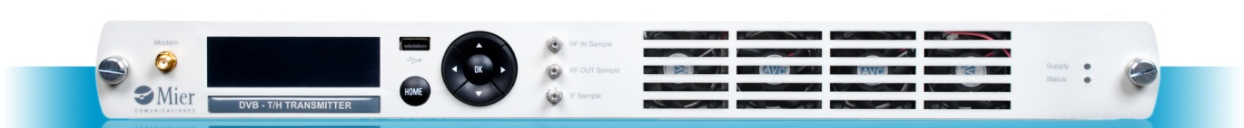

- Power amplifier unit (2U).
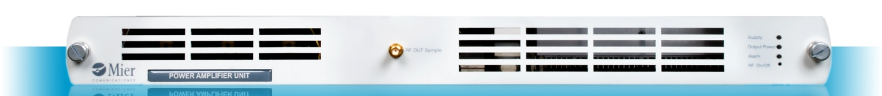

Driver unit interfaces

Inputs

The inputs interfaces are described below:

ASI input 1 and 2
Signal type: MPEG-TS ( ASI format)
Connectors: 2×BNC female 75 Ω (back-panel)

10MHz input
Signal type: External sinusoidal signal of 10MHz for frequency synchronization
Level: from 0 to +10dBm
Connector: BNC female 50 Ω (back-panel)

1 PPS input
Signal type: External 1 PPS signal for time synchronization.
Level: TTL
Connector: BNC female 50 Ω (back-panel).

GPS antenna input
Signal type: RF signal from GPS antenna.
Connector: SMA female 50 Ω (back-panel).

GSM antenna input
Signal type: GSM signal (dual band 900MHz /1800 MHz)
Connector: SMA female 50 Ω (front-panel)

Mains input
Signal type: AC 230V
Connector: IEC-320-C14

Outputs

RF output
Signal type: RF signal in the UHF band.
Level: 0 dBm maximum
Connector: N female 50 Ω (back-panel).

IF output sample
Signal type: IF signal (36.16 MHz)
Level: -20 dBm
Connector: SMA female 50 Ω (front-panel)

RF output sample
Signal type: RF signal in the UHF band.
Label: -30 dB lower than the nominal output power.
Connector: SMA female 50 Ω (front-panel).

Control interfaces.

External IP communication
Connector: RJ-45 female (back panel)

Local communication
Connector: RJ-45 female (back panel)

Dry contacts
Phoenix contact female 10 ways (back panel)

Power unit interfaces

Inputs
The inputs interfaces are described below:

RF input
Signal type: RF signal in UHF band, coming from driver unit
Connectors: N female 50 Ω (back-panel)

Mains input
Signal type: AC 230V
Connector: IEC-320-C14

Outputs

RF output
Signal type: RF signal in the UHF band.
Level: 25Wrms, 50Wrms and 100Wrms
Connector: N female 50 Ω (back-panel).

RF output sample
Signal type: RF signal in the UHF band.
Label: -30 dB lower than the nominal output power.
Connector: SMA female 50 Ω (front-panel).

RF output sample (driver unit feedback)
Signal type: RF signal in the UHF band.
Label: -30 dB lower than the nominal output power.
Connector: SMA female 50 Ω (front-panel).

Control interfaces.

Local communication
Connector: RJ-45 female (back panel)

Dry contacts
Phoenix contact female 20 ways (back panel)

Control and monitoring.

The transmitter incorporates a Remote control module in the driver unit based on an Ethernet 10Base-T interface which allows external management.

Through this interface different services and IP protocols are implemented, easing handling and maintenance of the equipment. The module includes a GPRS/EDGE modem for backup of the communications.

SNMP
The SNMP Agent provides access and control over basic parameters of the system through the SNMP protocol. The SNMP requests will be answered depending on the entry interface, and the traps sent to one or both interfaces depending on the configuration of the corresponding object of the MIB.

SNMP agent parameters can also be accessed via a Web Browser in order to easy its use by accessibility by using common interfaces.

WEB BROWSER
Web Browser interface provides embedded web control and monitoring features. Executable from any standard Internet browser, it doesn’t require any specific software.

Supported T2 modes and features.
The transmitter support the same features described in the paragraph 3.3.

Prototype 5: Mier DVB-T2 gapfiller.
Providing partner : MIER Comunicaciones S.A.

General description.

The gapfiller prototype is part of the modular serie which allows to build flexible configurations (several transmitters/repeaters/gapfillers in the frame, including optional modules like GPS, UPS, monitoring, ...).

The nominal output powers are 1Wrms, 2Wrms and 5Wrms.

This modular serie allows up to four 1W/2Wrms channels or three 5W channels per frame with two additional slots for service modules.

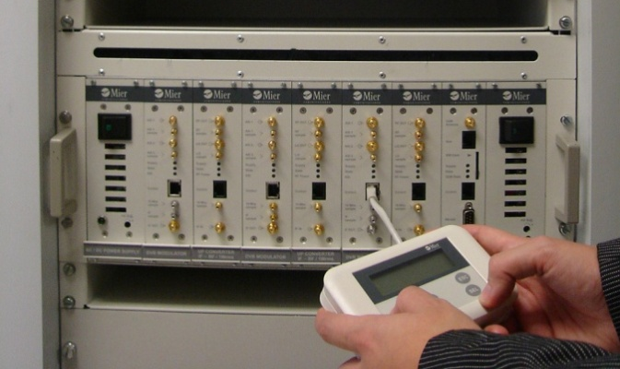

Each channel is made up of two different modules:

- Down-converter: It moves an UHF channel to IF.
- Up-converter: It moves the IF signal to an UHF channel and amplifies it to reach the nominal output power.

Down-converter interfaces.

Inputs.

RF IN
Signal type: RF signal in the UHF band, coming from the receiving antenna.
Level range: from -75 dBm to -20 dBm
Connectors: N female 50 Ω (module front-panel).

LO input
Signal type: LO sample coming from the up-converter and used for the down-conversion mixer.
Level: -5 dBm
Connectors: N female 50 Ω (module front-panel).

Outputs

RF sample
Signal type: Input signal sample (UHF band) for monitoring.
Connectors: SMB male 50 Ω (module front-panel).

IF sample
Signal type: IF signal sample for monitoring.
Level: -20 dBm
Connectors: SMB male 50 Ω (module front-panel).

IF output
Signal type: IF signal output to the up-converter.
Level: 0 dBm
Connectors: SMA female 50 Ω (module front-panel).

Control interfaces.

Easy check (RS-232) connector
Interface to connect handheld terminal for local monitoring.
Connector: RJ-45

Up-converter interfaces.

Inputs.

IF IN
Signal type: IF signal, coming from the down-converter.
Level: 0 dBm
Connectors: SMA female 50 Ω (module front-panel).

Outputs

RF output
Signal type: RF signal in the UHF band, going to transmitting antenna.
Level: 1, 2 and 5Wrms
Connectors: SMA female 50 Ω (module front-panel).

RF Sample
Signal type: RF output signal sample (UHF band) for monitoring.
Level: 20 dB lower than RF output level.
Connectors: SMB male 50 Ω (module front-panel).

LO OUT
Signal type: LO signal sample for mixing process in the down-converter module.
Level: -5 dBm.
Connectors: SMB male 50 Ω (module front-panel).

LO Sample
Signal type: LO signal sample for monitoring.
Level: -20 dBm
Connectors: SMB male 50 Ω (module front-panel).

10 MHz Sample
Signal type: 10 MHz reference signal sample for monitoring.
Level: 7 dBm.
Connectors: SMB male 50 Ω (module front-panel).

Control interfaces.

Easy check (RS-232) connector
Interface to connect handheld terminal for local monitoring.
Connector: RJ-45

Control and monitoring

LOCAL INTERFACES
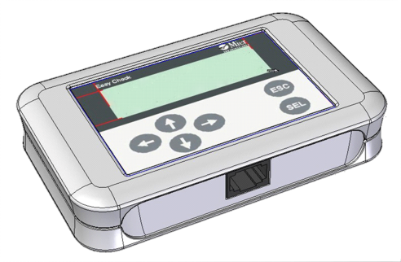
Easy-Check
- 6 button + LCD display device
- To adjust and check the operation of each of module.
Once plugged to a specific module it will browse all possible configuration, monitoring and status information of the module.

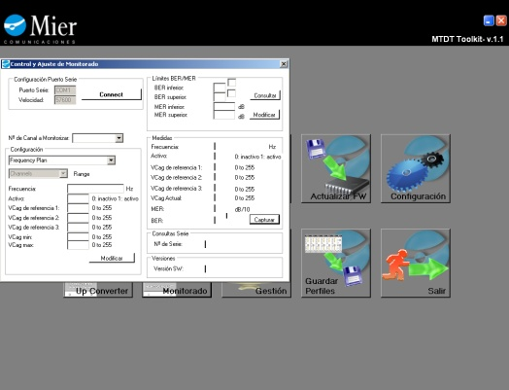
mTDT Toolkit
- Proprietary software Local Graphical User Interface
- Offers the most intuitive and friendly user way to manage the system by means of a laptop.
- When connected to a serial port, it allows automatic profile loading, exhaustive monitoring of the equipment, firmware updates and complete configuration.

REMOTE INTERFACES.

SNMP
- The SNMP Agent provides access and control over basic parameters of the system through the open architecture SNMPv2 protocol.
- Embedded on the SMU (System Management Unit) module.
- It includes a GPRS/EDGE modem as a backup of the communications
- 10Base-T interface to manage the equipment remotely over the Control module.

Web-browser
- Executable from any standard Internet browser, it doesn’t require any specific software
- Allows saving on proprietary programs
- Easy remote and local control and monitoring capabilities depending on user privileges.
- Embedded on the SMU (System Management Unit) module.

Prototype 6: LA SALLE DVB-T2 Gateway
Providing partner : Ramon Llull University – La Salle.

General description
La Salle DVB-T2 Gateway supports both Single and Multiple PLP and it has the ability to re-use existing DVB-T Multiplexers with its special feature of ‘OneBigTS Adaptation’. Its input/output interfaces are ASI, TS/UDP/IP and Files.
It is a SW application running on a PC with PCI boards for ASI input/output interfaces. The configuration is currently done via .ini files

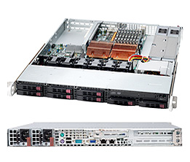

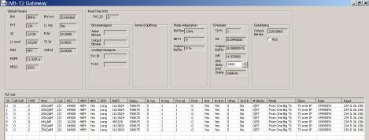

Features
- Multi format input: IP, DVB-ASI.
- Multi format output: IP, DVB-ASI.
- Single and Multiple PLP support
- SFN, DVB-T2 timestamp generation
- OneBigTS format: common extraction and ‘AnnexD’ implementation for PSI/SI
- Different hardware options available

Supported modes

Single PLP – VV500
La Salle DVB-T2 Gateway supports configurations similar to VV500 with Single PLP.

Multiple PLP – VV413
La Salle DVB-T2 Gateway supports configurations similar to VV413 with Multiple PLP in static multiplexing. In this mode, the allocation of BB frames is statically assigned according to the initial configuration.

Multiple PLP – VV400
La Salle DVB-T2 Gateway supports configurations similar to VV400 with Multiple PLP in dynamic multiplexing. In this mode, the allocation of BB frames is dynamically assigned per PLP according to the instantaneous bitrate of each PLP.
It supports ‘OneBigTS’ mode with a single input Transport Stream generated by a standard multiplexer. Then the DVB-T2 GW generates independent Transport Streams per each PLP (normally one PLP per service) and automatically distributes common service components and PSI/SI between Data PLPs and Common PLP.

Interfaces

T2-MI (TS/UDP/IP)
TS
OneBigTS Adapter
AnnexD Splitting
Mode Adaptation
Scheduler
Data Piping
L1 + SFN clock

T2-MI (ASI)
T2-MI
TS (ASI)
TS (TS/UDP/IP)

Inputs

TS(ASI)
Standard DVB-ASI signal via 75-Ω BNC.

TS(TS/UDP/IP)
TS/UDP/IP on multicast or unicast streams.

TS(FILE)
Input TS Files.

Outputs

T2-MI(ASI)
Standard DVB-ASI signal via 75-Ω BNC with T2-MI signal.

T2-MI(TS/UDP/IP)
TS/UDP/IP on multicast or unicast streams.

T2-MI(FILE)
Input TS Files.

The input/output interfaces can be combined in any form.

HW specifications

ASI Connector | 75-Ω BNC
Input Return Loss | > 15 dB
Error Free Cable | 300 m max
ASY Physical Layer | EN50083-9
Bit Rate | 0...214 Mbps
Packet Size | 188 or 204
Power supply | Redundant
IP Interfaces | Dual-port Gigabit
Dimensions (H/W/D) (mm) | 43/437/597  (1 RU, width 19”)
Weight | 16.5kg
Environmental spec | Operating Temperature:  10° to 35°C (50° to 95°F)  Non-operating Temperature:  -40° to 70°C (-40° to 158°F)  Operating Relative Humidity:  8% to 90% (non-condensing)  Non-operating Relative Humidity:  5 to 95% (non-condensing)

Prototype 7: MERCE SC-OFDM Evaluation Platform
Providing partner: MERCE.

General description
The MERCE platform is meant to evaluate the performance of the SC-OFDM waveform for the implementation of the satellite component of the DVB-NGH hybrid profile. As described in Deliverable D10.2 rev.0.3 [4] the SC-OFDM platform was initially due to be implemented on a FPGA board designed by Nallatech. The so-called Hardware Evaluation Platform (HEP) had recently been used to evaluate and demonstrate MERCE technologies related to the 3GPP/LTE system in uplink. The system was actually implementing a simplified version of the 3GPP “Release 8” standard. As the 3GPP/LTE uplink relies on the SC-OFDM modulation, it had initially been planned to perform some functional adaptations to the existing design so as to enable the evaluation of the SC-OFDM waveform in a satellite broadcasting environment.
At that time, MERCE was in the process of selecting a new hardware platform to replace the existing equipment due to resources limitations. The Nallatech platform was particularly lacking of free external memory, a key feature when it comes to evaluate long time interleaving schemes for satellite transmissions. As the specifications of the DVB-NGH system were also under finalization, it was decided to implement the actual SC-OFDM component of the DVB-NGH hybrid profile on the newly selected platform. The purpose was twofold: To benefit from a more powerful hardware platform, especially with a large amount of external memory for the long-time interleaving, and to evaluate the SC-OFDM waveform in a realistic DVB-NGH context, thus providing more relevant results.
As shown on Figure 1 the new HEP platform is made of three entities, the HEP Central Unit and the HEP TX and RX parts. The HEP platform is actually dedicated to the evaluation of new technologies for research purposes. In that purpose, both the transmitter and the receiver are implemented within the same equipment (HEP Central Unit), based on the HTG-V6HXT-x8PCIE FPGA board designed by HiTech Global (See Figure 2). To still allow for transmission over long distances, the main processing board is connected to 2 secondary units using 5 Gbps full duplex optical links. The first unit (HEP TX) implements the digital to analogue conversion on an intermediate frequency (IF) while the second unit (HEP RX) implements the analogue to digital conversion from IF down to baseband. These two units are built on the Xilinx ML605 board fitted with the FMC150 ADC/DAC FMC board designed by 4DSP.

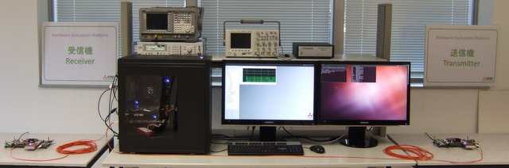
HEP Rx
HEP Central Unit
HEP Tx
Figure 1: Overview of the MERCE Hardware Evaluation Platform.
The HEP platform is a research tool. In its current version, it does not support the DVB physical and logical standard interfaces. It is not possible to interconnect the platform to other DVB compliant products. Instead, the platform is used in a standalone mode to carry on performance evaluation to be cross checked with simulation e.g. using a hardware LMS channel emulator.

HEP Central Unit
The HEP Central Unit is the core processing unit of the HEP platform. The physical layer functionalities are implemented on a COTS FPGA prototyping platform designed by HiTech Global, namely the HTG-V6HXT FPGA PCIe board (See Figure 2 and Figure 5). Figure 3 provides an overview of the features supported by the HTG-V6HXT. These are as follows:
- 1× Virtex-6 HX380T-2 Xilinx FPGA
- 1× x8 PCI Express Gen2 Edge Connector
- 2× SFP+ ports with EDC & CDR support through external PHY chips
- 2× SFP+ ports with direct interfaces to the on-board FPGA's GTH (10G) serial transceivers
- 2× DDR-3 SO-DIMM (currently fitted with 1 GB each, up to 8GB)
- 2× QDR-II+ SRAM (4Mx18 each)
- 2× HPC FPGA Mezzanine Connectors (FMC)
  - FMC #1: 9 LVDS I/Os and 10 GTH (11.18 Gbps) Serial Transceivers
  - FMC #2: 34 LVDS I/Os and 10 GTX (6.6 Gbps) Serial Transceivers
- Configuration through JTAG or CPLD
- USB to UART interface
- ATX and DC power supplies for PCI Express and Stand Alone operations
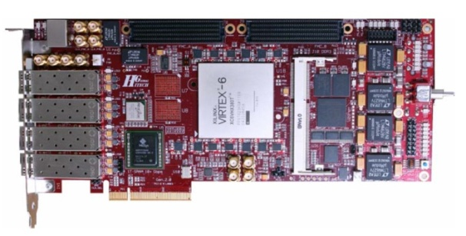
Figure 2: HTG-V6HXT-x8PCIE FPGA board.

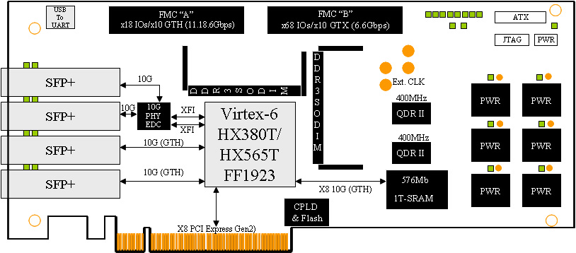
Figure 3: Hardware specifications of the HTG-V6HXT-x8PCIE FPGA board.

The two SFP+ cages directly connected to the FPGA (through a GTH serial link) are used to interconnect the HTG board with the two secondary boards. In that purpose, the cages are fitted with an optical transceiver (AFBR-57J7APZ from Avago) supporting data rates up to 7.4 Gbps through a pair of 850 nm multimode optical fibers. The two FMC connectors (not fully populated) are provisioned to interconnect with a second HTG-V6HXT board in case additional processing power would be needed.
Figure 4 compares the hardware resources count of the Virtex-6 HX380T FPGA (in red) to the other devices of the same family. In addition to supporting 24 high speed GTH serial links, the HX family provides a large number of DSP48E fast multipliers glued by more than 300,000 logic cells, thus enabling the joint implementation of the HEP transmitter and receiver in the very same device. The colocalization of the transmit and receive units provides a lot of flexibility to validate and evaluate the embedded functionalities by interconnecting both entities at different levels. It also simplifies the evaluation of synchronization algorithms.

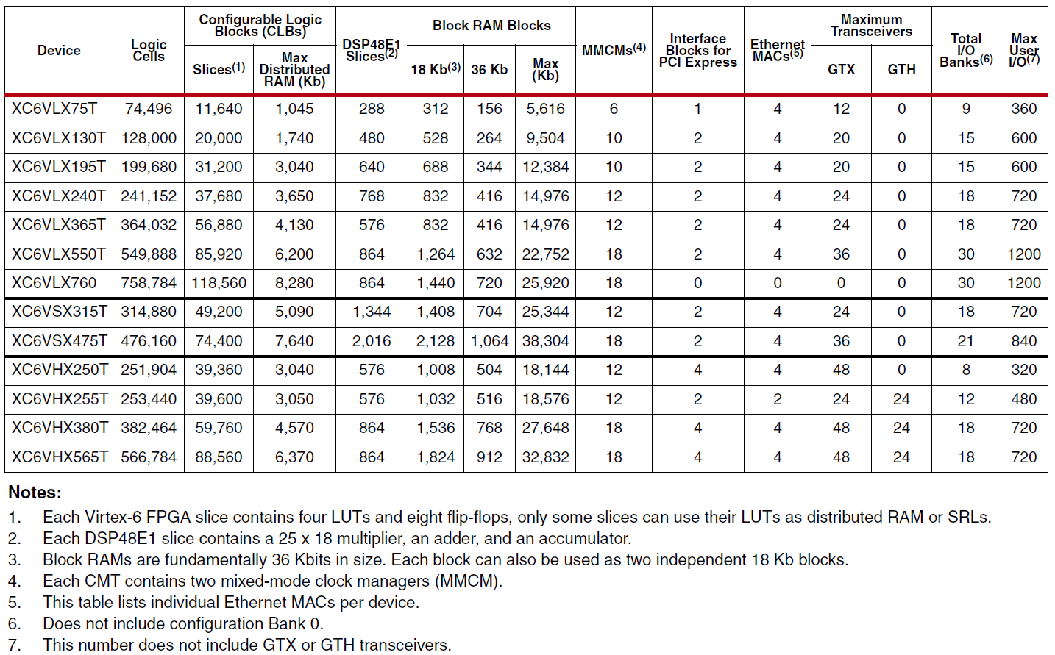
Figure 4: Virtex-6 FPGA Feature Summary by Device.

As shown on Figure 5, the HTG-V6HXT is enclosed within a standard PC (3820 Core i7 Intel processor with 16 GB of DDR3 SDRAM) running an Ubuntu Linux operating system (OS) installed with the Realtime Preemption (PREEMPT_RT) patch. The RT-Preempt patch converts Linux into a fully preemptible kernel by ”simply” modifying the original kernel. Unlike Xenomai or RTAI, it does not introduce a new layer within the Linux kernel. It is thus always possible to benenfit from the large software portofolio of the Ubuntu distribution. The host PC is used 1 – to control/configure the HTG-V6HXT board, 2 – to implement the upper layers of the transmission system and 3 – to run a powerful monitoring application.
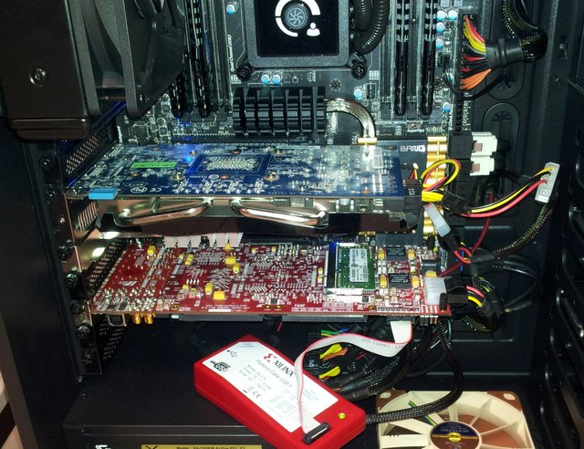
Figure 5: HTG-V6HXT-x8PCIE FPGA board enclosed in the host PC.

Transmitter (HEP Tx)
As previously mentioned, the baseband part of the transmitter is implemented by the HTG-V6HXT FGPA board of the HEP Central Unit. The digital baseband samples can however be forwarded to a separate platform through an optical link to allow transmissions over large distances. This secondary unit is indeed meant to interface with any RF front-end that would be made available for specific purposes. The secondary unit relies on the ML605 Evaluation board designed by Xilinx. The ML605 board is depicted on Figure 6 along with all the supported features. The key features are as follows:
- 1× Xilinx Virtex-6 LX240-1 FPGA
- 1× x4 PCI Express Gen2 Edge Connector (or x8 PCI Express Gen1)
- 1× 10/100/1000 Mbit/s Ethernet interface with the onboard Marvell Alaska PHY device
- 1× SFP port with EDC & CDR support through external PHY chips
- 1× DDR-3 SO-DIMM (currently fitted with 512 MB, up to 2GB)
- 1× VITA 57.1 HPC FPGA Mezzanine Connector (FMC)
  - 78 LVDS differential I/Os and 8 GTX Serial Transceivers
- 1× VITA 57.1 LPC FPGA Mezzanine Connector (FMC)
  - 34 LVDS differential I/Os and 1 GTX Serial Transceivers
- Configuration through JTAG or Flash
- USB to UART interface
- ATX and DC power supplies for PCI Express and Stand Alone operations
- USB 2.0 Host and Device interfaces

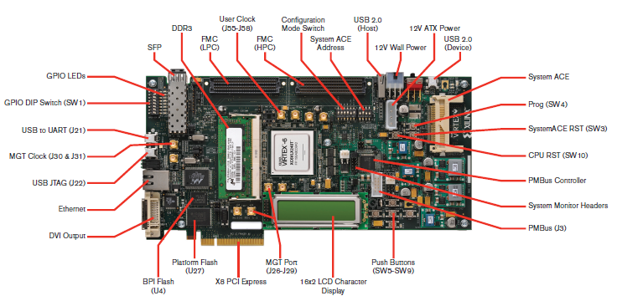
Figure 6: Hardware specifications of the Xilinx ML605 FPGA board.

The SFP cage (connected to the FPGA through a GTX link) is used to interconnect the ML605 hardware to the HEP Central Unit. In that purpose, the cage is fitted with an optical transceiver (AFBR-57J7APZ from Avago) supporting data rates up to 7.4 Gbps through a pair of 850 nm multimode optical fibers.
Figure 4 compares the hardware resources count of the Virtex-6 LX240T FPGA (in blue) to the other devices of the same family. The FPGA is used here to handle the different physical interfaces of the board and to generate the digital samples to be processed by a Digital to Analogue Conversion (ADC) module plugged into one FMC connector. The versatility of the ML605 board comes indeed from the support of two FMC connectors, one with a High Pin Count (HPC) interface (almost but not totally populated) and another one with a Low Pin Count (LPC) interface (fully populated). It is thus possible to plug on the board a great variety of FMC daughterboards featuring either digital or analogue interfaces.
In the present case, the board is populated with a FMC150 daughterboard from 4DSP featuring 2×14-bit A/D 250 MSPS channels and 2×16-bit D/A 800 MSPS channels (See Figure 7). This board can be used to interface in analogue with an RF front-end either in zero-IF or low-IF mode. In the present case, the system is configured to generate a signal modulated over a low-IF frequency at 70 MHz. The associated digital upsampling and modulation functions are carried out by the FPGA in the ML605. The 4FDP FMC150 module is shown plugged onto the ML605 on Figure 8.
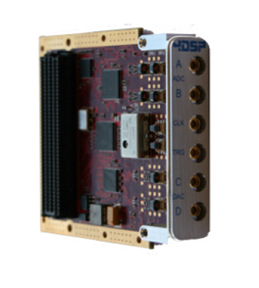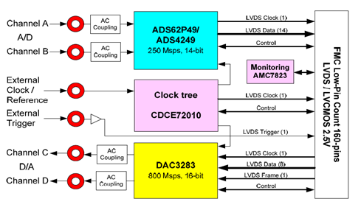
Figure 7: Hardware specifications of the 4DSP FMC150 daughterboard.

Receiver (HEP Rx)
Just like for the transmitter, the baseband part of the receiver is implemented by the HTG-V6HXT FGPA board of the HEP Central Unit. The digital baseband samples can however be retrieved from a separate platform through an optical link to allow transmissions over large distances. The interface with any RF front-end that would be made available for specific purposes is carried out using a second secondary unit similar to the one used for the HEP TX unit. In the present case, both units are stricly similar as the FMC150 module from 4DSP implements both ADC and DAC modules. The demodulation and down-sampling operations are implemented in the ML605 FGPA. The FPGA can also be used to implements part of the synchronization.

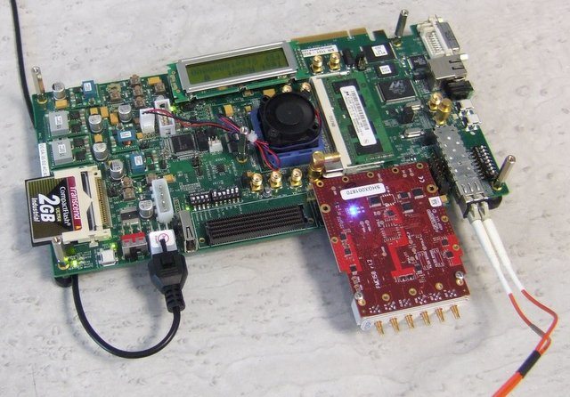
Figure 8: Xilinx ML605 board and 4DSP FMC150 daughterboard (HEP TX and RX units).

Transmitter

Inputs
32×(40/7) MHz input
Signal type: External sinusoidal signal with frequency=182.85 MHz.
Level: -10 dBm.
Connector: SSMC 50 Ω.
Note: The 4DSP FMC150 embeds a programmable oscillator that is only compatible with 3GPP/LTE frequencies.

Mains input
Signal type: AC 230V
Connector: IEC-320-C14

Outputs
IF output
Signal type: Low IF analogue signal (IF = 70 MHz).
Level: Max +7 dBm.
Connector: SSMC female 50 Ω.
Modulated bandwidth: 5 MHz.

Control interfaces
Ethernet link
Signal type: Ad-hoc control interface.
Throughput: 10/100 Mbits/s
Connector: RJ-45 female.

Receiver

Inputs
32×(40/7) MHz input
Signal type: External sinusoidal signal with frequency=182.85 MHz.
Level: -10 dBm
Connector: SSMC 50 Ω.

Low-IF input
Signal type: Low IF analogue signal (IF = 70 MHz).
Level: Max +10 dBm.
Connector: SSMC female 50 Ω.
Modulated bandwidth: 5 MHz.

Mains input
Signal type: AC 230V
Connector: IEC-320-C14

Control interfaces
Ethernet link
Signal type: Ad-hoc control interface.
Throughput: 10/100 Mbits/s
Connector: RJ-45 female.

Control interfaces
The FPGA board within the HEP Central Unit is fully configured by the host PC either through the PCIe interface or the 10G Ethernet interface. A dedicated monitoring interface has been developed to control and monitor the whole system using a configurable Graphical User Interface (GUI). The same application can be used to control the two secondary units from the PCIe or the Ethernet interfaces.

Features
The purpose of the HEP platform is to validate the performance of the SC-OFDM modulation in the context of satellite broadcasting. For that reason, the system does not implement the whole set of the DVB-NGH specifications. However, all the implemented functionalities are fully compliant with the standard. The platform actually focuses on the satellite component of the hybrid profile, and more particularly the SC-OFDM mode of the satellite component. Thus, neither the OFDM option of the satellite component nor the terrestrial component is supported even if the platform is obviously OFDM capable. The platform also focuses on the physical layer functionalities: the gateway functionalities are simply emulated when needed. Figure 9 shows the functional diagram of the overall SC-OFDM platform. It can be noticed that the platform implements a simplified LMS channel emulator in the purpose of performing basic tests on the overall system. It must be pointed out that the platform does not currently implements synchronization mechanisms that will be developed in a further step. The platform will be used at first to perform BER/PER performance evaluation with a perfect synchronization to be compared with theoretical results.

Figure 9: Functional diagram of the HEP platform.

Supported modes
As stated before, the HEP platform implements a subset of the DVB-NGH specifications.

The key functionalities supported by the HEP platform are as follows:
  - Full support of the SC-OFDM waveform (spreading, de-spreading, PP9 pilot pattern)
  - Support of type 1 and type 2 multi-PLPs
  - Ready for multi-PLPs, but only 1 PLP validated so far
  - Support of the logical frames and logical super-frames
    - Only the logical channel of type A
  - Support of long-time convolutional interleaving (CI)
    - Also for longer durations than in NGH (up to 10s)

The main deviations with respect to the DVB-NGH specifications are:
  - No support of TS or GSE inputs
    - So far, only PRBS raw traffic
  - No implementation of the P2 symbols (L1 signalling)
  - No support of TFS
  - So far, only uniform CI, uniform-late CI under completion

Table 1: Current specifications of the HEP platform.
The system parameters supported by the platform are summarized in Table 1. Figure 8 depicts the functional structure of the HEP transmitter with respect to DVB terminology. Figure 11 to Figure 15 graphically represent the DVB-NGH specifications supported by the HEP platform following the same terminology as used in DVB documentation. It can be noticed that a major part of the specifications are supported by the HEP platform.

Figure 10: General functional structure of the HEP transmitter.

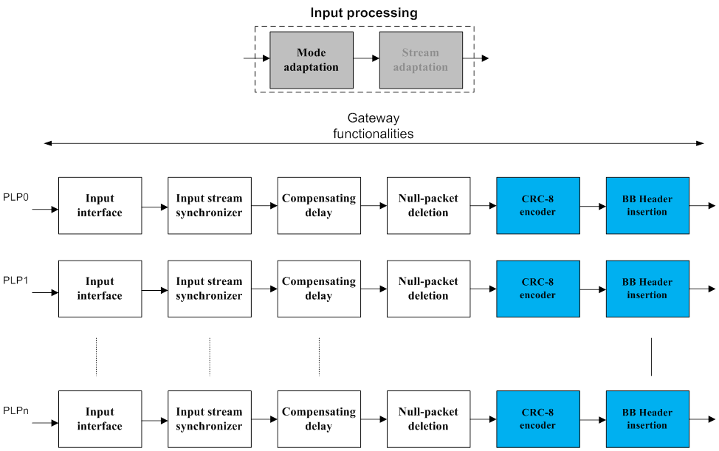

Figure 11: Specifications supported by the SC-OFDM platform: Input processing (a).

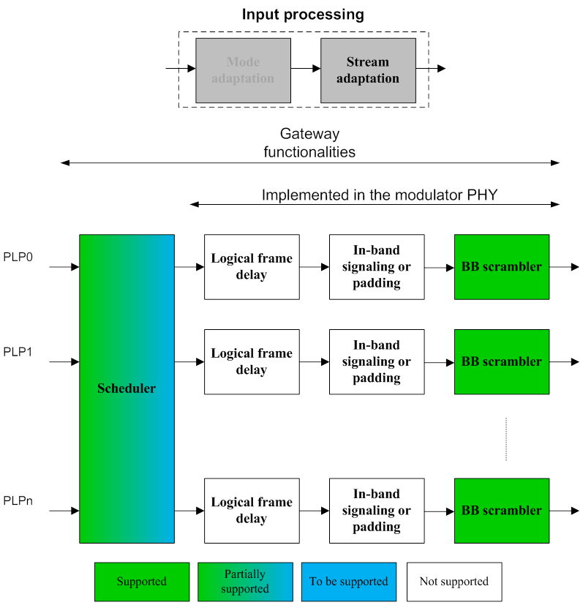
Figure 12: Specifications supported by the SC-OFDM platform: Input processing (b).

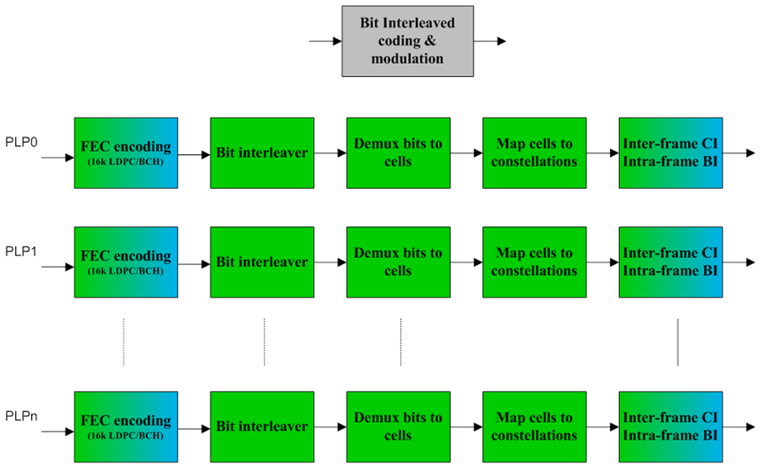
Some missing coding rates (commercial T2-lite IP core)
So far, CI with uniform law, NGH uniform-late to come later

Figure 13: Specifications supported by the SC-OFDM platform: BICM and Frame building.

Only data PLPs are supported

Figure 14: Specifications supported by the SC-OFDM platform: BICM and Frame building.

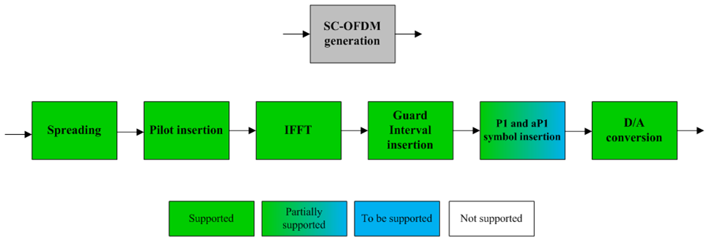
P1 and aP1 currently fixed and stored in a table
Figure 15: Specifications supported by the SC-OFDM platform: SC-OFDM generation.

Prototype 8: Enensys DVB-T2 gateway
Providing partner: Enensys


General description

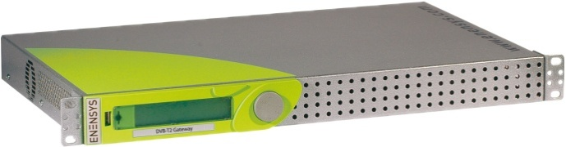

The NN6-T2Gateway is ENENSYS' DVB-T2 Gateway that encapsulates up to 8 DVB/MPEG-2 Transport Streams into a DVB-T2 stream, inserts synchronization data to allow Single Frequency Network (SFN) broadcasting (possibly in MISO mode), manages single and multiple PLP modes, and outputs the DVB-T2 stream towards the DVB-T2 modulators with the synchronization information using the new T2-Modulator Interface (T2-MI) over ASI and IP.

Running at the head-end right after a typical DVB-T multiplexer, the NN6-T2Gateway encapsulates the incoming MPEG-2 TS into baseband frames (BB frame). It packetizes the generated DVB-T2 stream using the T2-MI (Modulator Interface) protocol through ASI and/or IP.

The NN6-T2Gateway is the central body of the operational DVB-T2 network as it provides in-band control and signaling to all the DVB-T2 modulators throughout the T2-MI output interface. When using Multiple PLP (Physical Layer Pipes) to provide service-specific robustness, the NN6-T2Gateway enables all the modulators to generate the same data in a deterministic manner. When broadcasting DVB-T2 services over Single Frequency Network, operators must operate the NN6-T2Gateway that behaves as a SFN Adapter.

The NN6-T2Gateway provides in-band and out-of-band synchronization information to all modulators to generate the same data at the very same time over the same frequency.

Combined with the ENENSYS'ASI switch, ASIGuard, it implements an innovative and patented 1+1 redundancy mechanism, named T2guard. The whole solution offers a unique DVB-T2 seamless switch-over (in SFN and MFN broadcasting) between 2 DVB-T2 Gateways that prevents for any TV blackout due to the change-over operation.

Interfaces

Inputs

Control
2x Fast Ethernet for GUI and SNMP (RJ45)

MPEG2-TS
6x ASI inputs (BNC 75 ohms)
1x Gigabit Ethernet IP input (RJ45)

GPS
1x TNC input for internal GPS
1x PPS input (50 ohms)

Outputs

T2-MI/MPEG2-TS
1x Gigabit Ethernet IP output (RJ45)
2x Mirrored ASI outputs (BNC 75 ohms)

GPS
1xPPS and 1x10MHz outputs

Control and monitoring

Validation of DVB-T2 parameters
Easy-to-use web based GUI
User management
Full SNMP v2 support for remote management and integration with any NMS

Supported T2 modes and features

DVB-T2 encapsulation | Encapsulation into baseband frames  Full support of BB frame modes
DVB-T2 network conﬁguration | In-band control of T2 modulators  Individual addressing  FEF management
SFN Adaptation | Integrated SFN adapter  MISO Support  T2-MIP generation
PLP management | Single and Multi-PLP handling  Type1 and type2 management  Static and dynamic PLP allocation
T2-MI output | Generation of T2-MI packets  IP output featuring Pro MPEG  Forum CoP#3/SMPTE 2022  Optimized bandwidth output
T2Guard | Patented 1+1 seamless switch-over  between two T2 Gateways  One-click conﬁguration

The ENENSYS T2 Gateway supports the following parameters:

General Parameters
Length | 2 Superframes
Frames per Superframe | 2
Subslices per Frame | 1 (Single PLP) and up to 1670 (Multiple PLP)
DVB-T2 mode | System A (MPEG-TS only) and system B (T2MI over TS)
SFN transmission | Yes
Bandwidth | 5,6,7,8MHz
Multi-PLP | Yes, up to 8 PLPs
MISO | Yes
Null packet deletion | Yes
FEF | Yes
TX signaling | No
FFT size | 1K, 2K, 4K, 8K, 16K and 32K
Extended bandwidth | Yes
Guard interval | 1/4, 19/128, 1/8, 19/256, 1/16, 1/32 and 1/128
Pilot pattern | PP1, PP2, PP3, PP4, PP5, PP6 and PP7, PP8
PAPR | TR (Tone Reservation)
L1 constellation | BPSK, QPSK, 16 QAM and 64QAM
L1 Repetition | No
PLP parameters
PLP type | Type 1 and Type 2
LDPC | 16K, 64K
Coderate | 1/2, 3/5, 2/3, 3/4, 4/5, 5/6
Constellation | QPSK, 16QAM, 64QAM, 256QAM
Rotated constellation | Yes
Time interleaver | Yes
High efficiency mode | Yes
ISSY | Yes

Prototype 9: Enensys DVB-T2 modulator
Providing partner: Enensys

General description

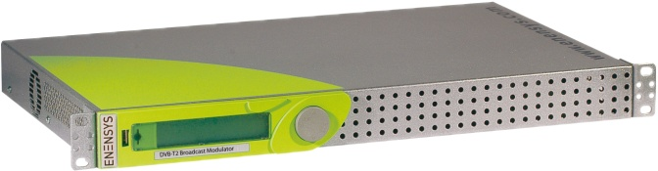

ENENSYS NetMod-DVB-T2 Modulator is designed to modulate a MPEG2 Transport Stream or T2-MI stream into a DVB-T2 fully compliant RF or IF signal. Integrating state of the art components and sophisticated signal processing methods, NetMod-DVB-T2 network adapter comprehensively covers all characteristics of the DVB-T2 specifications. With its integrated RF up-converter, NetMod-DVB-T2 Modulator outputs a RF signal that can be directly exploited for live broadcasting or testing purposes. It generates the exact signal needed for any validation campaign, debug test, integration constraints simulation with a broadcast signal quality that is required by operators, and matches with terrestrial transmitting systems.

Interfaces

Inputs

T2-MI/MPEG-2 TS
2x DVB-ASI (BNC 75 Ω)
1x Gigabit Ethernet IP input (RJ45)

Control
1x Fast Ethernet for GUI and SNMP (RJ45)

GPS
1x RF input for internal GPS (TNC 50 Ω)
1x PPS (BNC 50 Ω)

Outputs

RF Outputs
1x Main RF output (SMA 50 Ω)
1x Monitoring RF output (SMA 50 Ω)
Frequency spectrum: 100 - 870 MHz (step 1 Hz)
Power range : +2 to -60 dBm (step 0,1 dB)
MER over 42 dB in the whole band
Shoulders Over 55 dB

IF output
1x Main IF output (SMA 50 Ω)
Frequency spectrum: 20 - 85 MHz (step 1 Hz)
Power range : 0 to -30 dBm (step 0,1 dB)
MER over 45 dB in the whole band
Shoulders over 55 dB

Control and monitoring

Web Based Graphical User Interface
➔ Comes natively with the product
➔ Intuitive GUI allowing fast learning period to get ready to manage the
solution
➔ Can be remotely managed for automated tests
➔ User Manual stored in the GUI: no more paper nor manual lost
Full SNMP v2 support for remote management and integration with any NMS

Supported T2 modes and features

The ENENSYS T2 Modulator supports the following parameters:

General Parameters
Length | 2 Superframes
Frames per Superframe | 2 and 6
Subslices per Frame | 1 (Single PLP) and up to 270 (Multiple PLP)
DVB-T2 mode | System A (MPEG-TS only) and system B (T2MI over TS)
SFN transmission | Yes
Bandwidth | 5,6,7,8MHz
Multi-PLP | Yes, up to 8 PLPs
MISO | Yes
Null packet deletion | Yes
FEF | Null FEFs
TX signaling | No
FFT size | 1K, 2K, 4K, 8K, 16K, 32K
Extended bandwidth | Yes
Guard interval | 1/4, 19/128, 1/8, 19/256, 1/16, 1/32 and 1/128
Pilot pattern | PP1, PP2, PP3, PP4, PP5, PP6 and PP7, PP8
PAPR | TR (Tone Reservation)
L1 constellation | BPSK, QPSK, 16QAM, 64QAM
L1 Repetition | No
PLP parameters
PLP type | Type 1 and Type 2
LDPC | 16K, 64K
Coderate | 1/2, 3/5, 2/3, 3/4, 4/5, 5/6
Constellation | QPSK, 16QAM, 64QAM, 256QAM
Rotated constellation | Yes
Time interleaver | Yes
High efficiency mode | Yes
ISSY | Yes

Prototype 10: UPV/EHU DVB-T2 demodulator
Providing partner: University of the Basque Country - UPV/EHU

General description

The UPV/EHU DVB-T2 Test Receiver is a software-based receiver for demodulating DVB-T2, DVB-T2-Lite and combined signal. Figure 1 shows a diagram with the main blocks in which the software receiver is organized. Green boxes describe the measurements carried out in each of the different blocks.
Figure 1. Main blocks of the software demodulator

This receiver is a software demodulator that can work in two different modes. One of them is based on an offline analysis, by the demodulation of the IQ samples previously recorded into an IQ samples file.
The second one consists on demodulating RF signals by using an additional RF module, as shown in Figure 2. This module receives the DVB-T2 or DVB-T2-Lite RF signal as baseband IQ samples. These samples can be saved in a file, which could be later demodulated by the software demodulator, or can be sent directly to the software demodulator by a TCP/IP socket, getting a pseudo-real time analysis of the received signal. This additional module is an USRP N-210 (Universal Radio Software Peripherical) device from Ettus Research, which is connected to the computer using a GB-Ethernet link
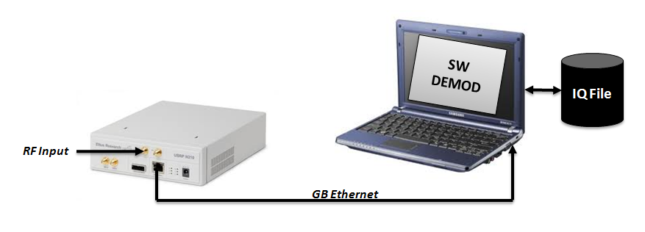
Figure 2. Operation with the USRP module

Interfaces

When doing offline analysis, the input to the software receiver is a file with the previously recorded IQ samples of the signal to demodulate. Supported formats for the input files are:
- Binary files with double (IEEE) IQ samples.
- Text files with double IQ samples separated by spaces or newline.
- Binary file with I/Q samples saved as signed Int16 little Endian.
- Binary file in the Tektronix IQT format.
- Binary file in the Tektronix TIQ format.
- Binary file in the HP VSA SDF format.
- Binary file in the HP VSA BIN format.
- Binary file in the ADIVIC TCX format after proprietary conversion.
- Binary file in the Anritsu DGZ format.

When doing pseudo-real time analysis, the input to the software receiver are the IQ samples sent by a TCP/IP socket. Supported formats are:
- Int16 IQ samples through TCP/IP socket.

In this last case, the RF signal is received using the RF input interface the USRP has.

Inputs

As this is a software demodulator, there are no physical input interfaces. The data input is by a binary file with the IQ samples of the signal to demodulate. In case of demodulating an RF signal using the USRP device, the input interface is:

RF input (when using the USRP N-210 device)

General function: DVB-T2 or DVB-T2-Lite RF signal reception.
Frequency range: From 50 MHz to 2.2 GHz.
Level range: -90 dBm to -20dBm
Connector: SMA - 50 Ω (Female)
Capture Bandwidth: 10 MHz

Outputs

As it is a software demodulator, there is no physical output interface.

Control and monitoring

There are two different software applications in order to control the signal demodulation. One of them controls the signal demodulation and carries out the measurements, while the second one is used for controlling the acquisition of IQ samples when using the USRP N-210 device and a pseudo-real time analysis is done.
Table 1 resumes the main text information monitored by the receiver.
Synchronization | Status (synced or no) | Signal Properties | CNR (dB)
Synchronization | P1 Freq. Shift | PLP Info | Mode: Modulation/Code rate
Synchronization | Norm. Freq. Shift | PLP Info | Interl. length
Synchronization | CPE | PLP Info | WMER (dB)
Synchronization | Clock Error | PLP Info | MER (dB)
Synchronization | Detected GI | PLP Info | PreLDPC BER
Equalization | Window position | PLP Info | PreBCH BER
Equalization | Time filter size | PLP Info | LDPC FER
Equalization | Delay Spread | PLP Info | BCH FER
Signalling | S1/S2/Pre/Post OK | PLP Info | LDPC iterations
Signalling | S1/S2 prob. | PLP Info | BitRate (TS)
Signalling | FFT Size | PLP Info
Signalling | Mode | PLP Info
Signalling | Pilot Patern | PLP Info
Signalling | Frame Length (ms) | PLP Info
Table 1: Main text information provided by the software demodulator

Besides, the demodulator gives some graphic information as it can be seen on Figure 3. This information is related to:

- Constelation
- Signal Spectrum
- Pilot Carriers Correlation
- P1 Symbol Detection
- Channel Estimator Module and Phase
Impulse Response

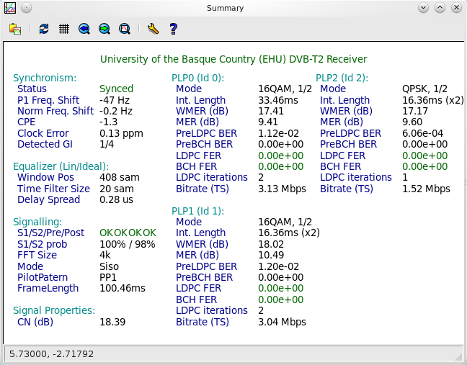
3a)

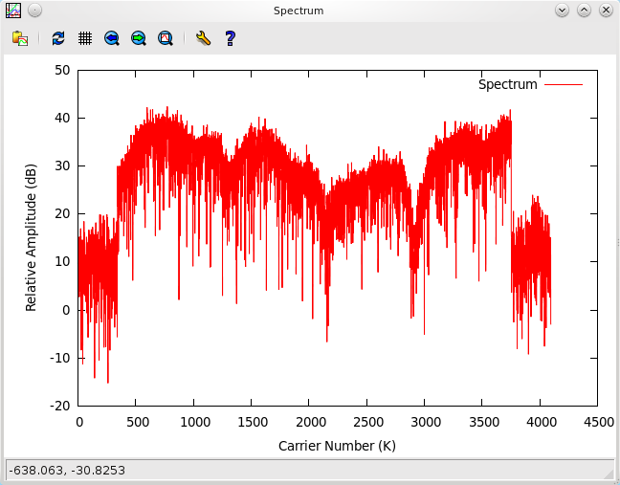
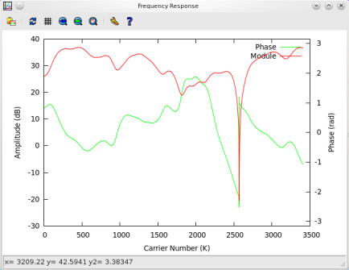
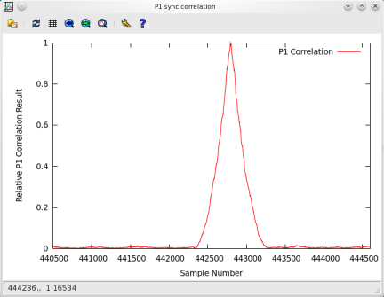
3b) 3c) 3d)

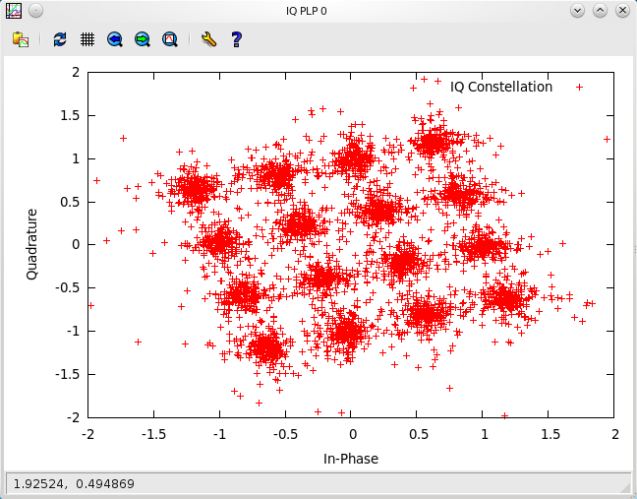
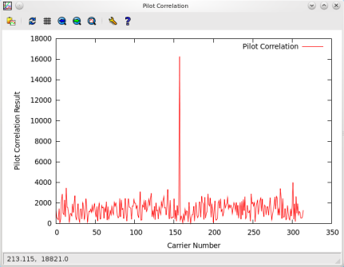
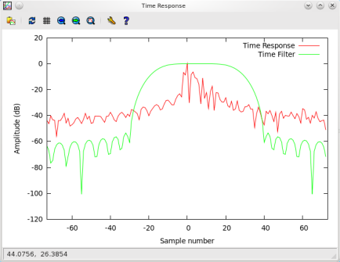

3e) 3f) 3g)
Figure 3: Information provided by the spftware demodulator
3a) Text information about the signal main parameters.
3b) Signal spectrum
3c) Channel estimation module and phase
3d) P1 symbol detection
3e) Impulse response
3f) Pilot carriers correlation
3g) Constelation

It is important to stress that the information obtained depends on the analysis done. In case of doing an offline analysis, all the information stated in Table 1 and Figure 3 is obtained. However, if the software demodulator is used in a pseudo-real time analysis of the RF incoming signal using the USRP module, all the information will not be available.

There are two possible pseudo-real time analysis modes. One of them gives every information from Table 1 and Figure 3 but it takes between 1 and 3 seconds (deppending on the configuration mode of the receiving signal) to analyse the receiving signal before updating the information about the received signal.

However, it is possible to obtain more frequent updates of the information in Table 1 and Figure 3 by using the second pseudo-real time analysis mode. This could be called Fast pseudo-real time analysis, as it only spends about 500 ms analysing the received signal before updating the graphic and text information. Nevertheless, when using the fast pseudo-real time analysis mode it is not possible to obtain BER and FER measurements. Besides, if the rotated constellation feature is in used , it is not possible to obtain neither a graphic of the constellation nor MER measurements.On the other hand, when the rotated constelation feature is not active, both results can be obtained.The other text and graphic results are always obtained.

Supported T2 modes and features

The main characteristic of the DVB-T2 and T2-Lite modes supported by the software demodulator are summarized in Table 2.
Supported modes
Single PLP | All VV.0XX with the exception of the VV.018 (MISO modes)
Multiple PLP | All VV.4XX with the exception of the VV.417, VV.419, VV.467 (MISO modes)
T2-Lite | All VV.8XX with the exception of the VV.804, VV.816, VV.832 (MISO modes)
Main Configuration Parameters
General Frame Parameters
Bandwidth | 1.7, 5, 6, 7, 8, 10 MHz
Multi-PLP | Yes
MISO | Not supported
TFS | Not supported
FEF | Yes
TX signaling | Yes
FFT size | 1K, 2K, 4K, 8K, 16K, 32K
Extended bandwidth | Yes
Guard interval | 1/4, 19/256, 1/8, 19/128, 1/16, 1/32, 1/128
Pilot pattern | From PP1 to PP8
PAPR | Yes
L1 constellation | BPSK, QPSK, 16QAM, 64QAM
PLP parameters
PLP type | Common, Type 1, Type 2
LDPC | 16K, 64K
Coderate | 1/2, 3/5, 2/3, 3/4, 4/5, 5/6, 2/5, 1/3
Constellation | QPSK, 16QAM, 64QAM, 256QAM
Rotated constellation | Yes
Time interleaver | Disable, intra-frame, inter-frame
Stream format | All
Table 2. Main DVB-T2 and T2-Lite configuration parameters supported by the software demodulator

References
- Frame structure channel coding and modulation for a second generation digital terrestrial television broadcasting system (DVB-T2) – DVB BlueBook A122 – ETSI EN 302 755 V1.3.1., July 2011
- Modulator Interface (T2-MI) for a second generation digital terrestrial television broadcasting system (DVB-T2) – DVB BlueBook A136 - ETSI TS 102 773 V1.2.1
- Engines - Workpackage 4 - Task Force 10 description form. V5 April 7, 2011.
- Engines – “Identification and specification of "NGH-Ph.1" prototypes to be built”, Deliverable D10.2 rev. 0.4, March 2012

