Technical Report TR6.1
Intermediate Progress Report
on
TF6 End-to-End System Integration

Editor: David Gomez Barquero

Abstract

This Interim Report aims to show the main advances achieved in the ENGINES Task Force 6, focused on the upper layers above the physical layer that have a direct impact on the end-to-end performance.
First of all, DVB-NGH Task Force - System and Upper Layers (TF-SUL) main outcomes have been explained. Regarding this, it should be noted the Future Extension Frame (FEF) Bundling which sets a structure to include DVB-NGH services within DVB-T2 FEFs. In addition, Transport Stream (TS) and Internet Protocol (IP) profiles have been optimized according to their specifically features, including OMA-BAST to facilitate the interoperability with cellular networks. RoHC methods have been developed in order to reduce overheads introduced in the IP Profile.
On the other hand, SVC analysis has been developed for DVB-T2 and DVB-NGH. In DVB-T2 have been introduced methods to take advantage of Multiple PLP (MPLP) configuration to improve the SVC performance and in DVB-NGH has been shown the more recent researches in terms of MPLP encapsulation, synchronization and signalling.
Finally, an Upper Layer- Forward Error Correction (UL-FEC) research has been performed both for DVB-T2 and DVB-NGH. The studies have been focused on Expanding Window Fountain (EWF) Coded Scalable Video Broadcasting, on Receiver-Controlled Parallel Fountain Codes (RCPF) and a Fading Margin Reduction due to Inter-Burst Upper Layer FEC in Terrestrial Mobile Broadcast.

Table of Contents

1 DVB-NGH Upper Layers 5
1.1 Overview SUL 5
1.2 FEF Bundling 5
1.2.1 Introduction 5
1.3 Transport Stream (TS) Profile 14
1.4 Internet Protocol (IP) Profile 14
1.4.1 Upper Layer Information (ULI) 15
1.4.2 Local Multiplex Information (LMI) 17
1.4.3 Other Multiplex Information (OMI) 18
1.4.4 Step-by-step overview for service mapping 19
1.4.5 Service discovery example based on the proposed signaling elements 21
1.5 Robust Header Compression (ROHC) 24
1.5.1 Adaptation Module 27
1.5.2 Overhead Reduction Module in DVB-NGH 28
1.5.2.1 ROHC module 29
1.5.3 Adaptation module 30
1.5.3.1 TX side 30
1.5.3.2 RX side 30
1.5.3.3 Example output from the Adaptation module 30
1.5.4 Mapping to GSE 30
1.5.5 Signalling 30
1.6 Results 31
1.6.1 Overhead Reduction Module (IP Profile) 31
1.6.1.1 Compression Efficiency 31
1.6.1.2 Error Propagation 32
2 Scalable Video Coding in DVB-T2 and DVB-NGH 32
2.1 SVC in Mobile Broadcasting DVB Systems 32
2.1.1 Spatial scalability 33
2.1.2 Temporal scalability 34
2.1.3 SNR scalability 34
2.2 SVC Delivery in DVB-T2 35
2.2.1 SVC Delivery Using Multiple PLPs 35
2.2.2 SVC Delivery Over Multiple Channels 36
2.2.2.1 IP encapsulation for DVB-T2 transport 37
2.2.2.2 Demonstrator architecture 37
2.2.2.3 CONCLUSIONS 41
2.3 SVC Delivery in DVB-NGH 41
2.3.1 Multiple PLP solution 42
2.3.2 PLPs Synchronization 42
2.3.3 SVC Signalling 44
3 Upper Layer FEC in DVB-T2 and DVB-NGH 45
3.1 Expanding Window Fountain Coded Scalable Video Broadcasting 45
3.1.1 EWF Code Design 45
3.1.2 Measurement Setup 46
3.1.3 SVC Coding Parameters 46
3.1.4 EWF Code Parameterization 47
3.1.5 Measurement Results 48
3.1.6 Video Quality Analysis 49
3.1.7 Conclusions 50
3.2 Receiver-Controlled Parallel Fountain Codes 50
3.2.1 RCPF Code Design 50
3.2.2 Analysis of RCPF Coding Scheme 51
3.2.3 Simulation Results 52
3.2.4 Conclusions 54
3.3 Fading Margin Reduction due to Inter-Burst Upper Layer FEC in Terrestrial Mobile Broadcast Systems 54
3.3.1 Problem description 55
3.3.2 Theoretical analysis for streaming delivery with uncorrelated shadowing 58
3.3.2.1 Analytical Framework 58
3.3.2.2 Analytical Results 58
3.3.3 Theoretical analysis for streaming delivery with correlated shadowing 60
3.3.3.1 Analytical Framework 60
3.3.3.2 Analytical Results 61
3.3.4 Validation results 61
3.3.4.1 DVB-H Results 62
3.3.4.2 DVB-SH Results 62
3.3.4.3 DVB-T2 Results 63
3.3.5 Discussion file download services 64
3.3.6 Conclusions 66
4 References 66

DVB-NGH Upper Layers

Overview SUL

Within the DVB-NGH (Next Generation Handheld) standardization process the Task Force – System and Upper Layers (SUL) has focused their efforts in the encapsulation, upper layer synchronization and physical layer signalling. In these terms, the main SUL topics have been the Future Extension Frames (FEF) Bundling utilization, the definition of MPEG2-TS (Transport Stream) and IP (Internet Protocol) profiles, the inclusion of header compression methods such as Robust Header Compression (ROHC) in the IP profile and finally the compatibility study with other technologies like cellular networks (Long Term Evolution, LTE) through OMA-BCAST interface.
For the specification of the DVB-NGH system, the TM-H group has agreed to consider two profiles, namely a TS profile for transport over legacy TS-based broadcasting networks [1], and an IP profile for transport over IP-based networks [2]. The two corresponding system structures are being developed in parallel. This is done by specifying the transmission bearer layers (i.e. L1 and L2) and selecting upper layer solutions tailored to each profile.

FEF Bundling

Introduction

The super frame (SF) structure was defined in the DVB-T2 standard. An SF is divided into an integer number of frames, these may be of two types: T2 frame and Future Extension Frame (FEF). The maximum frame T_{F} duration is 250ms. The maximum number of frames in an SF is equal to 256. This actually means that the maximum duration of an SF is T_{SF}=64sec. There are three possibilities for the SF definition:

- Case 1: Contains only T2-Frames.
- Case 2: Contains only FEF (= DVB-NGH standalone).
- Case 3: Contains both T2 & FEFs.

The envisaged typical deployment scenario for DVB-NGH is to provide in-band mobile services within a DVB-T2 multiplex transmitting DVB-NGH services into Future Extension Frames (i.e. case 3). This way, it is possible to start providing DVB-NGH services without deploying a dedicated network, which signficantly reduces the required investments.
FEFs are an especial type of frame defined in the DVB-T2 standard [3] which permits to transmit new frames in a conventional T2 multiplex. The following figure shows the logical structure of a T2 frame.

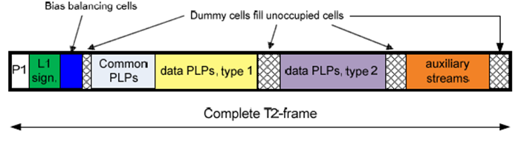
Figure 1. Logical structure of a T2 frame.
The T2 frames are composed by P1 symbols, P2 symbols and data symbols. The initial symbol is the preamble symbol P1, which carries a limited amount (7 bits) of signalling data in a robust way (differentially BPSK-modulated). It has a constant FFT size, i.e. a 1K OFDM symbol, with guard intervals at both ends as we can see in Figure 1. Apart from the detection of the signalling information it carries, P1 allows the receiver to obtain timing, frequency, and coarse time offset estimations as well as reduces scanning time. The subsequent symbols of a T2 frame are called P2. These are normal-sized OFDM symbols with an increased number of pilots (1:3). Their number is fixed for a given FFT size, and provides all static, configurable and dynamic layer-1 signalling. The P2 symbol will in general also contain some data (for common and/or data PLPs), which continues into the other symbols of the T2-frame. The increased number of pilots will enable a fast channel estimation that is particularly important in a time segmented frame transmission (i.e. case 3). Figure 2 and 3 presents a “case 3” SF, that contains both T2-Frames and FEFs. This mixed type of SF seems to be the most interesting one, since it permits with the same network to transmit in the same frequency band both fixed and mobile TV services each with an optimized waveform (i.e. time segmented transmission of T2 and FEF frames). For this combined only transmission (case 3), there are some additional properties that need to be followed:

- Inside an SF the same pattern ratio of FEF and T2-Frames is repeated. For example, in Figure 2 we have 1 T2-frame for 1 FEF.
- An SF must start with a T2-frame and should end with a FEF.
- It is not possible to have 2 consecutive FEFs.

This actually means that the maximum ratio of FEF frames with respect to T2 frames is 1:1. In addition, having 2 consecutive FEF frames will mean that the current SF contains only FEFs. However, the duration of a T2-Frame with respect to a FEF is not constrained.

In the same way as T2, each FEF begins with one P1 symbol (which indicates the transmission type and basic transmission parameters), followed by P2 symbols and data symbols. The L1 signalling are carried by P2 symbols and it provides the receiver the necessary information to access physical layer pipes within the T2-frames.The FEF size is signaled in L1 signaling and its maximum size is 250ms. Due to the very high capacity requirements of T2 services (typically HDTV services), the amount of bandwidth per RF channel used for NGH may be quite low (e.g., less than 20% of the transmission time). Moreover, in order to not affect the zapping time of the existing T2 services, the FEFs should be rather short. A representative use case is that the size of T2 Frames and FEF are 250 ms and 50 ms respectively, with one FEF transmitted after every T2 frame (i.e. FEF interval equal to 1). This case is shown in the Figure 2.

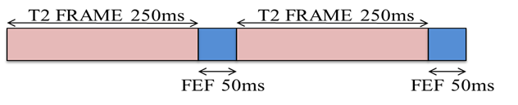
Figure 2. Typical case of a super-frame with T2-frames and FEFs.

In a shared T2/NGH multiplex, the number of NGH services will be very low (e.g., 3-5 TV and radio programs), limiting the gain achievable by statistical multiplexing. Another problem that may occur is the signalling overhead that is introduced in each FEF, since the overhead may be important when the FEFs are small. It must also be taken into account that the T2 system which transmits NGH can optionally use the technique of Time-Frequency Slicing (TFS). This technique has been proposed to improve the frequency diversity and the gain by using statistical multiplexing. TFS was already proposed in the standardizacion process of DVB-T2.

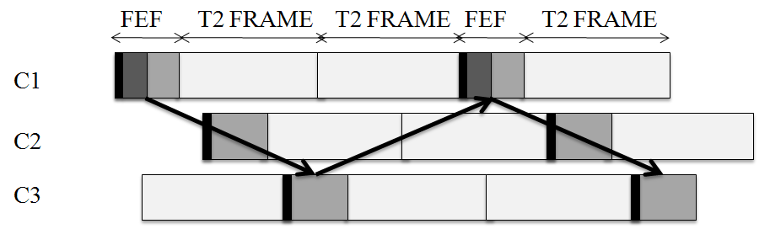
Figure 3. Distribution of a FEF in 3 RF channels when TFS is used.

Time-Frequency Slicing (TFS) is a novel transmission technique that consists on transmitting one service across several Radio Frequency (RF) channels (multiplexes) with frequency hopping and time-slicing (i.e., discontinuous transmission).
With TFS, services are allocated over a set of several RF channels (multiplexes). Thereby, time slices of one service are transmitted sequentially in a different RF channel, implementing frequency hopping. This allows services to be potentially spread over the whole RF frequency band. The reception of a particular service is performed by using frequency hopping at the receiver side among the multiplexes that transmit the time slices of the service. TFS performance permits services to be spread in the time and frequency domains which supply a large time/frequency diversity that can be exploited in a number of different ways. The major advantages of TFS are a gain in capacity and a gain in coverage. The capacity gain of TFS is due to a more efficient Statistical Multiplexing (StatMux) for Variable Bit Rate (VBR) services. The coverage gain of TFS is due to increased frequency diversity.

FEF bundling is introduced to create a logical structure for DVB-NGH similar to the logical structure of DVB-T2. The FEF bundling technique is compatible with TFS, and keeps all its benefits (i.e., coverage gain due to improved frequency diversity and immunity to interferences, and capacity gain due to enhanced statistical multiplexing). In fact, FEF bundling may be seen as TFS generalization. When the FEFs are on the same RF channel, this option is called time-domain bundling. When the FEFs are in different RF channels, it is called time+frequency domain bundling. Furthermore, FEF bundling adds some new advantages:

- Lower signalling overhead than in T2.
- Flexibility to combine RF channels with different bandwidths allocated to NGH.
- Possibility of hybrid satellite-terrestrial reception with a single demodulator (tuner).

It should be pointed out that this technique does not degrade the zapping time and handover time, provided that the FEFs are transmitted with a sufficient high frequency.

FEF Bundling Technique

The FEF bundling technique defines how to carry NGH frames into FEFs creating a logical structure similar to the one in DVB-T2. The elements that are part of this structure are:

- NGH channel (LNC)
- NGH frame (LNF)
- NGH slot
- FEF part

A NGH-Frame is distributed in several NGH slots. Each NGH slot is mapped into a FEF part. FEF bundling distinguishes between the FEF and the NGH frame, which allows to optimize the L1 signaling overhead. The NGH frame structure defined by FEF bundling is shown in Figure 4.

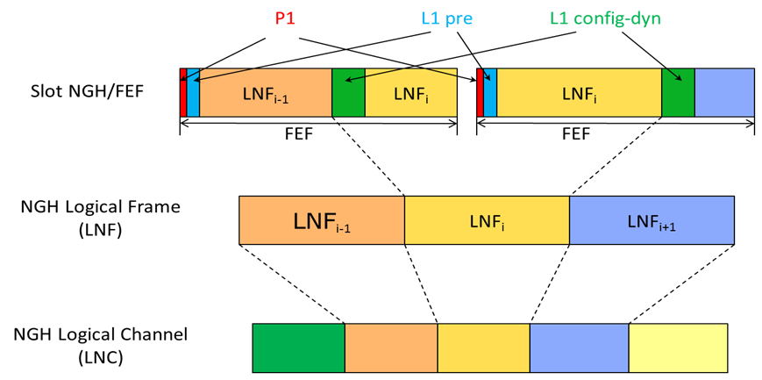
Figure 4. DVB-NGH frame structure with FEF bundling.

As it can be seen, all NGH slots start with P1 and L1-pre signaling information. However, L1-post signaling information is only transmitted when the NGH slot transmits the beginning of the NGH frame. Defining the L1-post at the logical frame level allows a significant reduction of the signalling overhead (as compared to when the L1-post is transmitted in every slot and on every frequency), because the size of L1-post signalling is larger than sum of P1 signalling and L1-pre signalling.
Depending how NGH slots are mapped into the Logical NGH Channel (LNC), it is possible to distinguish four LNC types:

- Type 0:
  - Single RF transmission with the LNFs aligned with the slots.
- Type 1:
  - Single RF transmission.
  - Slots and LNF are not aligned.
- Type 2:
  - It is formed of slots transmitted sequentially from NRF frequencies.
  - LNF may span across multiple slots.
  - The hopping between frequencies takes place only from one slot to another (inter frame).
- Type 3:
  - It is formed of parallel synchronized NRF slots.
  - LNF may span across multiple slots.
  - The hopping between frequencies may take place within one slot (intra frame).

In the following table are shown the four types of LNC and their features in terms of overhead reduction, temporal and frequency diversity, statistical multiplexing gain and system flexibility. The type 0 corresponds to the case in which it is not used FEF bundling or TFS. In the type 1 is used only the FEF bundling technique and it improves the overhead reduction and the temporal diversity. Types 2 and 3 use both techniques, the FEF bundling combined with TFS inter slot and intra slot respectively.

LNC | Description | Overhead reduction | Temporal diversity | Frequency diversity | StatMux gain | System flexibility
Type 0 | No bundling, no TFS | o | o | o | o | o
Type 1 | Time bundling, no TFS | + | + | o | o | o
Type 2 | Time+Freq bundling inter slot | + | + | + | + | +
Type 3 | Time+Freq bundling intra slot | + | + | ++ | ++ | -
Table 1. Comparison between different types of LNC.

In Figure 5, it is shown a system that uses FEF bundling with four RF channels and two NGH logic channels (LNC1 shaded in pink and LNC2 in yellow). Also are distinguished several types of information, such as P1 signalling, L1 signalling or data, differentiated by colour coding. This technique allows that the FEFs size is different in each RF channel, which contributes to better utilize the available capacity. Another important detail is that FEFs of same logical NGH channel must respect the tuning time (5 ms) of the tuners used by the receivers, these time intervals are painted in black in Figure 5. The tunning time is the minimun time required by the receiver tuner for hopping and tunning between two RF channels. This is accomplished by performing a proper scheduling.

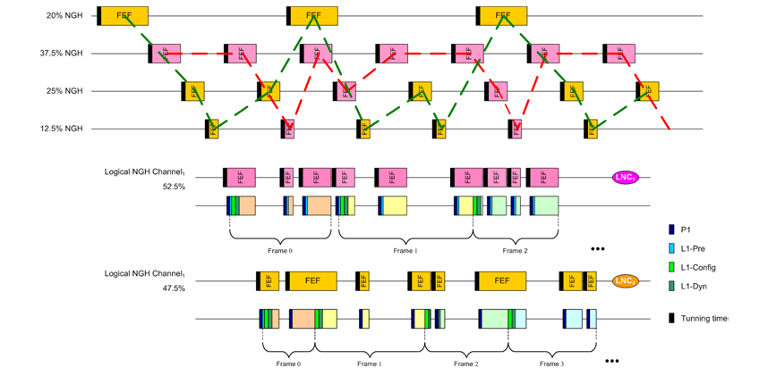
Figure 5. Example of FEF bundling.

Another advantage of FEF bundling is that it allows hybrid configurations terrestrial-satellite. This means that the different NGH slots are mapped both into FEF of the terrestrial channels like satellite slots. This allows increasing frequency diversity and enabling properly reception in areas where the quality of the terrestrial link is low. In the following figure is shown an example of hybrid LNC.
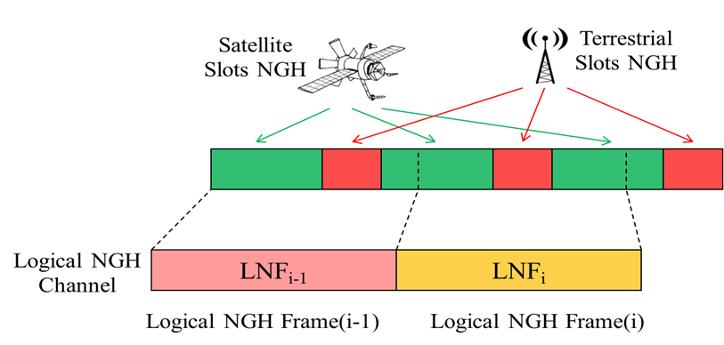
Figure 6. Example of hybrid LNC where the LNF are transmitted by terrestrial and satellite channels.

Implementation of FEF Bundling Technique

FEF bundling requires the introduction of two new blocks at the transmitter side, known as FEF bundler and FEF distributor, see Figure 7. The FEF bundler is responsible for creating NGH logical channels and allocating them to FEFs. The FEF distributor receives all NGH slots, builds T2-MI packets and sends these packets to the corresponding T2 modulator. The purpose of packages T2-MI is to encapsulate the information coming out of the T2/NGH gateways so it can be sent to the modulator through the distribution network.

Figure 7. New blocks of NGH system called FEF Bundler and FEF distributor.

Use the FEF bundling technique causes it is necessary to implement a few changes in other parts of NGH system, which are explained below.

In terms of L1 signalling, it is necessary to make small changes in the L1-pre and L1-config where it is necessary to add some new fields that replace some fields. These changes are discussed in more detail in the following section (1.1.4). In the block BICM is not necessary to make any change for the implementation of the FEF bundling. Finally in terms of power and efficiency the insertion of NGH signal into FEF part of a T2 signal should not affect the use of T2-repeaters, which could be used to improve the coverage of both the NGH signal and the T2 signal. However, amplifying the T2 signal is a waste of power when what needs to be improved is the NGH coverage since T2 is to be received from roof-top antennas with much better reception conditions.

L1 signalling
The fields that have been added to the L1-pre signalling with respect to T2 are shown shaded (yellow and orange) in the figure below. These fields allow L1-Pre to be able to point to the start of the next LNF frame. The following briefly explains the meaning of each of the fields added:

- NGH_SLOT_LENGTH: This 12-bit field indicates the number of data OFDM symbols per NGH-frame, excluding P1 and P2.
- NGH_SLOT_INTERVAL: This 24-bit field indicates the number of T periods between NGH slots (max. equivalent value 1s). The number of OFDM symbols per slot could be derived from it.
- L1_OFFSET*: This 24-bit field indicates the number of T periods until next LNF corresponding to the current LNC (an L1_OFFSET = “0x000” indicates the LNF is allocated further than 1s).
- LNC_ID: This 3-bit field indicates to which LNC belongs the current slot.
- NOF_LNC: This 3-bit field indicates the total number of LNCs.
- L1_RF_FREQUENCY*: This 32-bit field indicates the frequency in which the next LNF is allocated.
- TFS_MODE: This 2-bit field indicates which TFS mode is used (see table to the left).

Figure 8. Estructure of signalling L1-pre.

In the L1-config the fields added are:

- NUM_NGH_FRAMES: This 8-bit field indicates the number of NGH frames per superframe.
- NUM_CELLS_NGH_FRAME: This 22-bit field indicates the number of cells per LNF.

Figure 9. Estructure of signalling L1-config.

The changes in the L1-dynamic and in the L1 in-band are the same and consist of the introduction of a loop of LNC_WINDOW. This loop contains the next fields:

- LNC_WINDOW: This 3-bit field indicates the number of slots that are mapped to the LNC and that are signalled. This information is only required when TFS_MODE=‟01‟, otherwise its value should be 0.
- RF_ID: This 3-bit field indicates the RF index.
- T_DELTA: This 3-bit field indicates the slot that is allocated the last/previous slot signalled.

Figure 10. Loop added in L1-dyn and L1 in-band.

Transport Stream (TS) Profile

Transport stream (TS) profile of the DVB-NGH system is dedicated for transmission of the TS multiplexes [4].
A MPEG-2 [4] imposes strict constant bit rate (CBR) requirements on a TS multiplex. However, TS multiplex may contain number of variable bit rate (VBR) services, which do not necessary have to create a multiplex characterized with CBR. Thus, in order to ensure CBR, the TS multiplexer introduces to the stream additional packets. Those packets are often referred to as null packets, as they typically do not contain any useful data. Depending on the bit rate characteristic of the multiplexed services, it is possible that null packets may constitute a large percentage of the TS multiplex bitrate.
The physical layer of DVB-NGH, similarly to the DVB-T2 system [5], does not require an input data to possesses CBR characteristic. Thus, in order to reduce the unnecessary transmission overhead, null-packets shall be identified at the transmitter side, and removed from the TS multiplex before over the air transmission. The removal of null packets at the transmitter side shall be carried-out in a way, that at the receiver side, the removed null-packets can be re-inserted in the TS on their original positions.

Internet Protocol (IP) Profile

Internet protocol (IP) profile of the DVB-NGH system is dedicated for transmission of the IP version 4 [6] or IP version 6 [7] data flows. IP protocols are parts of so called Internet Protocol Suite intend to operate in the Internet structure. The protocols are designed to ensure reliable interchange of data over a communication channel with multiple hops, requiring routing.
DVB-NGH targets to deliver a wide range of multimedia services. Therefore, the system has been designed to support Internet Protocol (IP) and Transport Stream (TS) based network layer solutions. On account of IP based service support, DVB-NGH is able to deliver the same multimedia services, in a bearer agnostic way, as are accessible through mobile cellular networks. Support of TS based service allows infrastructure reuse with other DVB broadcast systems, such as DVB-T2 or DVB-S2.
In the first generation DVB standards, IP based services were transmitted over MPEG2-TS [4] using Multiprotocol Encapsulation (MPE) or Unidirectional Lightweight Encapsulation (ULE). However, MPEG-2 TS is a legacy technology optimized for media broadcasting and not for IP services transmission. The main drawback of IP datagrams over the MPEG2 TS MPE/ULE transmission is an additional overhead, which is reducing the efficiency of the utilization of the channel bandwidth.
In the second generation DVB standards MPEG-2 TS is not anymore a link layer protocol, as data is carried over BB frames. Therefore, an alternative to IP datagram over MPEG2-TS MPE\ULE transmission exists. Generic Stream Encapsulation (GSE) is design to carry IP content and, therefore, it is able to provide efficient IP datagrams encapsulation over variable length link layer packets, which are then directly scheduled on the link layer BB fames. Using GSE to transport IP datagrams reduces the overhead by a factor of 2 to 3 times when compared to IP over MPE/ULE and MPEG-TS transmission.
In DVB system the overhead of transmitted data usually comprises 8 bytes of UDP header, 20 bytes of IPv4 header or 40 bytes of IPv6 header, and 7 to 10 bytes of GSE header, or 2 bytes of MPE header and 4 bytes of CRC, or 4 bytes of ULE header and 4 bytes of CRC check. If MPE or ULE are used as an IP carrier then, additionally, 4 bytes of TS header for every 184 bytes of data is added. With the average protocol data unit (PDU) size equal 1000 bytes, the overhead is 55 or 58 bytes in GSE use case, 88 bytes in MPE over TS is use case, and 84 bytes in ULE over TS use case. The overhead depends on the average packet size as it is presented in Table 2.
Table 2 Transmission overhead including Ipv6 header and UDP header
Average Packet Size [bytes] | Overhead
Average Packet Size [bytes] | MPE [%] | ULE [%] | GSE [%]
100 | 41,52 | 38.65 | 36,71
200 | 28,06 | 25.93 | 22,48
400 | 17,53 | 16.14 | 12,66
600 | 13,29 | 12.28 | 8,81
800 | 11,01 | 10.21 | 6,76
1000 | 9,58 | 8.93 | 5,48
1200 | 8,61 | 8.05 | 4,61
1400 | 7,89 | 7.41 | 3,98
One of the main recommendations from the NGH study mission report was to improve bandwidth usage by designing low overhead protocol stack. As consequence, GSE is used as an encapsulation protocol for IP data traffic transmission over DVB-NGH. By choosing GSE instead of MPE over MPEG-TS a 12 to 50 percentage overhead reduction is achieved. Moreover, to further reduce the protocols overhead an overhead reduction method, which allow to reduce the overhead connected with IP/UDP headers, is used.
In terms of signalling, for the IP profile of the NGH it is proposed that all signalling, except the L1 signalling is carried in the top of IP layer. Hence, according to this proposal, there would be no L2 signalling within NGH (except possibly for the ROHC), since the signalling would be carried at above the Layer 3. Figure 11 depicts the protocol stack of the DVB-NGH system, where the signalling at the top of IP layer consists of the Upper Layer Information (ULI), Local Multiplex Information (LMI), Other Multiplex Information (OMI) and also ‘L2 signalling’ for the other DVB systems, such as DVB-T2 and DVB-T/H.
Figure 11. The protocol stack of the NGH system where all signaling, except L1 signalling is carried above the layer 3.

Upper Layer Information (ULI)
The Upper Layer Information (ULI) (see Figure 12) consists of two parts. The first part (A.) is the ESG (Electronic Service Guide), which is consist of the signaling and content delivery protocols defined in OMA BCAST or DVB IPDC. The second part (B.) is the service/component mapping with the NGH signaling. The service/component mapping is done by means of service_association_section, which maps URI with the LLP_ID and PLP_ID and also provide RoHC information for each data stream.
The LLP_ID is an identifier for the Link Layer Pipe, which bundles one or more PLPs into one logical entity and which have common buffer model. The buffer model is required for the pre-allocation of memory resources for the time interleaving and for the improvement of LDPC decoding speed. The LLP_ID maps the service information from ULI and the buffer model information from LMI.
The PLP_ID is an identifier for the physical layer pipe, which delivers the IP streams with signaled URI or IP address + port number pair. This mapping gives the basic information between physical layer and IP layer, so that the receiver can locate the position of target stream.
The RoHC information for each data stream is also provided through ULI. Each IP data streams are compressed by RoHC-U+ mode, and some basic information is needed to decompress the RoHC stream. The ULI will give the compressed stream id for each IP stream, what kind of profile it is using, and the static chain byte to initialize the decompression.

Figure 12.The structure of Upper Layer Information (ULI).
Syntax | Number of bits | Identifier
service association section() {
section_length | 32 | uimsbf
number_of_services | 8 | uimsbf
for (i=0; i<N; i++){
number_of_components | 8 | bslbf
for (j=0; j<N1; j++) {
URL_length | 8 | bslbf
for (k=0; k<N2; k++) {
URL_byte or IP address + port number | 8 | uimsbf
}
num_context_id | 8 | uimsbf
for (l=0; l<N3; l++) {
context_id | 8 or 16 | uimsbf
context_profile | 8 | uimsbf
static_info_length | 8 | uimsbf
for (l=0; l<N3; l++) {
static chain byte() | 8 | bslbf
}
}
PLP_id | 8 | uimsbf
}
LLP_id | 16 | uimsbf
}
CRC_byte | 32 | uimsbf
}
Table1. The structure of service association section in Upper Layer Information (ULI).
section length : This 32-bit field indicates the length of the following section.
number of services: This 8-bit field indicates the number of services delivered through current channel.
number of components: This 8-bit field indicates the number of components delivered through the corresponding service in the service loop.
URL length: This 8-bit field indicates the length of the URL or IP address + port number field.
URL_byte or IP address + port number:
This byte sequence is the text byte for URL or 6 or 8 digits number sequence of IPv4/IPv6 address + port number.
num context id: This 8-bit field indicates the number of context id’s that mapped to the URL or IP address/port number specified. If set to ‘0’, it indicate that the URL or IP address/port number is not compressed.
context id: This 8-bit or 16-bit field indicates the context id of the compressed IP stream. The RoHC uses two kinds of CID (context id) ’s – one is small and the other is large. The small CID is one octet from 1 to 15, and the large CID is one or two octets from 1 to 16383. The size of context id is determined from the rule below:
- Start with ‘1110’: small CID, context size is 1 octet, CID is remaining 4 bits (range: 1~15)
- Start with ‘0’: large CID, context size is 1 octet, CID is remaining 7 bits (range: 1~127)
- Start with ‘10’: large CID, context size is 2 octet, CID is remaining 14 bits (range: 1~16383)

context profile: This 8-bit field indicates the context profile of the compressed IP stream. It notifies the range of protocols that RoHC uses to compress the stream.
static info length: This 8-bit field indicates the length of the static chain byte sequence.
static chain byte: This byte sequence is the static information of the compressed IP stream. This field is used to initialize the compressed IP stream by RoHC, and the size and structure of this byte sequence are dependent upon the context profile.
PLP ID: This 8-bit field identifies uniquely the physical layer pipe through which the corresponding component is delivered.
LLP ID: This 16-bit identifier identifies uniquely one logical layer pipe within network (identified with network_id).
CRC byte: This 32-bit field is the CRC byte of the sercie association section.

Local Multiplex Information (LMI)
Local multiplex means the multiplex carried within the signal, which the receiver is receiving. Local Multiplex Information (LMI) (See Figure 13.) consists of the mapping of LLP_IDs with the PLPs within the local multiplex. In addition, the local multiplex information provides information about the buffer model of the associated LLP. The proposed signaling for the aforementioned mapping is proposed to be done by means of LMI section, where the fields are as follows:

Figure 13. Local Multiplex Information (LMI).

Other Multiplex Information (OMI)
The Other Multiplex Information (OMI) lists those components carried within the local multiplex, which are also available within the other multiplexes located within the signals adjacent to the currently received signal. The parameters of the OMI_section are described in the following,

section_length: This field indicates the length of the section. [Defined in EN 300 468]
network_id: This field identifies uniquely the DVB network. [Defined in EN 300 468]
n_of_multiplexes: This field indicates the number of the multiplexes signaled within the loop which follows after this field.
frequency: This field indicates the frequency in which the associated multiplex is transmitted [Defined in EN 300 468]

GUARD_INTERVAL: This field indicates the guard interval of the current super-frame according to EN 302 755.

FFT_SIZE: This field indicates the FFT size according to EN 302 755

PILOT_PATTERN: This field indicates the scattered pilot pattern used for the data OFDM symbols according to EN 302 755.

cell_id: This field identifies uniquely the cell within network. [Defined in EN 300 468]

frame_synch_offset: This field indicates the offset betweenthe physical layer frame transmitted within the current multiplex vs. the physical layer transmitted within the associated neighbouring multiplex.

COMPONENT_ID: A ‘short_id’ or index which is used temporarily for the identification of services/service components within current and neighbouring/adjacent multiplexes. COMPONENT_ID is unique within each local OMI_section and hence it can be re-used by each multiplex for it’s signaling of current and adjacent services.

Figure 14. The Other Multiplex Information (OMI).

Step-by-step overview for service mapping

Previously dedicated PLP type, i.e. common PLP has been defined in DVB-T2 in order to have separation of signaling from the service data. Similar structure could be used also within NGH, where separate PLP type could be defined for ‘Layer 2 signalling’ and for the Upper layer information. On the other hand, further separation of different signaling elements could be done within the IP layer by using dedicated IP addresses and ports for the different signaling elements. These IP addresses and ports could be dynamically allocated

Figure 15 depicts the signaling data model according to the proposed signaling structures, where the service components are mapped with the LLP and PLPs. The step-by-step overview of the service mapping according to the proposal is described in section 2.1.

Figure 15. The signaling data model for the NGH IP profile according to XXX.

In the following, a step-by-step overview of the signaling mapping from the service component, until the L1 signalling is depicted in Figure 16, where the steps as follows:

Step1: The IP source, destination addresses and ports announced within the SDP of OMA BCAST ESG are associated with the PLP_IDs in Service Association Section. The PLP_IDs are further associated with the LLP_IDs.
Step2: The LLP_ID maps the LLP with LLP buffer parameters carried within the LMI_section, where the LLP_ID is further associated with one or more PLP_IDs.
Step3: The PLP_IDs announced within the service_association_section are used to find related PLP_ID information from the L1 signalling. The LLP_IDs are used to find the related buffering information from the LMI section.

Figure 16. The signaling mapping for IP transmission.

Service discovery example based on the proposed signaling elements

The following flowcharts depict example service discovery based on the proposed signaling elements. First, Figure 17 describes exemplary service discovery procedure of the Upper Layer Information (ULI), where the steps from 1-5 are as follows,

Step1: The reception of DVB-NGH signal is started. This can preceed the processing of L1 information.

Step2: The L1 signalling and PLP carrying the Upper Layer Information is received and decoded. At this stage the PLP carrying the Upper layer information can be either hard coded or it can be signaled by means of PLP_type. PLP carrying the Upper layer information can contain also other signaling, whereas the separation of different signaling elements can be provided within IP layer (see next Step)

Step3: The ULI is further decapsulated from the IP packets and decoded. ULI can be provided with dedicated IP address and port. Alternatively the IP address and port of ULI can be provided within dedicated bootstrap information, which can be sent in the beginning of the PLP carrying one or more different signaling elements. (such as ULI, LMI and OMI).

Step4: Once the ULI has been decoded, end user can select the desired service(s) from The ESG and receiver can proceed to Step5.

Step5: The mapping of the service with the PLP_IDs and LLP_IDs is decoded from the service_association_section and stored to memory.

Figure 17. The discovery and processing of Upper Layer Information (ULI).

Next, the discovery and processing of LMI and the discovery of service is provided within Figure 18. The steps are described as follows:
Step1: In a similar fashion as the discovery of the PLP carrying the ULI information the PLP carrying the LMI information is discovered. I.e. The LMI information can be carried within the same PLP as the ULI and other signaling information, whereas the separation of different signaling elements would be done based on IP addresses and ports. Also dedicated Bootstrap file could be used within the beginning of such PLP.

Step2: The buffer information and the mapping between PLP_IDs is acquired from the LMI.
Step3: The actual discovery of the PLPs and/or PLP components carrying the services and furthermore the discovery of the services can be done based on the combination of LMI information and L1 signalling.

Figure 18. The discovery and processing of LMI and discovery of service.

Finally, the Figure 19 depicts the handover procedure according to the proposed signalling solution. The steps are described in the following:
Step1: Similar fashion as in the case of the discovery of PLPs carrying ULI and LMI, the OMI information is decoded from the PLP.
Step2: If handover threshold or some other criteria is met, the handover is performed. Otherwise the procedure is continues into the step3.
Step3: As the OMI information carries information on all components carried within the local multiplex and associated other multiplex, these components are listed in the OMI, if available. The components announced within the OMI and available within the local multiplex have mutually identical COMPONENT_ID.
If no match is found between the COMPONENT_IDs listed in OMI and the COMPONENT_IDs currently consumed, the procedure exits and announces that handover is not possible. Otherwise procedure is continued into the step4.
Step4: Receiver performs handover into the multiplex carrying the currently consumed service based in the information provided in previous steps. The frame_synch_offset parameter is used to enable the correct timing and preventing delays when starting the reception of NGH frame of new multiplex.
Step5: After receiver has switched into the reception of new multiplex (i.e. has possibly also changed into different frequency), receiver discovers the L1 signalling and hence acquires the complete information needed to the reception of desired PLPs and/or PLP components and ultimately the service itself.

Figure 19. The handover procedure according to the proposed signalling solution.

Robust Header Compression (ROHC)

In an IP when the transmission occurs over point-to-point medium such as DVB-NGH, some of the protocol fields, which are required in traditional Internet, serve no useful purpose. Also, some of the headers’ fields do not vary randomly from packet to packet during transmission. Some of the fields exhibit static behaviour or change in a more or less predictable way. Moreover, some of the field can be obsolete by information extracted from lower layers protocols. For example, length of the IP packet could be inferred from Generic Stream Encapsulation (GSE) protocol [8], which is employed in the DVB-NGH system to transport IP flows.
In IP Profile the overhead of transmitted multimedia service typically comprises 12 bytes of RTP [9], 8 bytes of UDP [10], and 20 (40) bytes of IPv4 (IPv6) headers. If the average protocol data unit (PDU), size is assumed to be 1000 bytes, the overhead would constitute around 4% (6%) of the transmitted data. One of the main new features of DVB-NGH is the use of Robust Header Compression (ROHC) protocol [11] as mechanism to reduce overhead caused by RTP/UDP/IP protocols. By employing ROHC protocol the overhead can be reduce to approximately 1% of the transmitted data [12].
The ROHC protocol uses inter-packet dependencies by relying on the establishment of a correct static and dynamic context on the receiver side. However, due to the large number of receivers targeted by the DVB-NGH system, it is highly unlikely that all receivers will be synchronized to the context refresh rate. Consequently, the zapping time to a service may be increased. Moreover, the error propagation caused by the inter-packet dependencies is likely to happen at any time for a set of receivers. Hence, when using ROHC, the frequency of transition between the compressor states must be balanced between minimizing the zapping time and error propagation after failure and maximizing the overhead reduction efficiency. Therefore, in order to reduce a zapping time to a service and the probability of error propagation, while maximizing the overhead reduction efficiency of ROHC, DVB-NGH introduces so-called adaptation module.
In DVB-NGH ROHC module together with Adaptation module compose Overhead Reduction Module (ORM), presented in Figure 20.
Figure 20. Overhead Reduction Module in IP profile
In ORM, the ROHC module is responsible for overhead reduction in IP flow while the adaptation module is introduced to loosen constraints of ROHC module in regard to zapping delay and error propagation. Consequently, the overhead reduction performance of ORM may be increased without impact on the zapping and error propagation, when compare to standalone ROHC operation. Moreover, ORM is designed to guarantee backward compatibility to standalone ROHC framework, which allows the reuse of exiting software implementations of the ROHC protocol.
The ROHC header compression algorithm [9, 11] was created to reduce the overhead in IP streams. The algorithm classifies the header fields into: a) inferred, b) static, and c) dynamic. The classification is based on how the values of the header fields change in the consecutive packets. Inferred are these fields that contain values that can be concluded from other lower protocols information (e.g. IP length and UDP length). These values are removed from compressed header and are not transmitted by the compression flow. Static are these fields that are: a) expected to be constant throughout the lifetime of the packet flow (e.g. IP destination address) and therefore must be communicated to receiver only once or b) expected to have well-known values (e.g. IP version) and therefore do not need to be communicated at all. Dynamic are these fields that are expected to vary during the transmission of the packet flow (e.g. IP Hope Limit, UDP checksum, etc.).
Figure 21. Split of header fields into Static, Dynamic, and Inferred fields according to ROHC framework [9]
Header compression with ROHC is characterized as an interaction between two state machines, one compressor machine and one decompressor machine, each instantiated once per context. The compressor and the decompressor poses three states each, which in many ways are related to each other even if the meanings of the states are slightly different for the two parties. Both machines start in the lowest compression state and transit gradually to higher states. Transitions do not have to be synchronized between the two machines. In normal operation, it is only the compressor that temporarily transits back to lower states. Decisions about transitions between the various compression states are taken by the compressor on the basis of periodic timeouts or variations in packet headers. In the decompressor, transition between states happen when context damage is detected.
Figure 22. ROHC compressor states and transsition between states in U-mode
In compressor, the three states are: a) Initialization and Refresh (IR), b) First Order (FO), and c) Second Order (SO) states. The compressor in each state create different packets format to establish the information in the decompressor, see Figure 22. IR state is to initialize the static parts and dynamic parts of the context at the decompressor, or to recover after failure. In this state, the compressor sends complete header information. This includes all static and non-static fields in uncompressed form plus ROHC header bytes. The purpose of the FO state is to efficiently communicate irregularities in the packet stream. When operating in this state, the compressor rarely sends information about all dynamic fields, and the information sent is usually compressed at least partially. The compressor enters the FO state from the IR state and from the SO state whenever the headers of the packet stream do not conform to their previous pattern. It stays in the FO state until it is confident that the decompressor has acquired all the parameters of the new pattern. The compressor enters the SO state when the header to be compressed is completely predictable. The compressor leaves this state and goes back to the FO state when the header no longer conforms to the uniform pattern and cannot be independently compressed on the basis of previous context information. When operating in U-mode, transitions between compressor states are performed only on account of periodic timeouts and irregularities in the header field change patterns in the compressed packet stream.
Figure 23. ROHC decompressor states and transsition between states in U-mode
The decompressor starts in its lowest compression state, "No Context" and gradually transits to higher states. Initially, while working in the "No Context" state, the decompressor has not yet successfully decompressed a packet. Once a packet has been decompressed correctly (after receiving IR packet) the decompressor can transit all the way to the "Full Context" state.
The decompressor state machine normally never leaves the "Full Context" state once it has entered this state. Only upon failure, it transits back to lower states. However, when this happens, the decompresor first transits back to the "Static Context" state. In this state, reception of any packet generated in the IR or FO state of the compressor (IR, IR-DYN, UOR-2) is sufficient to enable transition back to the "Full Context" state. When decompression of packets generated in the FO state of the compressor fails in the "Static Context" state, the decompressor goes all the way back to the "No Context" state.
Figure 24. Example of the generic format of some of ROHC packets

Adaptation Module
DVB-NGH introduce adaptation module, to minimize inter-packet dependencies which could cause the error propagation and increased zapping time.
The channel zapping time is defined as the amount of time elapsed from the moment the user decides to consume a service to the moment when the rendering of the service starts. The channel zapping time can be considering as a cumulative sum of the many components. In DVB-NGH these components may be: time to synchronize to NGH frame, time to acquire the L1 signalling, time to acquire the L2 signalling, time until media decoders are refreshed to produce correct output samples, time to compensate the varying bitrates of media (e.g. video buffering), time to synchronize associated media streams (e.g. audio and video). The ROHC may introduce an additional delay, caused by the time needed for the decompressor to initialize; in ROHC it would be time to receive the IR packet.
Mobile data delivery over DVB-NGH is prone to errors at it may happen that some of the ROHC compress packet may be received corrupted. If any of these packets would be IR packet then all packets received subsequently, even when not corrupted, would be typically marked as unusable till the next received IR packet.
Therefore, from zapping time and error propagation perspective it would be desirable to maximize the IR packet transmission frequency. On the other hand from compression efficiency perspective it is desirable to make the refresh as seldom as possible.
The adaptation module allows to loosen the trade-off by providing the full refresh with frequency transmission of IR-DYN packet, which may be transmitted more frequent than refresh of IR packet with smaller impact on the compression efficiency. To achieve that the adaptation module splits transmission of static and dynamic information fields of ROHC compressed stream into two logical channels. The dynamic header information is sent without any modification over in-band channel together with the payload data, while the static header information are sent out-of-band. An example of out-of-band transmission is OMA signalling described in 1.5.5 section.
The adaptation module extracts the static chain information (as defined in [9]) from IR packets and converts the IR packets to IR-DYN packets by changing the corresponding header fields accordingly and recalculating the CRC value of the IR-DYN packet. The extracted static chain data is then transmitted over designated signalling bytes. The newly created IR-DYN packet is transmitted together with the rest of compressed data flow.
Due to the splitting transmission to two logical channels, the receiver possesses all static information for all available services as soon as the signalling data is processed. Due to this, a receiver is able to convert any received IR-DYN packet to IR packet on account of early received static chain data. The conversion can be done by adding the static chain information to IR-DYN packet, and changing the corresponding header fields accordingly and recalculating the CRC value of the packet. As a result, ROCH de-compressor may start the decompression of the ROHC flow not only with the reception of IR packet but also IR-DYN packet.

Overhead Reduction Module in DVB-NGH
The Overhead Redaction Module is optional in DVB-NGH and, if used, is applied to IP streams carrying service data. An example deployment of the module in the DVB-NGH system is depicted in Figure 25.
Figure 25. Block diagram of the DVB-NGH system employing Overhead Reduction Module

ROHC module
The ROHC module is responsible for reduction of overhead in IP flow. The detailed operation of the ROHC module is specified in [9, 11].

Supported profiles
ROHC framework defines multiple header compression algorithms, called profiles. Each profile is specific to the particular network layer, transport layer or upper layer protocol combination. The profiles presented in Table 3 must be supported.
Table 3 ROHC Profiles supported in DVB-NGH
Profile Identifier | Usage: | Reference
0x0001 | RTP/UDP/IP | RFC 3095, RFC 4815
0x0002 | UDP/IP | RFC 3095, RFC 4815
0x0003 | ESP/IP | RFC 3095, RFC 4815
0x0004 | IP | RFC 3843, RFC 4815

ROHC module parameters
The ROHC framework has configuration parameters that are mandatory and that must be configured between compressor and decompressor peers [9, section 5.1.1].
The usage and definition of the parameters in DVB-NGH shall be as specified below.
- MAX_CID: This is the maximum CID value that can be used. The parameter MAX_CID is delivered in L2 signalling.
- LARGE_CIDS: This value is inferred from the configured value of MAX_CID according to the following rule:
If MAX_CID > 15 then LARGE_CIDS = TRUE else LARGE_CIDS = FALSE.
- PROFILES: Profiles are used to define which profiles are allowed to be used by the UE. The list of supported profiles is described in section 6.3.1.1. The parameter PROFILES is delivered in L2 signalling.
- FEEDBACK_FOR – not used
- MRRU – segmentation not used

ROHC module restriction
DVB-NGH imposes additional restriction to the operation of ROHC framework.
- If any change in the static fields of the input IP stream is detected by the ROHC compressor, then the ROHC compressor must perform context re-initialization (CONTEXT_REINITIALIZATION signal is triggered as described in [9, section 6.3.1] and the new value of the Context ID (CID) must be assigned to the compressed IP stream. The new value should be unique for the system and be not used by any other instance of ROHC compressors operated in the system.
- ROHC compressor and decompressor, employed in DVB-NGH, must always operate in unidirectional mode as described in [9].

Example output from the ROHC module
The example output of ROHC module is presented on Figure 26. The output corresponds to the DVB-NGH setup presented on Figure 25
Figure 26 An example output of from the ROHC module on TX side

Adaptation module
The adaptation module allows to: a) minimize the impact of header compression mechanism on zapping delay and b) improve error robustness of compressed flow. Consequently, by deploying the adaption module the compression efficiency of ORM can be increased, due to the loosen constrains imposed on the ROHC compressor.

TX side
The adaptation module shall extract the static chain bytes from the each IR packets transmitted in the ROHC compressed data flow. After extracting the static chain bytes, each IR packet shall be converted to IR-DYN packet type by the Adaptation module.
Note: ROHC module may be configured to produce only one IR packet at the beginning of the compression process. Consequently, the operation of extraction of the static bytes and conversion of the packet type may be performed only once.

RX side
The Adaptation module shall detect IR-DYN type packets in the ROHC compressed data flow. At least one IR-DYN packet from the received data flow shall be converted by the Adaptation module to IR packet type, using the static chain bytes received through signalling. The conversion ensures that initialization of ROHC decompressor (i.e. transition to Full Context) is possible.

Example output from the Adaptation module
The example output of the Adaptation module is presented on Figure 27. The output corresponds to the DVB-NGH setup presented on Figure 25 and input to the Adaptation module as presented on Figure 26.
Figure 27 An example output of from the Adaptation module on Tx side

Mapping to GSE
Protocol carried by GSE stream is identified by Protocol Type/Extension field included in GSE header. The Protocol Type field is mandatory when GSE is carried over DVB-NGH and its value shall be set as presented in Table 4.
Table 4
Protocol Type value | Protocol
0x22F1 | ROHC
0x0800 | IPv4
0x86DD | IPv6

Signalling
Signalling for the IP profile of the DVB-NGH is still under discussion. The DVB TM-H SUL Task Force has been progressing with the specification of NGH upper layer signalling for the IP profile, based on an initial proposal from Nokia. The proposal defines an equivalent structure of the PSI/SI [4] in the TS profile, featuring three elements: ULI (Upper Layer Information), LMI (Local Multiplex Information), and OMI (Other Multiplex Information). ULI and LMI elements will be used for the ESG and service/components mapping to PLPs (equivalent role of EPG and PAT/PMT tables in PSI/SI). OMI element will include all network related information in the local and other multiplexes (equivalent to INT/NIT tables in PSI/SI). The structure of ULI/LMI/OMI contents is still open for further refinement before the DVB TM-H SUL Task Force comes to decision.
The Overhead Reduction Module related data is carried in the ULI element. More precisely, in service association section, which is responsible for mapping the URI with PLP id and also provide ROHC related information for each data stream.

Figure 28 Protocol stock and an example service association section carrying ROHC related information
The ULO/LMI/OMI tables will utilize OMA BCAST service guide channels as the conveyors.

Results

Overhead Reduction Module (IP Profile)

Compression Efficiency
The compression efficiency of the ORM depends on the incoming IP flow and characteristics of payload it carries.
Use Case 1:
Two video sequences (Ice, City), in 4CIF format and with 30 fps frame rate, were compressed using H.264/AVC codec. The resulted compressed bitstream bit rate was 1500 kbps with an average NAL unit size of 1150 bytes. The bitstream was encapsulated into RTP, UDP, IP packets. In RTP protocol packetization mode 0 was used. The timestamp field of RTP header was monotonically increasing over time. Timestamp delta between two consequitive packets was not constant value. The ROHC used TS_STRIDE value equal to 90 and refresh packet was inserted every 62nd packet, i.e. every 380 ms.
Table 5 Use Case 1
 | ORM | Uncompressed
Ice | 10.10 bytes (0.918%) | 40.00 bytes (3.47% )
City | 10.08 bytes (0.925%) | 40.00 bytes (3.47% )
Use Case 2:
Two video sequences (Ice, City), in 4CIF format and with 30 fps frame rate, were compressed using H.264/AVC codec. The resulted compressed bitstream bit rate was 1500 kbps and average NAL unit size was 800 bytes. The bitstream was encapsulated into RTP, UDP, IP packets. In RTP protocol packetization mode 1 was used. The timestamp field of RTP header was not monotonically increasing over time. Timestamp delta between two consequitive packets was constant value. The ROHC used TS_STRIDE value equal to 3600 and refresh packet was inserted every 62nd packet, i.e. every 270 ms.
Table 6 Use Case 2
 | ORM | Uncompressed
Ice | 9.91 bytes (1.267%) | 40.00 bytes (5.00%)
City | 9.67 bytes (1.385%) | 40.00 bytes (5.00%)
Use Case 3:
Live video content in VGA format and with 30 fps frame rate, were compressed using H.264/AVC codec. The resulted compressed bitstream bit rate was 800 kbps and average NAL unit size was 900 bytes. The bitstream was encapsulated into RTP, UDP, IP packets. In RTP protocol packetization mode 0 was used. The timestamp field of RTP header was monotonically increasing over time. Timestamp delta between two consequitive packets was not constant value. The ROHC used TS_STRIDE value equal to 1 and refresh packet was inserted every 62nd packet, i.e. every 550 ms.
Table 7 Use Case 3
 | ORM | Uncompressed
Live | 10.65 bytes (1.249%) | 40.00 bytes (4.40%)

Error Propagation
To present how the error propagation may degrade the video quality, a simple scenario is assumed where a BB frame carrying IR packet is corrupted during transmission. Transmission of two sequences, Ice and City, were simulated. Both sequences were in 4CIF resolution and with frame rate 30 fps. The frequency of IR packet in the compressed ROHC stream was every 250ms and the frequency of IR-DYN packet was every 50 ms,. Thus, with at a frame rate of 30 fps, 8 video frames are affected in standalone ROHC and 2 frames in ORM. Table 7 shows the impact of the loss of one IR packet on the video quality.
Table 8 PSNR
 | Ice | City
ROHC | 37.191 | 32.859
ORM | 39.706 (38.600) | 34.131(33.751)
Error Free | 40.346 | 34.509

Scalable Video Coding in DVB-T2 and DVB-NGH

SVC in Mobile Broadcasting DVB Systems

Current commercial DVB-H offerings mainly employ the H.264/AVC video codec with QVGA (Quarter Video Graphics Array) resolution [14]. However, a promising development as far as video coding is concerned is the extension of the H.264/AVC standard known as Scalable Video Coding (SVC), recently adopted within the DVB toolbox. SVC is an amendment to the H.264/AVC standard to provide efficient scalability functionalities on top of the high coding efficiency of H.264/AVC. SVC encodes the video information into a base layer and several enhancement layers [15]. While the base layer is compliant with H.264/AVC, and ensures backwards-compatibility with existing devices, the enhancement layers bring additional information that increases video quality, resolution, and/or frame rate.

SVC presents a great potential to achieve a more efficient and flexible provisioning of mobile TV services in DVB-H/SH systems. Compared to using a simple simulcast approach, SVC reduces the overall data rate required to cope with heterogeneous receivers’ capabilities (e.g., screen size, processing power), by distributing different service qualities within a single scalable stream. SVC also enables a more efficient usage of the allocated bandwidth, since it provides more flexibility for statistical multiplexing algorithms [16].

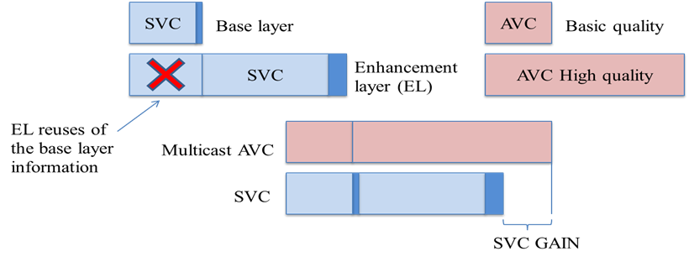
Figure 29. Diagram comparing multicast and scalable video coding (SVC) solutions.

SVC does not only provide benefits in terms of bandwidth savings, but potentially also in terms of improved coverage. SVC can provide a graceful degradation of the received service quality when suffering strong channel impairments by protecting more heavily the SVC base layer.

Scalable coding is very attractive in mobile broadcasting applications because it allows simple rate and format adaptation and efficient support for heterogeneous receiving devices and varying network conditions. A video stream is called scalable if it can be truncated in such a way that the resulting sub-streams can still be decoded providing lower reconstruction quality or resolution than the original stream.

SVC is a scalable extension of H.264/AVC that provides temporal, spatial, and quality scalability (and any combination of those). Its stream has a layered structure consisting of a base layer that can be decoded by H.264/AVC decoders (ensuring backwards compatibility), and one or more enhancement layers.

Spatial scalability

Spatial scalability involves generating two or more layers with different spatial resolutions from a single video source. The base layer is encoded at a low resolution and the enhancements layers make possible to increase the resolution of the video. In the following figure it can be seen an example of spatial scalability. Also it is shown the GOPs of the base layer (this GOP is consisted of frames red and blue) and the enhancement layer (GOP is consisted of frames red, blue and green).

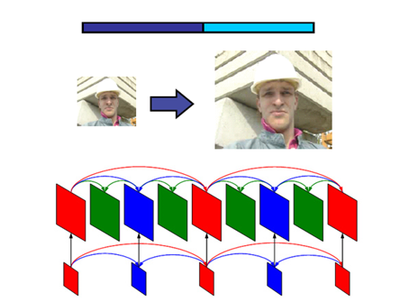
Figure 30. Spatial scalability.

Temporal scalability

Temporal scalability involves partitioning of video frames into layers, in which the base layer is coded to provide the basic frame rate and the enhancement layer(s) is coded with temporal prediction with respect to the base layer. In the figure 31 it is shown the part of GOP transmitted by the base layer (frames painted red, green and blue) and the part transmitted by the enhancement layer (yellow frames). The base layer generates a video with bit rate B and the combination of base and enhancement layers generates a video with bit rate 2B.
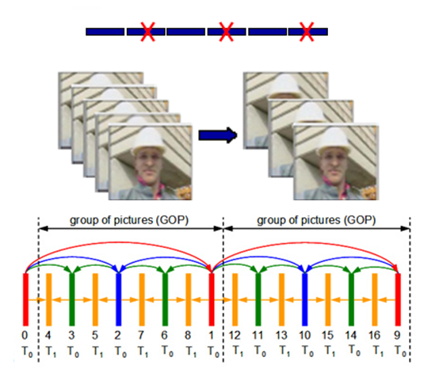
Figure 31. Temporal scalability.

SNR scalability

Unlike the spatial and temporal scalability, in the SNR scalability all layers have the same resolution and frame rate. The difference between the layers is the quality, typically quantified by PSNR method. In following figure it can be seen an example of SNR scalability. The blue flow and red flow, which are shown in figure 32, are corresponded to base layer and enhancement layer respectively.

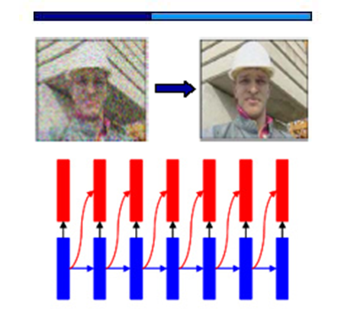
Figure 32. SNR scalability.

By this way, the more enhancement layers the receiver decodes the higher the reconstruction video quality. An overview of SVC broadcasting in mobile DVB systems is presented in [17].

SVC Delivery in DVB-T2

SVC Delivery Using Multiple PLPs

The support for multiple PLPs in DVB-T2 is ideal for broadcasting scalable video, due to the possibility to use different coding and modulation parameters for the various SVC layers. The base layer may then be broadcast in a robust PLP, while the enhancement layer(s) may be broadcast in less robust PLPs with higher spectral efficiency.

In order to simulate realistic reception conditions, we based our simulations on field measurements using regular DVB-T USB sticks (Hauppauge WinTV Nova-T) connected to a laptop. The USB sticks were only used to read variations in carrier-to-noise (C/N) ratios to be used in simulations. The measured C/N ratios were input into a DVB-T2 physical layer simulator, where the DVB-T2 performance at the desired modulation and coding settings was simulated. From the DVB-T2 simulator we obtained baseband frame error traces, which were converted into TS packet error traces. The TS error traces were, in turn, converted into SVC packet error traces giving us information on which layers of video were lost.

When analyzing the SVC packet error traces, we assumed that if one frame of an SVC layer inside a group of pictures (GOP) was lost, that layer and any layer dependent upon it was not decodable for the entire duration of the GOP. In reality, a good SVC decoder would be able to more or less effectively conceal some errors, depending on which frame in a GOP is lost. Furthermore, we ignored the possible impact of some packet headers resulting from encapsulation of SVC video in an MPEG-2 TS stream, but instead we assumed that the raw NAL (Network Abstraction Layer) packets of the SVC stream were directly encapsulated in TS packets.

Preliminary simulations were based on a 750-second field measurement. We simulated the use of two PLPs, where one PLP used a 16-QAM configuration with ½ code rate, while the other was set to 64-QAM, ½-rate. An SVC video clip was encoded, where the base layer was coded in 640x360 resolution at 25 frames per second (fps), and the enhancement layer resolution was 1280x720 at 50 fps. The average bitrates of the base layer and enhancement layer were 2048kbps and 7168kbps, respectively. The GOP size for the enhancement layer was 16 frames (8 frames for the base layer).

Fig. 33 shows the results from these preliminary simulations. The figure shows the measured C/N ratios, the average bit error rate in a simulated TI-block, as well as which SVC layers were successfully recovered per GOP (0 means no layers, 1 means base layer only, and 2 means both base and enhancement layers were recovered).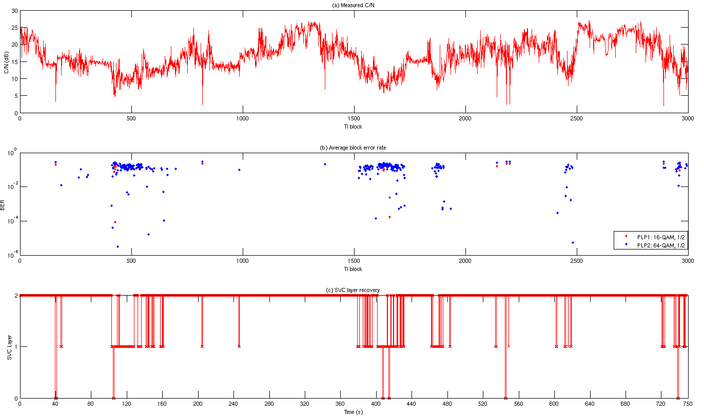
Figure 33. (a) The measured C/N ratios over the 750-second (3000 TI-blocks) field measurement round. (b) The average BER in each simulated TI-block for both PLPs. (c) The number of recovered SVC layers per GOP.

With this configuration, we found that the ESR5(20) (at most 1 erroneous second in a 20-second segment) criterion was fulfilled in about 49% of the 20-second segments for the enhancement layer, while the criterion was fulfilled 84% of the time for the base layer. From Fig 33, we can see that loss of the base layer is often caused by short sudden drops in signal quality. These losses could perhaps be avoided by using for example upper layer FEC coding for longer time interleaving. In some cases, however, the sudden drops in quality may also be a result of an incorrectly read or calculated C/N value from the receiver, rather than actual channel conditions.

SVC Delivery Over Multiple Channels

The following section designs a demonstrator for the delivery of video using Scalable Video Coding (SVC) standard simultaneously over multiple (fixed) channels: over DVB-T2 networks and over high-speed Internet. We pursuit the two following objectives:
- To improve bandwidth usage in DVB-T2 and optimize network planning
- To ensure the coverage of advanced video services for population distant to broadcast infrastructure or living in unfavourable signal-propagation areas
- To verify the inherent benefits of SVC in terms of scalability and adaptivity of the systems
As we see in the following section, the approach proposed is to send the full-quality video content over T2 using a multi-PLP configuration, splitting the video into a base layer and several enhancement layers. These enhancement layers will also be streamed simultaneously over high speed Internet. The content can consist of either a high-definition video or a 3D video. The base layer will offer a basic version of the HD video (either a SD or a more basic HD mode) in the first case and a 2D version in the second case.

IP encapsulation for DVB-T2 transport

DVB-T2 provides two main encapsulation protocols, the MPEG-2 TS packetization, which has been the classical encapsulation scheme for DVB services, and the Generic Stream Encapsulation (GSE), which was designed to provide appropriate encapsulation for IP traffic.
The standard ways to carry IP datagrams over MPEG2-TS are Multiprotocol Encapsulation (MPE) and Unidirectional Lightweight Encapsulation (ULE). However, their design was constrained by the fact that DVB protocol suite used MPEG2-TS at the link layer. MPEG-2 TS is a legacy technology optimized for media broadcasting and not for IP services. Furthermore, the MPE/ULE encapsulation of IP datagrams adds additional overheads to the transmitted data, thus reducing the efficiency of the utilization of the channel bandwidth.
An alternative to MPEG2 TS is GSE which was design mainly to carry IP content. GSE is able to provide efficient IP datagrams encapsulation over variable length link layer packets, which are then directly scheduled on the physical layer BB fames. Using GSE to transport IP datagrams reduces the overhead by a factor of 2 to 3 times when compared to MPEG-TS transmission.
For simplicity reasons, we will consider the traditional MPE technique in the demonstrator, since the IP encapsulation choice does not have a decisive influence on the pursued results.

Demonstrator architecture

The following figure illustrates the functional blocks of the communication infrastructure of SVC content delivery demonstrator through DVB-T2 and IP networks in mobile scenario. The upper part of the figure represents the SVC Server, which handles the raw video to convert it in SVC streaming in the proper format for the transmission. The bottom part of the figure shows the modules in charge of the reception and decoding of the content. The schema is general enough to allow the testing with different video standards, such as H.264/MPEG-4-AVC y its SVC extension.

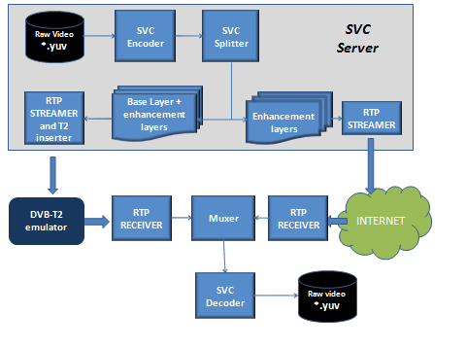
Figure 34. Block diagram of demonstrator

The modules above are programmed in C++ and currently they are in development stage. Next, we present a description of the main blocks.

The SVC ENCODER allows video coding operations according to SVC standards (ISO/IC 14496-10 / Amd.3 Scalable video coding) and AVC/H.264 (MPEG-4 Part 10 AVC, ISO/IEC 14496-10). As SVC coder, it can scale the video in the three dimensions specified by the standard: temporal, spatial and quality domain. In case of temporal scalability, the coder only allows 3 scalability layers. Finally, the module requires raw video as input that has to be previously stored in one of the following formats: YUV 4:0:2, YUV 4:2:2, YUV 4:4:4, RGB 24 bits.
The SVC coding of high definition video content for the tests will consist of taking the standard definition version of the video as the base layer and one or more enhancement spatial layers providing the extended resolution.
The encoder naturally supports scalable coding of stereo (3D) video by sequential interleaving of right and left views using the present SVC MCTF structure without update steps. It has already been shown that the coding efficiency with hierarchical B pictures (MCTF without updates) and a closed-loop control is higher or similar to that of the MCTF-based coding.

The SVC SPLITTER module allows splitting the original SVC video in several files that contains the different base and enhancement layers that will be transmitted over the two targeted communication channels.
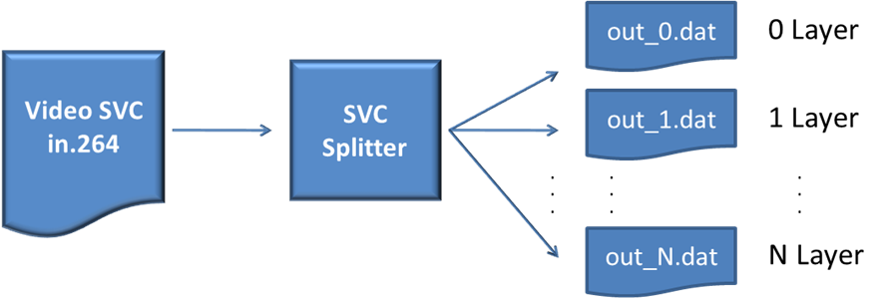
Figure 35. Block diagrams of SVC Splitter

This module receives an elemental SVC streaming and splits it in several sub-streaming. Each NALU (Network Abstraction Layer Unit) represents the unique structure of data which is possible to find in each SVC video streaming. There are 31 types of NALU. Each NALU is associated to a DTQ (Dependency, Temporal y Quality) which describes the essential parameters of SVC layer. Therefore the Splitter is a like a “NALU multiplexor” that analyzes the input video and forward the different NALUS to output sub-streaming according to the layer of such NALU. The following table summarizes a trace file of NALU with information of its associated layer.

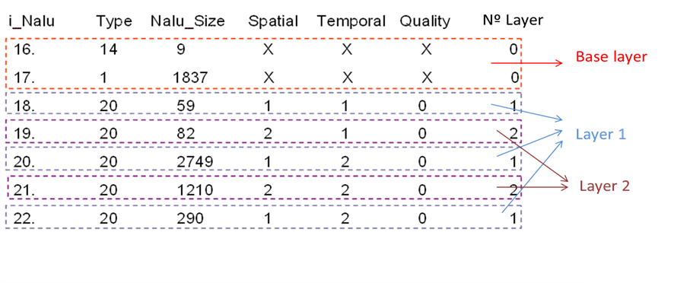
Figure 36. SVC Splitter

The SVC splitter also routes the different SVC layers to the targeted communication channel, this is different PLPs in the DVB-T network and the high speed Internet channel. The PLP destined to transport the enhancement layers will have a high efficient modulation scheme, requiring a very high C/N. This means that only areas close enough to the transmitter will be able to receive the enhancement layers. On the other hand, the PLP bearing the base layer will be configured with a highly robust MODCOD, so that a large area can be served with a minimum service quality.

The RTP STREAMER module encapsulates and transmits the RTP/IP streaming of the base layer, which is one of the outputs of the SVC Splitter. The encapsulation is done according to the H.264 / MPEG-4 AVC payload format, since this format is compliance with SVC standard. The output RTP streaming is broadcasted in DVB-T2 network. The streaming is received by the RTP Receiver that processes it and generates the base layer of SVC video.

The MUXER module rebuilds the SVC video from the layers generated in the SVC Splitter. The main feature of this module is to build the SVC video with the available layers while discarding if needed selected layers or layer segments due to detected errors or end user terminal limitations. One of the most critical problems to solve in the muxer is the synchronization between the different received layers.

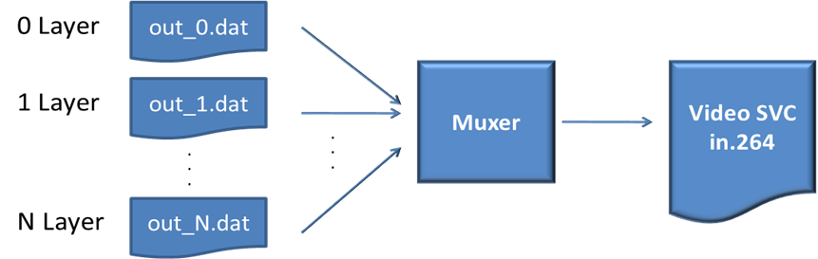

Figure 37. Block Diagrams of Muxer

The RTP SVC streamer module encapsulates the local SVC video in RTP/IP streams according to standard H.264/MPEG-4 SVC and transmits the video in unicast mode. This tool offers several functionalities related to the transport of the NALUs payload in RTP format for H.264 and SVC, such as SNU, STAP, MTAP and FU as specified by IETF and reflected in the above figure. The RTP module will take into account the fact that the base layer on the one hand and the enhancement layers on the other hand will be delivered using transmission bearers with different capacity and reliability characteristics.
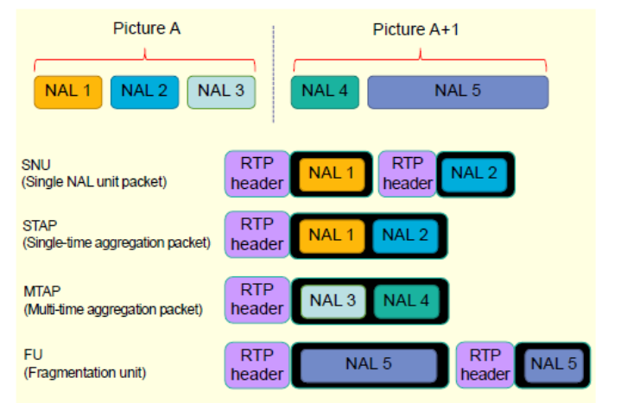
Figure 38. Basic RTP packets for SVC

It is for further study which RTP technique will be used for in the DVB-T2 bearer, taking into account both overhead minimization and interleaving features at the RTP layer.

The SVC decoder receives the RTP/SVC streaming (from RTP SVC), decodes it and creates a file with the raw video. It allows video decoding according to SVC (ISO/IC 14496-10 / Amd.3 Scalable video coding) and AVC/H.264 (MPEG-4 Part 10 AVC, ISO/IEC 14496-10) standards. The output file can be customized to different versions of YUV format (YUV 4:0:2, YUV 4:2:2, YUV 4:4:4).

The DVB-T2 emulator is in charge of emulating in real time the DVB-T2 transmission channel, including propagation effects. An open source event-based network simulator named NCTUNs will be used for that purpose. In brief, three main components will be developed:
- a DVB-T2 gateway module featuring the T2 link layer at the transmitter side;
- a physical layer module (representing both the transmitter and the receiver) hosting performance profiles of the T2 physical layer under different propagation conditions (Gaussian noise, multipath, mobile etc.) and according to the received signal level at the receiver
- an RF module in charge of calculating the time-variant signal level received by the terminal according to the establish propagation scenario
- A DVB-T2 link-layer receiver module
The following configuration is preliminary proposed for the DVB-T2 PLPs to transport both the base and enhancement layers. The two first configurations are destined to test SD/HD services, and the third one will test 2D/3D services

Configuration | MODCOD |  | Bitrate |  | Content
Configuration | PLP#1 | PLP#2 | PLP#1 | PLP#2 | PLP#1 | PLP#2
#1 | 64QAM, FEC rate 4/5, GI 1/128, 32k, 56 blocks | 256QAM, rate 4/5, GI 1/128, 32k, 127 blocks | 13,2 | 30,5 | SD (3-4) programmes) | 720p+1080p (3-4 programmes)
#2 | 64QAM, FEC rate 5/6, GI 1/128, 32k, 80 blocks | 256QAM, rate 5/6, GI 1/128, 32k, 99 blocks | 19,2 | 24,6 | 720p (3-4 programmes) | 1080p (3-4 programmes)
#3 | 64QAM, FEC rate 5/6, GI 1/128, 32k, 80 blocks | 256QAM, rate 5/6, GI 1/128, 32k, 99 blocks | 19,2 | 24,6 | Several 2D (right channel reference) | Several 3D (left channel)

CONCLUSIONS

This section reports the current status of demonstrator that will be used to verify the delivery of broadcast video using Scalable Video Coding (SVC) over two different channels (DVB-T2 and high speed Internet) that complement each other in order to serve a coverage area with varying reception conditions: over DVB-T2 networks and over Internet.

SVC Delivery in DVB-NGH

The standardization process of the new mobile broadcasting system, known as DVB-NGH (next generation handheld), started at the end of February 2010. The main goal is to provide an efficient, flexible, and robust mobile broadcasting system to accompany the digital switch-over and the convergence of fixed and mobile services. One of the main commercial requirements of DVB-NGH is that it should allow transmission of scalable video content with UEP [18]. It is expected that DVB-NGH will be largely based on DVB-T2, the second generation standard for terrestrial television broadcasting [19]. Another commercial requirement is that DVB-T2 and DVB-NGH should be able to share a single multiplex in a time division manner, which can be achieved through the use of the DVB-T2 Future Extension Frames (FEF). Hence, DVB-NGH will have a discontinuous transmission scheme, such as those in DVB-H/SH. For the sake of discussion, we briefly review DVB-T2 and then point out the technical enhancements that are currently under consideration for DVB-NGH.
For the delivery of scalable video content with UEP in DVB-NGH, practical implementation and signalling issues are being evaluated for the cases of assigning one service to multiple PLPs, or having different modulations and code rates within a single PLP. Regarding MIMO, different schemes for the SVC base layer and enhancement layers are also being considered. While the MIMO schemes for the SVC base layer aim to increase the spatial diversity for improved coverage, the MIMO schemes for the SVC enhancement layers aim to increase the capacity with spatial multiplexing techniques [21]. Layer-aware FEC schemes are also being considered as a generic approach for UEP (both at the physical layer and the upper layers).

Multiple PLP solution

The input interface to the NGH system is one or more syntactically correct MPEG-2 TS or IP flows. Each contains one or more services with all service components. A service component is a flow that carries video, audio or any other information. For example, for the case when using the TS profile, a MPEG-2 TS may carry several SVC TV programs and each TV program requires two or more service component, one for audio and the others for the different SVC video layers. Hence MPEG-2 TS that must be transmitted requires different protection to different layers of SVC video, high robustness to base layer and audio and high efficiency to enhancement layers. The way to obtain this, it is using the multiple PLP solution.

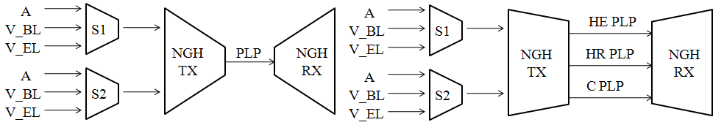
Figure 39. Example of transmision of two SVC programs for the single PLP case (left) and multiple PLP case (rigth).
This solution permits to transmit contents asymmetrically protected. Some PLP may be defined like PLP of high robustness (HR PLP), and therefore, the physical parameters of these PLP are selected to supply robustness. Others PLPs are used like PLP of high efficiency (HE PLP). These PLPs are capable of carrying more information in exchange for losing robustness. In the figure 39 is shown an example of Multiple PLP transmission. In this example where it is transmitted two SVC TV services, the Common PLP (C PLP) is used to carry information common to several services, like PSI-SI signalling information or ESG. High Robustness PLP (HR PLP) is used to carry data of audio, base layer of video and radio. Finally, High Efficiency PLP (HE PLP) transmits enhancement video layers.
Moreover, two types of PLP have been defined for M-PLP mode, these types are named: anchor PLP and associated PLP. Common PLP, High Robustness PLP and High Efficiency PLP are associated PLP because they carry information of services but do not carry signalling information. Instead, Anchor PLP is responsible for transporting in-band signalling information for its service component and also for the associated service components.
The Task Force of Signalling and Upper Layers (SUL) has been working on different aspects as synchronization between PLP and SVC signalling services.

PLPs Synchronization

The synchronization between PLP that carry the different layers of the several NGN services is a critical aspect. The synchronization depends on the chosen profile. In DVB-NGH are defined two profiles, TS profile and IP profile.
The protocol stack of TS profile is shown in figure 40. In this profile the multimedia contents are directly encapsulated over MPEG2 Transport Stream (MPEG2-TS). Transport stream specifies a container format encapsulating packetized elementary streams (video, audio and other information), with error correction and stream synchronization features for maintaining transmission integrity when the signal is degraded. The synchronization mechanism used in TS profile is Input Stream SYnchronizer (ISSY). ISSY is a BBHeader field which carries the value of a counter clocked at the modulator clock rate and can be used by the receiver to regenerate the correct timing of the regenerated output stream.

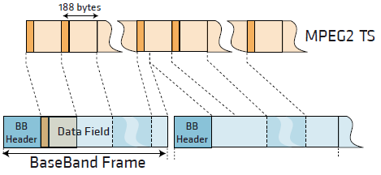
Figure 40. Protocol stack of TS profile and example of MPEG2-TS encapsulation on BBFrames.

ISSY field may carry three values:
- ISCR (Input Stream Time Reference), loaded with the LSBs of the counter content at the instant the relevant input packet is processed. ISCR shall be transmitted in the third ISSY field of each Interleaving Frame for each PLP.
- BUFS maximum size of the requested receiver buffer to compensate delay variations BUFS shall be transmitted in the second ISSY field of each Interleaving Frame for each PLP.
- TTO provides a mechanism to manage the de-jitter buffer in DVB-T2. TTO shall be transmitted in the first ISSY field of each Interleaving Frame for each PLP in High Efficiency Mode, and in the first complete packet of the Interleaving Frame in Normal Mode.

Figure 41. Input Stream Synchronizer block diagram.

Each Interleaving Frame for each PLP shall carry a TTO, a BUFS and at least one ISCR field.
ISSY solution could be a basis for DVB-NGH synchronization model:
- Delays between PLPs transmitting service components of the same service.
- Each operation point may require different initial buffering delay.
- A receiver before processing of data PLPs should know buffering time and required memory to decide whether it is capable of processing the data or not.

The other profile is the profile IP, in the figure 42 is shown the protocol stack of this profile. The RTP protocol provides the necessary mechanism to synchronize the different multimedia streams, the timestamp is the main field for this purpose. Moreover, ISSY also is used in this profile to synchronize different PLPs.

Figure 42. Protocol stack of IP profile.

SVC Signalling

The input interface to the NGH system is one or more syntactically correct MPEG-2 Transport Stream (TS), and each of these TS carry only one service (normal or SVC). The solution adopted by NGH forum consists in the introduction of a new descriptor in the PSI/SI signalling. The new descriptor is named NGH delivery system descriptor and it is carried by Network Information Table (NIT).

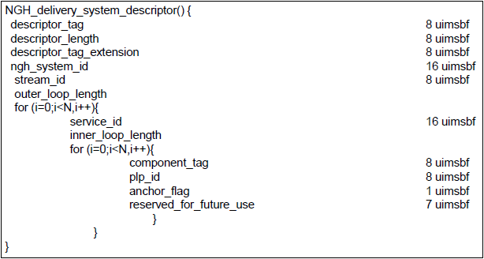
Figure 43. Fields of NGH delivery system descriptor.
As shown in the figure 43, each service_id entry in the outer loop contains an inner loop with all service components of the service_id, as indicated by the component_tag, and the plp_id where the service component is transmitted. One of these plp_ids is marked as an anchor PLP and contains at least PAT/PMT and SDT actual. With the information provided by this descriptor, the receiver can identify which streams are transmitted on the network and how to access them.

Upper Layer FEC in DVB-T2 and DVB-NGH

Expanding Window Fountain Coded Scalable Video Broadcasting

The Expanding Window Fountain (EWF) codes [18][19] are a class of rateless codes, providing Unequal Error Protection (UEP). These codes are especially suitable for Scalable Video Coding (SVC) having unequally important data layers. The EWF codes are used for transmitting scalable video in mobile channels. The channel is characterized by field measurements in a DVB-H network. The EWF code parameters are tuned to achieve real-time transmissions of SVC video. If some latency in the video is acceptable, then EWF codes can be used for real-time transmissions [20].

EWF Code Design

The EWF [18][19] codes are rateless codes, meaning that they can produce a potentially infinite stream of encoded symbols. The UEP property of the code, which is achieved through a windowing approach, allows a receiver to recover some codeword symbols with a higher probability than other codeword symbols. Because EWF codes are rateless, potentially an infinite stream of encoding symbols can be generated, and each encoding symbol is a random linear combination of some information symbols.

Let the subsets s₁, s₂,…, s_{r} determine the partitioning of the set of source symbols x₁,…,x_{k} into importance classes, such that $\sum_{j=1}^{r}{s_{j}=k}$, and s_{j} contains source symbols that are more important than those in s_{i} if j<i. The i-th window will contain the first $k_{i}=\sum_{j=1}^{i}{s_{j}}$ source symbols. Thus the first window contains the most important symbols, and the r-th window contains the entire source message, as illustrated in Fig. 44. Compactly, this division can be described as $∏\left(x\right)=\sum_{i=1}^{r}{\prod_{i}{x^{i}}}$, where $\prod_{i}{=\frac{s_{i}}{k}}$. Encoding symbols are generated for each window according to the standard LT encoding process [21]. That is, the i-th window is assigned a degree distribution ${}^{\left(i\right)}(x)=\sum_{d=1}^{k_{i}}{{}_{d}x^{d}}$, where ${}_{d}$ is the probability that the encoded symbol is a combination of d source symbols, i.e., that it has degree d.

Figure 44. Division of importance classes into windows. Encoded symbols are generated based on random windows.
At the encoder, each encoding symbol is assigned to a randomly chosen window with respect to the window selection distribution $\left(x\right)=\sum_{i=1}^{r}{{}_{i}x^{i}}$, where ${}^{i}$ is the probability that window i is chosen. Using the degree distribution of the corresponding window ${}^{\left(i\right)}(x)$, the degree of the encoding symbol is sampled, and a number of symbols equal to the degree, which are randomly chosen from the set k_{i}, are combined to form the encoding symbol. Note that if r = 1, the code is identical to the LT code [21].

Measurement Setup

For measuring the performance of the EWF code, field measurements were carried out using the DVB-H test network in Turku, Finland. A laptop connected to a USB DVB-T device was used for gathering the transmitted data. Since DVB-H builds upon the DVB-T standard and adds additional functionalities on the link and application layers, the link and application layers were implemented in software, effectively obtaining a DVB-H receiver. The IP error traces were recorded and the EWF decoding was performed on these traces.

The performance of the EWF code was measured in terms of the reception overhead required for complete reconstruction of the information symbols. If the number of received symbols at the time when the information symbols are recovered is denoted as $n'=\left(1+\right)k$, then ε is the reception overhead. However, since SVC is a layered video coding technique, and each layer incrementally improves the video quality, reception overheads were measured separately for each SVC layer as

$$n_{BL}^{'}=\left(1+{}_{BL}\right)k$$
$$n_{EL(i)}^{'}=\left(1+{}_{EL}\right)k$$

where ε_{BL} and ε_{EL} are the reception overheads for the SVC base layer and enhancement layer i respectively.

SVC Coding Parameters

The SVC coded video material used for the measurements was encoded using the JSVM (Joint Scalable Video Model) reference encoder. The video was encoded into blocks of 64 frames each. The average bit rate of each such block was constrained to 295 kbps maximum (-4% deviation allowed). In the three-layer stream, the base layer bit rate (again calculated as the average over a block) was constrained to 90 kbps (±2%), and the combined bit rate of the base layer and first enhancement layer was constrained to 170 kbps (±2%). The base layer of the video was coded in QCIF (Quarter Common Interchange Format) resolution, while both enhancement layers were coded in CIF resolution. The maximal frame rate of each layer was 25 frames per second (fps). The frame rate implied that each 64 frame block represented 2.56 seconds of video.

Table 9 summarizes the properties of the video layers. The video clip used was “Rush-hour''. The table includes the average PSNR (peak signal-to-noise ratio) of the luma component of the frames in the coded video sequence. The base layer Y-PSNR value was calculated by comparing the decoded and up converted (to CIF resolution) base layer frames to the original frames in CIF resolution, in order to make the value directly comparable to the PSNR values of the enhancement layers.

Table 9. SVC layer properties

Each 64-frame block would then be separately coded using EWF. The choice of block length was a compromise between channel zapping time and time diversity. The bit rate constraints set on the three layers meant that the base layer specific data would occupy less than, although nearly, 32% of a data block. Similarly, the base layer and first enhancement layer together would account for less than 60% of the data. This resulted in the window division distribution for the EWF code being $∏\left(x\right)=0.32x+0.28x^{2}+0.40x^{3}$.

The IP packet payload size used in the DVB-H test network was 1472 bytes. The 295 kbps bit rate constraint on the video stream implied that each 2.56-second video block would require up to 94400 bytes. Because of this, each video block was padded (if necessary) to exactly 94400 bytes.

EWF Code Parameterization

In this section we go through in detail how suitable EWF code parameters were determined. The transmission rate in the network was 452 kbps and since the SVC bit rate was approximately 295 kbps, the EWF code rate had to be at least r=2/3 or higher, corresponding to a maximal reception overhead of ε_{MAX} = 0.5 in error free receptions. Because of the properties of linear codes, a symbol size of 8 bytes was chosen in order to get a sufficiently long code, implying 184 encoding symbols per IP packet, k = 11800 source symbols per block, and $n_{MAX}^{'}=17700$. The degree distributions Ω(x) for all windows was the Robust Soliton distribution [21]. Following [19], the procedure for selecting window selection probability distributions can be summarized into the following steps:

- For all possible window selection probability distributions, analyze the asymptotic EWF performance for a sufficiently large range of reception overheads.
- Based on the asymptotic performances, and the source block length, analyze the finite length performance.
- Define desired reception overheads for complete recovery of each importance class.
- For the defined reception overheads and from the finite length analysis, find the subset of window selection probability distributions that satisfies these requirements with a high probability.

Using these 4 steps, the layer-wise probabilities of recovery as function of window selection probability distribution and reception overhead were analyzed (see [20] and [19] for more details).

Figure 45. Probability of recovery of the base layer at ε = 0 with k = 11800.
Fig. 45 illustrates the probability of recovery of the base layer at ε = 0 for the scalable video clip for the finite length analysis. When Γ₁ and Γ₂ are sufficiently large and at this reception overhead, the probability of recovery of the base layer is close to 1. However, increases in Γ₁ and Γ₂ imply increased reception overheads for enhancement layer 2 because Γ₃ is reduced. Fig. 3 also indicates that window selection probabilities chosen from within the region limited by Γ₁ < 0.22 and Γ₂ < 0.43 will not produce negative reception overheads for the base layer. However, as will be detailed below, a negative reception overhead is desirable.

In the third step, desired reception overheads for each importance class are defined. The reasoning behind our choice of these overheads is the following. A major advantage of EWF codes is their potential to provide negative reception overheads for the most important classes. Under the assumption of an almost error free reception, the smaller the reception overhead the shorter is the channel zapping time, since it is highly unlikely that when changing channels, the receiver will receive all data belonging to the block. Rather, the reception will on average begin in the middle of the block. Suppose the required reception overhead for successful reconstruction of the base layer is ε_{BL} = -0.15. This means that a number of symbols equal to 0.85k is needed for the reconstruction. In a rate 2/3 transmission, this corresponds to the requirement of receiving approximately 56.7% of the encoding symbols in a block. An ideal Equal Error Protection (EEP) code would require 66.7% of the symbols for the reconstruction under the same circumstances. Thus, it is more likely that a code with a negative reception overhead will be able to reproduce at least the base layer more quickly than an ideal EEP code. Also, in a DVB-H network the IP packet error rates should be low on average. Therefore, one can choose to have high reception overheads on the least important classes. Note that the choice of reception overheads is related to the IP packet error rate (IP PER) tolerances for each importance class, i.e., a high reception overhead implies a small IP PER tolerance and vice versa.

For the chosen reception overheads, a subset of window selection probability distributions were found that maximized the probability of recovery of all layers. Finally, from this subset the possible choices of window selection probability distributions can be further narrowed down for example by selecting those that maximize the average PSNR in the scalable video [19]. Choosing any Γ(x) from this set is arbitrary with respect to the video quality.

Since the IP error trace was recorded and decoding was performed separately, three different window selection probability distributions were chosen with different properties. Common to all chosen Γ(x) was the requirement on a negative reception overhead for the base layer. An overall robust performance was also desired, and finally a separation between the reception overheads of the enhancement layers was desired. The chosen window selection probability distributions are listed in Table 10.

Table 10. Chosen window selection probability distributions.

Measurement Results

Fig. 46 illustrates the reception overhead results from the measurements along with the block-wise IP PER. As can be seen in Fig. 46(a), the overall IP PER remains very low over time, but with a few occasional burst losses. Additionally, there are some longer periods of outages where the receiver was completely shadowed from the available transmitters, most notably in the approximate region of blocks1600-2000. As can be seen from the remaining figures, none of the codes could cope with these outages, and only if the code length had been significantly longer had the EWF codes managed with the outages.

Fig. 46(b) shows the results for Code 1, where the window selection probability distribution was chosen such that the base layer could be decoded with a very low reception overhead. This had the benefit of having an EWF code that could successfully decode the base layer even at IP PERs as high as 48%. Moreover, as discussed in Section 3.1.4, the negative reception overhead would improve the average channel zapping time. On the other hand, in order to achieve an overall robust behavior the selection probability for window 3 had to be large, resulting in a very small selection probability for window 2. In Fig. 46(b), this can be seen as practically no separation between the reception overheads of enhancement layer 1 and 2.

For Code 2, illustrated in Fig. 46(c), the window selection probabilities for windows 1 and 3 were slightly reduced, to obtain a separation of the reception overheads for the enhancement layers. The chosen window selection probability distribution resulted in an increased average reception overhead for the base layer and enhancement layer 2, while decreasing the reception overhead for enhancement layer 1, as desired. However, the decrease in the selection probability for window 3 resulted in a reception overhead that was too close to the maximal reception overhead ε_{MAX}, which can be seen as occasional failures in decoding enhancement layer 2 at IP PERs close to zero.

The results for Code 3 are illustrated in Fig. 46(d), and with this code an attempt to find a balance between Codes 1 and 2 was made. The results show an overall robust reception overhead performance, albeit with large fluctuations in the reception overheads for the base layer and enhancement layer 1. A negative side effect of this Γ(x) was that the requirement on a negative reception overhead for the base layer had to be relaxed. The result of this is clearly visible in Fig. 46(d), as the reception overhead for the base layer is fluctuating around zero. An interesting thing to note is that the average reception overhead for enhancement layer 2 is slightly lower than for Code 1, although the selection probability for window 3 is smaller in Code 3 than in Code 1.

Figure 46. Measurement results for various Γ(x) for the EWF codes. The reception overhead of the base layer is illustrated with black, enhancement layer 1 with dark gray, and enhancement layer 2 with light gray.

Video Quality Analysis

To evaluate the Quality of Service (QoS), two quality measures were used. The ESR5(20) and the average PSNR in the scalable video was measured. Table 4 lists the fraction of the time that the codes meet the ESR5(20) criterion separately for each video layer and the average PSNR when using the codes.

Table 11. Scalable video quality analysis.

As can be seen from Table 11, the ESR5(20) results are all close to each other. The reason to not fulfilling the ESR5(20) follows mostly from the outage areas. A comparison of the ESR5(20) results reveals that Code 2 meets the ESR5(20) criterion as often as Code 1 does for the base layer (BL), but has a worse performance than Code 1 with respect to the enhancement layers (EL) . Moreover, it is evident that the BL is notably more robust than the EL for all codes. On average, Code 3 has the most robust performance although it suffers from a slight degradation in robustness for the BL as compared to the other codes. On the other hand, when observing the average PSNRs, Code 3 produces the lowest PSNR. The difference to the other codes is however negligible.

Conclusions

The possibility of transmitting scalable video in real-time over a DVB-H network has been explored. The video has been encoded with the Expanding Window Fountain (EWF) codes with carefully chosen code parameters to achieve this goal. The results are based on field measurements, obtained by using a DVB-H test network in Turku, Finland. Our results demonstrate that real-time transmission of scalable video can be achieved with a subjectively perceived good quality when using EWF codes. This is confirmed by assessing the fraction of the time that the overall performance meets the ESR5(20) criterion and measuring the average PSNR in the scalable video. The reason to the occasional failures in meeting the ESR5(20) criterion follows from extremely high IP packet error rates.

Receiver-Controlled Parallel Fountain Codes

An upper layer unequal error protection (UEP) FEC scheme for distribution of SVC content over multiple parallel paths to receivers is presented, which is referred to as Receiver-Controlled Parallel Fountain (RCPF) codes [22]. Unlike previously proposed UEP fountain codes, where the UEP performance is controlled by the fountain code design at the transmitter side, this solution allows receivers to tailor their own set of received fountain coded packets thereby controlling the UEP performance. By selecting which parallel broadcast channels to connect to, each receiver independently controls the encoded data collection process according to its device capabilities, reception conditions and the desired video quality. The RCPF code design is motivated by the second generation DVB standards employing multiple PLPs for transmission of data. When using RCPF coding, each PLP can be viewed as a transmission path to receivers. Thus receivers collect data from a number of PLPs and decode the collected data jointly, allowing for a flexible and robust coding scheme.

RCPF Code Design

The RCPF codes are rateless codes, meaning that they can produce a potentially infinite stream of encoded symbols. The UEP property is achieved through a windowing approach, identical to that of the EWF codes [18][19].

The main difference between EWF codes and RCPF codes is that the encoded symbols are not generated based on random windows when using RCPF codes. Rather, encoded symbols are simultaneously produced from different windows and streamed in parallel over different broadcast channels. The encoded symbols of window i are transmitted over channel i, where channel i has a bit-rate R_{i}. If the total transmission rate over all parallel channels is R, then the relative transmission rates can be expressed as $Φ\left(x\right)=\sum_{i=1}^{r}{Φ_{i}x^{i}}$, where $Φ_{i}=\frac{R_{i}}{R}$. The receivers obtain symbols from each channel separately, which are then jointly decoded. This transmission scenario is illustrated in Fig. 47. In the context of DVB-T2 and DVB-NGH, each path from the encoder to the decoder in Fig. 47 can be considered as the transmission and reception of a PLP. Receiver devices can control the level of UEP simply by connecting to a number of parallel channels, according to their needs and capabilities.

Figure 47. Transmission scheme using RCPF coding.

Analysis of RCPF Coding Scheme

Following a similar analysis approach as in [18], the probability of error while decoding iteratively an RCPF encoded message can be determined as follows [22]. Let an RCPF code be applied over an r-layer source message with division into importance classes defined by ∏(x), where the set of degree distributions $\left\{{}^{1},…,{}^{r}\right\}$ is defined over the set of r windows. The encoded symbols from the r different windows are streamed over the set of r parallel broadcast channels with parameters (R_{i}, p_{i}), 1 ≤ i ≤ r, respectively, where p_{i} is the symbol erasure probability in channel i. The number of received encoded symbols of size L bits the receiver has obtained from the i-th broadcast channel at time t is on average equal to

Using n_{i}(t), the expected received window selection distribution Γ_{R}(x), i.e., the distribution on the fraction of received encoding symbols generated from different windows, is obtained as

where $n\left(t\right)=\sum_{i=1}^{r}{n_{i}(t)}$ is the total number of received encoded symbols from all the parallel channels until time instant t. The excess number of encoded symbols over the source message length, n(t)-k, normalized by the length of the source message k, is called the average reception overhead $\left(t\right)=\left(n\left(t\right)-k\right)/k$. Given Γ_{R}(x) at time instant t, and assuming a sufficiently large length k of the source message, we can obtain asymptotic (as k → ∞) probabilities of decoding source symbols from different importance classes after receiving $n\left(t\right)=\left(1+\left(t\right)\right)k$ encoded symbols (c.f. [18]). The probability $y_{l,j}$ that a source symbol of the j-th importance class is not recovered after l iterations of the iterative message-passing decoding algorithm at time instant t is equal to

Fig. 48 illustrates the asymptotic BER versus the reception overhead ε(t) for a scenario with two importance classes. The RCPF encoder applies the Robust Soliton degree distribution [21] over both windows, where the first importance class contains the most important bits (MIB) and the second contains the least important bits (LIB). The three different pairs of curves show how the erasure rates of broadcast channels influence the BER when the receiver connects to both parallel channels. The waterfall regions of the MIB and LIB curves correspond well to the simulation results presented in Section 3.2.3, with respect to required reception overhead for successful recovery.

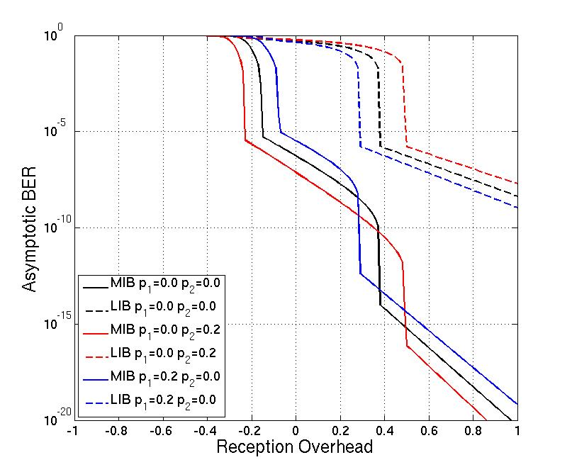
Figure 48. Analysis of asymptotic BER versus reception overhead ε for ∏(x)=0.3x+0.7x², Φ(x)=0.33x+0.67x², for some sample erasure rates p₁ and p_{2.}

Simulation Results

The RCPF codes are analyzed in terms of required reception overhead ε(t) for successful recovery of the source data with the following simulation settings. The source data contains two importance classes and k=3000. The division into windows is ∏₁={0.1, 0.2, 0.3, 0.4} and ∏₂=1-∏₁. The information in the first importance class contains the most important bits (MIB) and the information in the second importance class contains the least important bits (LIB). Encoding symbols from window 1 (covering the MIB) are transmitted over channel 1 and encoding symbols from window 2 (covering both the MIB and the LIB) are transmitted over channel 2. The code rate is 1/2, and the degree distribution for each window is the Robust Soliton distribution [21]. Since the code rate is 1/2, if the reception overhead ε(t) > 1, a decoding failure is declared. The relative transmission rates are Φ(x)=0.33x+0.67x², i.e., one encoding symbol is transmitted over channel 1 during the same time interval as two encoding symbols are transmitted over channel 2. The channels are modeled as binary erasure channels (BEC), each with erasure rates 0-100%.

Fig. 49 illustrates the required reception overheads for successful recovery of the MIB and the LIB. On the left in Fig. 49, the erasure rate over channel 1 is set to zero, while the erasure rate over channel 2 is allowed to vary. The opposite case is illustrated on the right in Fig. 49. It can be seen that the reception overhead for the MIB decreases with increasing erasure rates over channel 2. This follows from the fact that the reception overhead increases for each received encoded symbol from both channels, but since we assume channel 1 is error free, the increase in erasure rate over channel 2 decreases the number of encoded symbols received from channel 2, thus leading to the MIB reception overhead decrease. A similar but opposite trend is visible on the right in Fig. 49. It is noteworthy that as long as either one of the two channels has a relatively small erasure rate, the MIB are always successfully recovered, either by recovery of the first or the second expanding window.

Figure 49. Reception overheads for the simulation scenario, with zero erasure rate over channel 1 (left) and zero erasure rate over channel 2 (right).
Fig. 50 shows the decoded BER for the same scenario, with increasing erasure rates over channel 2. It is readily seen that the error tolerance of the RCPF code increases with increasing MIB fractions of the message under the assumption that channel 1 is error free. Note that for all the applied values of ∏₁, when channel 1 is error free, the MIB are always successfully recovered (i.e., the decoded BER is equal to 0). In the opposite case, when channel 2 is error free and channel 1 is erroneous, both the MIB and LIB are successfully recovered, which was already seen in Fig. 50.

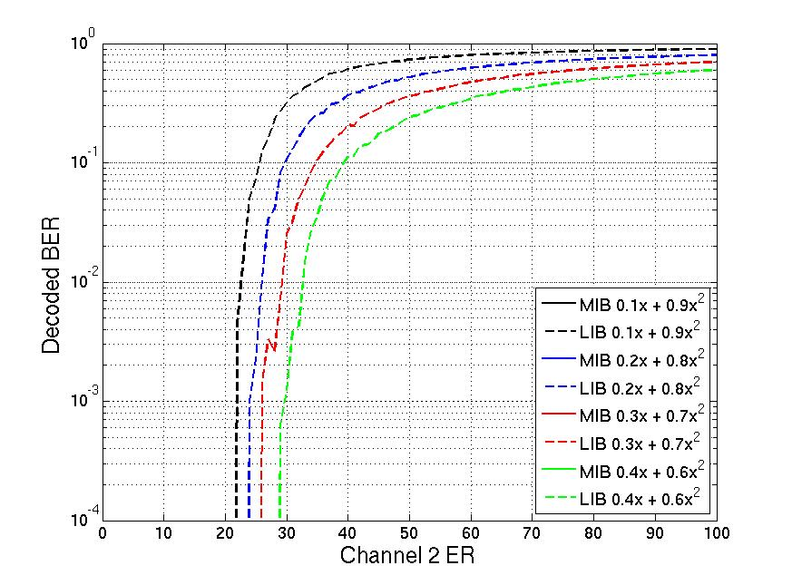
Figure 50. Decoded BER with zero erasure rate over channel 1.
Fig. 51 shows the reception overheads required for the recovery of window 1 and window 2 respectively with increasing erasure rates over both channels for the window division distribution ∏(x)=0.3x+0.7x². The black regions in the figures correspond to decoding failures. As can be seen on the left in Fig. 51, the MIB are recovered for any erasure rates over channel 2 as long as the erasure rate over channel 1 is below 50%. When the erasure rate over channel 2 is below 20%, the MIB are recovered for any erasure rate over channel 1. The right part of Fig. 51, which illustrates the reception overhead for the LIB, reveals that the LIB are recovered for erasure rates below 30% over channel 2, as long as the erasure rate over channel 1 is below 80%. Thus, the LIB are not as tolerant against transmission errors as the MIB are, but are still easily recovered under normal reception conditions with this setup. By changing the window division distribution ∏(x), the code rate, or the relative transmission rate Φ(x), more or less robust performances are obtainable. For instance, if ∏(x)=0.1x+0.9x², the MIB are even more robust at the expense of less protection for the LIB. This is evident from Fig. 51. However, as can be seen in Fig. 51, a reduction in the MIB fraction does not significantly reduce the robustness of the LIB.

Figure 51. Reception overheads for ∏(x)=0.3x+0.7x² for successful recovery of the MIB (left) and the LIB (right) for various channel erasure rates. The black regions correspond to decoding failures.

Conclusions

We have presented the Receiver-Controlled Parallel Fountain (RCPF) coding scheme for transmission over parallel communication channels. The RCPF codes provide Unequal Error Protection (UEP) to layered source and allow receivers to control the layer decoding performance. This is achieved through a windowing approach, identical to that of the Expanding Window Fountain (EWF) codes. Using RCPF codes, receivers collect data from a number of parallel broadcast channels according to their needs and capabilities. If the RCPF codes are used to protect scalable video, receivers may collect data from a number of channels according to the desired video quality of the end-user. The proposed coding scheme additionally allows receivers to adapt to varying reception conditions and thus allows receivers to recover at least the most important layer in the source, even while experiencing poor reception conditions. The RCPF codes have been analyzed both analytically and through simulations. We have shown that the RCPF codes can effectively protect layered source while providing a robust decoding performance.

Fading Margin Reduction due to Inter-Burst Upper Layer FEC in Terrestrial Mobile Broadcast Systems

In wireless communications mobile users typically experience signal fading effects due to the superposition of multiple propagation paths between transmitter and receiver. In general, it can be distinguished between slow or long-term fading due to local shadowing effects, commonly known as shadowing, and fast or short-term fading due to the coherent superposition of the signals reaching the terminal, commonly known as fast or multipath fading [23]. Shadowing implies significant variations of several dB over distances of several tens of meters (comparable to the widths of buildings in the region of the mobile), whereas fast fading involves variations on the scale of a half-wavelength and frequently introduces variations as large as 35 to 40 dB.
Signal fading can be compensated with forward error correction (FEC) with a time interleaving large enough to essentially average out the fading statistics. FEC mechanisms rely on the transmission of redundant repair information (parity data) such that the receiver can correct errors occurred during the transmission. For the FEC code to be efficient, the different code symbols should ideally experience uncorrelated fading. In this case, it is possible to cope with erasure rates as large as the inverse of the code rate. Otherwise, the efficiency of the FEC mechanism is reduced.
In case of fast fading, a relatively short time interleaving is usually required to eliminate it (in the order of few to several milliseconds, depending on the user velocity and operating frequency). This is traditionally done at the physical layer as part of the radio interface for wireless communication systems.
This is typically not a feasible way to cope with shadowing due to memory and latency constraints. The memory requirement is directly proportional to the service data rate, the interleaving duration, the proportion of parity data transmitted, and the interleaver profile. On the other hand, terminals should in principle wait and store all data jointly encoded before decoding. The traditional approach to cope with shadowing consists in adding an extra fading margin of several dB to the link budget, in order to assure a reliable communication with a given probability at the cell edge. Nevertheless, for mobile users it is in principle possible to reduce the required fading margin exploiting the time diversity of the mobile channel using a FEC scheme spanning a sufficiently long time. Recent advances in FEC make this possibility a reality.
Digital video broadcasting standards such as DVB-H (Handheld) [24] and DVB-SH (Satellite to Handhelds) [25], define FEC schemes with long time interleaving profiles to exploit the time diversity of the mobile channel. These mobile broadcasting technologies are characterized by a discontinuous transmission technique, known as time-slicing, where data is periodically transmitted in so-called bursts. Hence, these FEC schemes are usually referred to as inter-burst FEC. For file download services, both DVB-H and DVB-SH adopt application layer FEC (AL-FEC) using Raptor coding [26]. For streaming services, in DVB-SH it is possible to provide long time interleaving together with fast zapping support either at the physical layer or at the link layer. The physical layer FEC outperforms the link layer FEC at the expense of higher memory requirements [27]. The link layer FEC mechanism is known as multi protocol encapsulation inter-burst FEC (MPE-iFEC) [28], and it specifies two coding schemes: one mandatory using sliding Reed-Solomon encoding (SRSE) and another optional using Raptor coding.
On the other hand, in the new generation of DVB standards such as DVB-T2, UL-FEC methods are also interesting. Due to the limited amount of TDI (time de-interleaving) memory available in DVB-T2 receivers (approx. 2¹⁹ cells), long interleaving durations (i.e. several seconds) cannot be provided for typical mobile TV data rates. In addition, the time interleaver included in the physical layer of DVB-T2 does not support fast zapping, and long time interleaving cannot be used with tolerable channel change times. In order to overcome these limitations, UL-FEC protection can be used in DVB-T2 to provide long time interleaving at upper layers with fast zapping support. If fast zapping is enabled, receivers in good reception conditions can start to display the service before the reception of all the information and parity data. Depending on the UL-FEC implementation, it may be still possible to achieve full protection (e.g. the entire information and parity data is available for decoding) later on by means of parity recovery techniques [29].
Here it is described a theoretical framework to evaluate the shadowing fading margin reduction that can be achieved in a generic terrestrial broadcast system with inter-burst upper layer FEC (UL-FEC, i.e. either link or application layer [30]).

Problem description

A generic terrestrial mobile broadcast system with time-slicing, where the different services are transmitted at the same frequency but in different time slots (bursts). Without loss of generality, we assume that the cycle time between bursts of the same service is constant. The system is characterized by a receiver sensitivity, which is the minimum signal level at which reception is possible. Fast fading is assumed to be eliminated at the physical layer with some form of FEC and short time interleaving during the burst duration.
Shadowing is assumed to remain constant during this time. It is worth to note that these assumptions are commonly accepted in DVB-H and DVB-SH. Their physical layer FEC have a brick-wall characteristic that corrects above a certain signal to-noise ratio (SNR) threshold whereas fails below; and the burst duration is in the order of few hundreds of milliseconds. The variations of the shadowing in dB are described by a zero-mean Gaussian random variable with standard deviation σ_{l} and correlation distance d_{corr} [23]. The shadowing standard deviation is known as the location variability, and it determines the spread of the signal field strength around the mean value. Values typically used for terrestrial outdoor broadcasting signals are 5.5 dB in the UHF band and 8 dB in the S band [31]. On the other hand, the spatial correlation is usually modeled as a first-order exponential model [32]:

$ρ(d) = e^{-d/d_{corr}}$ (1)

where d_{corr} is distance taken for the autocorrelation to fall by e⁻¹. Typical values range from 20 m to 100 m, depending on the environment surrounding the receiver [23].

Figure 52. Shadowing fading margin concept.

Shadowing makes coverage prediction statistical, such that what is predicted is the signal availability rather than the signal level, see Fig. 52. The outage probability at a single reception point with an average signal level $\overline{SNR}$, is equal to the probability that the shadowing increases the mean path loss by at least $\overline{SNR}-{SNR}_{th}$ (in dB), where ${SNR}_{th}$ is the required $SNR$ threshold for the system. The outage probability can be computed as:

$Outage Probability=Q\left(\frac{\overline{SNR}-{SNR}_{th}}{σ_{l}}\right)$ (2)

where the Q(•) function is the complementary cumulative normal distribution:

$Q\left(x\right)=\frac{1}{\sqrt{2π}}\int_{x}^{∞}{e^{-t/2}dt.}$ (3)

The shadowing fading margin required to assure a reliable communication with a given probability, also known as correction location factor in broadcasting C_{l} [31], is usually expressed as the product of the shadowing standard deviation, σ_{l}, and a correction coefficient, µ:

$C_{l}= μ ∙ σ_{l}$ (4)

The value of the correction coefficient µ depends only on the target coverage probability. It takes the value of 0 for 50%, 0.52 for 70%, 1.28 for 90%, 1.64 for 95%, and 2.33 for 99% [31]. Typical coverage probability targets in DVB-H and DVB-SH (terrestrial) are 95% for good pedestrian reception and 99% for good vehicular reception. We consider an ideal systematic FEC erasure code operating above the physical layer that produces repair packets which are sent along with the original source packets to compensate for potential losses due to shadowing. The original multimedia stream is divided into source blocks, which are treated and encoded independently. The inter-burst UL-FEC configuration parameters are: the ratio of source information to the total amount of source and repair data transmitted, commonly known as code rate (CR), and the number of bursts jointly encoded, here denoted as protection period (PP). An illustrative example is depicted in Fig. 53.

Figure 53. Inter-burst UL-FEC concept in a generic mobile broadcast system with time-slicing. Under our assumptions, if the received signal strength is lower than the receiver sensitivity the burst (slot) is lost.

The error correction capability of inter-burst UL-FEC in terms of percentage of erroneous bursts that can be corrected within each protection period depends only on the code rate. The more repair data is transmitted, the more robust the transmission (at the expense of a decreased system capacity). However, the transmission robustness depends also on the protection period. In general, the longer the interleaving depth, the more robust the transmission (at the expense of an increased latency and larger memory capabilities at the terminals). In practice, depending on the channel, the reception speed, and the code rate, there is a point where no visible gain is achieved by increasing the interleaving.
In the example shown in Fig. 53, a code rate 2/3 can correct up to 33% errors, and thus it will be possible to recover from one erroneous burst out of three (for PP 3), two erroneous bursts out of six (for PP 6) and so on; as soon as all other bursts within the protection period are correctly received.
Inter-burst UL-FEC reduces the fading margin required to cope with shadowing because the probability of correctly receiving a burst, henceforth denoted as service availability, is higher than the coverage probability (percentage of covered locations with an average signal level higher than the receiver sensitivity). This gain stems from the time diversity of the mobile channel due to the mobility of the users. Therefore, for a given scenario and transmission configuration (code rate and protection period), the gain depends on the user trajectory and velocity [33].

Figure 54. The Gilbert-Elliott channel.
In this case, the analysis can be easily derived analytically using the well-known Gilbert-Elliott (GE) channel model, see Fig. 54. The GE model dates back to the early 60’s [34]-[35]. In this model, the channel is assumed to be either in a good state where the error rate is small, or in a bad state where the error rate is large. The good and the bad states are denoted G and B respectively, and the probabilities that the channel changes from the good state to the bad state and vice versa b and g. We further assume that the probability of erasure is 1 in the bad state and 0 in the good state. The stationary probabilities that the channel is in the good state, $P^{∞} (G)$, and in the bad state, $P^{∞}(B)$, are:

${P^{∞}(G)=\frac{g}{g+b};P}^{∞}\left(B\right)=\frac{b}{g+b}$ (5)

Theoretical analysis for streaming delivery with uncorrelated shadowing

Analytical Framework

The maximum reduction of the shadowing fading margin occurs when there is no shadowing correlation between reception conditions of consecutive bursts. In this case, the GE channel is memoryless, and the probability of being in the good or bad state is independent of the previous state. The GE channel becomes memoryless when g + b = 1. Therefore, g and b are the coverage and outage probabilities respectively.
Under these conditions, if the GE channel is observed at n consecutive instants of time, the probability that the channel is in the bad state d times (0 ≤ d ≤ n), denoted as Pn(d), is given by:

$P_{n}\left(d\right)=\left(\begin{matrix}n \\ d\end{matrix}\right)g^{\left(n-d\right)}∙{(1-g)}^{d}$ (6)

With inter-burst UL-FEC, given the code rate, CR, and the protection period PP, the minimum number of bursts needed to decode a source data block, n_{min}, can be computed as:

$n_{min}= \left\lceil CR ∙ PP\right\rceil$, (7)

where $\left\lceil ∙ \right\rceil i$s the ceiling function.

Finally, the service availability, S_{av}, defined as the probability of receiving a burst correctly after inter-burst UL-FEC decoding, can be computed using Eq. (6) as:

$S_{av}=1-\sum_{i=PP-n_{min}+1}^{PP}{P_{PP}\left(i\right)∙(\frac{i}{PP})}$ (8)

Note that the second term in Eq. (8) covers all the cases where the inter-burst UL-FEC decoding is not successful.

Analytical Results

Fig. 55 shows the service availability as a function of the coverage probability for inter-burst UL-FEC with code rate 2/3 for different protection periods. The case without UL-FEC (CR 1, PP 1) is also shown for comparison. In this case, the service availability is equal to the coverage probability.
In the figure we can see how the service availability perceived by the users with inter-burst UL-FEC is considerably increased compared to the reference case, and that the improvement depends on the protection period and the coverage probability. It should be noted that increasing the interleaving depth (protection period) is only beneficial when the code rate is robust enough to correct the total number of errors (i.e., for coverage probabilities above 66% in the figure). Otherwise, the performance is reduced.

Figure 55. Service availability vs. Coverage probability. Uncorrelated shadowing.
From the results shown in Fig. 55, it can be obtained a new distribution factor µ for computing the fading margin as in Eq. (4). Therefore, the fading margin reduction depends on the code rate, protection period and target service availability, and it is directly proportional to the standard deviation of the shadowing.
Fig. 56 presents the fading margin reduction as a function of the protection period for different UL-FEC code rates (σ_{l} is 5.5 dB and the service availability 95%). In this case, the fading margin without inter-burst UL-FEC would be 9 dB. We can see that the reduction increases for more robust code rates and for larger protection periods. The potential gain is very significant, even for short interleaving depths, especially for code rates 1/2 and 2/3 (almost 5 dB and 4 dB reduction for protection periods of jut 2 and 3 bursts, respectively). Finally, we want to point out that the reduction increases not only for larger values of the standard deviation of the shadowing (e.g., for σ_{l} 8 dB reductions are 45% larger than for 5.5 dB), but also for more demanding service probabilities. For example, for 99% service availability the reduction is between 1 dB and 3 dB larger than the values shown in Fig. 56.

Figure 56. Shadowing fading margin reduction for 95% service availability vs. Protection period in burst units. Uncorrelated shadowing: σ_{l} = 5.5 dB, dcorr = 0 m.

Theoretical analysis for streaming delivery with correlated shadowing

The shadowing correlation between consecutive bursts depends on the shadowing correlation distance, the cycle time between bursts, and the user velocity, see Eq. (1). In general, the assumption that the shadowing is uncorrelated between consecutive bursts does not apply in most cases. Typical cycle time values for mobile TV streaming services in DVB-H/SH are in the range of one to few seconds. Therefore, only users with very high speeds experience uncorrelated shadowing between consecutive bursts, and the fading margin reduction is, in practice, smaller than the values presented in the previous section. The gain decreases for larger shadowing correlation distances, smaller user velocities, and cycle time values. Nevertheless, it should be clear that the maximum reduction does not depend on these parameters. These parameters basically determine the level of time interleaving depth required to achieve a target shadowing fading margin. Indeed, all three parameters can be combined into one: the ratio between the moved distance by the user during the cycle time and the shadowing correlation distance.

Analytical Framework

In case there is correlation between consecutive burst, the GE channel is no longer memoryless, and the probability of being in the good or the bad state depends on the previous state (i.e., g + b ≠ 1). The parameters of the GE channel can be obtained taking into account that the GE has an exponential correlation function like the shadowing [36]. At time m, the correlation function of the GE channel, ρ(m), equals to:

$ρ\left(m\right)={(1-b-g)}^{m}$ (9)

Comparing Eq. (1) and Eq. (9), it follows that:

$\left(1-b-g\right)=e^{-{(v∙T_{c})}/{d_{corr}}}$, (10)

where v is the receiver velocity, and Tc is the time step used in the discrete time GE model (i.e., cycle time between bursts).
Comparing Eq. (2) and Eq. (5) we obtain:

$\frac{b}{g+b}=Q(\frac{\overline{SNR}-{SNR}_{th}}{σ_{l}})$. (11)

Using Eq. (12) and Eq. (13), the GE parameters b and g are easily determined. Note that the ratio b = (g + b) does not depend on the dynamics of the channel. It is also intuitively clear that the GE channel become closer to being memoryless for larger Tc or v, and for smaller dcorr.
For the correlated GE channel, the probability distribution for being in the bad state d times out of n, 0 ≤ d ≤ n, is given by:

$P_{n}\left(d\right)=\left\{\begin{aligned}P^{∞}\left(G\right){\left(1-b\right)}^{n-1} \\ P^{∞}\left(G\right)\left(P_{n}\left(d\left|GG\right.\right)+P_{n}\left(d\left|GB\right.\right)\right)+ \\ P^{∞}\left(B\right){\left(1-g\right)}^{n-1}\end{aligned}\right.P^{∞}\left(B\right)\left(P_{n}\left(d\left|BG\right.\right)+P_{n}\left(d\left|BB\right.\right)\right)\begin{matrix} d=0 \\ 1≤d<n \\ d=n\end{matrix}$
(12)

where Pn(d|GG) is the conditional probability of being d times in the bad state out of n, conditioned on being in the good state both the first and the last instants of time. The other conditional probabilities are defined accordingly. They can be computed as (for details and demonstration, interested readers are referred to [37]):

$$P_{n}\left(d\left|GG\right.\right)=\sum_{i=2}^{\min\left(d+1,n-d\right)}{\left(\begin{matrix}n-d-1 \\ i-1\end{matrix}\right)\left(\begin{matrix}d-1 \\ i-2\end{matrix}\right)}∙ {\left(1-b\right)}^{n-d-i}b^{i-1}{\left(1-g\right)}^{d-i+1}g^{i-1}$$

(13)
$$P_{n}\left(d\left|GB\right.\right)=\sum_{i=1}^{\min\left(d,n-d\right)}{\left(\begin{matrix}n-d-1 \\ i-1\end{matrix}\right)\left(\begin{matrix}d-1 \\ i-1\end{matrix}\right)}∙ {\left(1-b\right)}^{n-d-i}b^{i}{\left(1-g\right)}^{d-i}g^{i-1}$$
(14)

$$P_{n}\left(d\left|BG\right.\right)=\sum_{i=1}^{\min\left(d,n-d\right)}{\left(\begin{matrix}n-d-1 \\ i-1\end{matrix}\right)\left(\begin{matrix}d-1 \\ i-1\end{matrix}\right)}∙ {\left(1-b\right)}^{n-d-i}b^{i-1}{\left(1-g\right)}^{d-i}g^{i-1}$$
(15)
$$P_{n}\left(d\left|BB\right.\right)=\sum_{i=2}^{\min\left(d,n-d+1\right)}{\left(\begin{matrix}n-d-1 \\ i-2\end{matrix}\right)\left(\begin{matrix}d-1 \\ i-1\end{matrix}\right)}∙ {\left(1-b\right)}^{n-d-i+1}b^{i-1}{\left(1-g\right)}^{d-i}g^{i-1}$$
(16)

Analytical Results

Fig. 57 shows the fading margin reduction achieved with inter-burst UL-FEC with a code rate 2/3 for the case of correlated shadowing (σ_{l} 5.5 dB), as a function of the interleaving depth for different (v•Tc)=dcorr ratios. The service availability is 95%. We can see how the reduction decreases when the correlation between consecutive bursts increases. It should be noted that there is no gain by performing an inter-burst UL-FEC protection of the transmission for fully static reception conditions (i.e., (v • Tc)=dcorr = 0), as users either receive all content or nothing.

Figure 57. Shadowing fading margin reduction for 95% service availability vs. Protection period in burst units. Code rate 2/3. Correlated shadowing: σ_{l} = 5.5 dB.

Validation results

DVB-H Results

Fig. 58(a) compares the theoretical fading margin results shown in Fig. 56 for uncorrelated shadowing (dashed lines) with laboratory measurement results for DVB-H (solid lines). The DVB-H transmission mode employed in the measurements is: FFT size 8K, guard interval 1/4, modulation 16-QAM and code rate 1/2; and for an ideal inter-burst UL-FEC code in the upper link or application layers (burst size is 2 Mb). The channel model employed is the typical urban 6-tap TU6 channel model for 10 Hz Doppler (18 km/h at 600 MHz). This channel model is representative for DVB-H vehicular reception [24], and it includes the time variant small-scale fluctuations of the received signal due to receiver mobility (i.e., fast fading). The shadowing component is modeled adding to the mean SNR of every burst an uncorrelated lognormal component with 5.5 dB standard deviation.
In the figure, we can see that the laboratory DVB-H measurement results resemble to some extent the theoretical results (the maximum difference is about 1 dB). The differences are due to the fact that fast fading is not completely eliminated at the DVB-H physical layer because there is no time interleaver [24]. Hence, the inter-burst UL-FEC code copes not only with completely erroneous bursts due to shadowing, but also with partial received bursts due to fast fading [28]. As a consequence, some parity data is employed to repair partially received bursts, reducing the protection against shadowing.
However, inter-burst UL-FEC in DVB-H also reduces the fading margin required to cope with fast fading, and this reduction can even exceed the potential reduction of the fading margin due to shadowing. This occurs for high code rates, where the percentage of completely lost bursts that can be
recovered is rather small (e.g., for a code rate 7/8 only one out of eight bursts can be repaired if the remaining seven bursts are received without errors), and when the shadowing correlation between consecutive bursts is high. On the other side, for robust code rates such as 1/2, the potential reduction of the fading margin of only due to shadowing inter-burst UL-FEC is higher than the fading margin reduction obtained in DVB-H due to both fast fading and shadowing. The difference is larger for shorter interleaving depths, as the influence of receiving partially a burst is more significant.

(a) DVB-H (b) DVB-SH
Figure 58. Fading margin reduction for 95% service availability vs. Protection period in bursts units. Uncorrelated shadowing: dcorr = 0 m.

DVB-SH Results

Fig. 58(b) compares the theoretical fading margin results shown in Fig. 56 for uncorrelated shadowing (dashed lines) with laboratory measurement results for DVB-SH (solid lines). The DVB-SH transmission mode employed in the measurements is: FFT size 2K, guard interval 1/4, modulation QPSK, code rate 1/3, and for a time interleaving depth of 210 ms at the physical layer (short uniform time interleaving profile), and MPE-iFEC with sliding Reed-Solomon encoding at the link layer (burst size is 2 Mb). The channel model employed is TU6 channel model for 40 Hz Doppler with uncorrelated shadowing with standard deviation 8 dB. In the figure, we can see that the laboratory DVB-SH measurement results coincide with the theoretical results. The reason is that the assumption that the fast fading is completely eliminated at the physical layer holds for DVB-SH. In the figure, we can also see that there are values for the protection period where the fading margin reduction is maximized. The reason is that the percentage of bursts that can be recovered is maximum (and equal to the proportion of parity data transmitted) for values of the protection period that are multiple of n, being k/n the code rate.

DVB-T2 Results
It has been investigated the use of time diversity in DVB-T2 by means of computer simulations. Table 12 shows the simulation parameters. We have selected the BB FER (Baseband Frame Error Rate) 1% as quality of service (QoS) criterion at the physical layer, whereas we have selected the IP PER (IP Packet Error Rate) 1% in the case of UL-FEC. Bit error ratios (BER) were used to evaluate the system performance in the standardization process of DVB-T2. More specifically, the QoS criterion followed was a BER of 10⁻⁷ after LDPC (Low Density Parity Check) decoding [38]. However, BER criterions only indicate the percentage of erroneous bits and are not a proper indicator of the QoS seen by upper layers.
Table 12
Simulation Parameters

System Parameters | Value
Bandwidth | 8 MHz
FFT mode | 8K
Guard interval | 1/4
Input mode | B
FEC word length | 16200
Code rate | 1/2
Channel estimation | Perfect
QAM demapping | Optimum soft maximum a posteriori (MAP)
Channel model | TU6  SFN TU6  TU6 + shadowing
QoS criterion | BB FER 1%

In order to investigate the influence of shadowing, we have assumed a user moving at constant velocity across a log-normal carrier-to-noise (CNR) map with mean of 0 dB defined by its standard deviation σ and correlation distance d_{corr}. The user velocity is given by the Doppler frequency f_{d} and the carrier frequency f_{rf}. In the simulations we have used Doppler frequencies of 10 Hz and 80 Hz with a carrier frequency of 600 MHz, which correspond to user velocities of 18 km/h and 144 km/h respectively. The shadowing model outputs CNR values that are used in the TU6 simulations as the average CNR over time. This way it is possible to combine the presence of fast fading and shadowing in the received signal.

In Fig. 59 we show the performance of DVB-T2 when UL-FEC is used to provide long time interleaving. In particular, we have consider the protection of IP packets by means of MPE-iFEC. We have used this as an example of how UL-FEC protection could be implemented in DVB-T2 in order to validate the performance of the system. For the simulations we have used a configuration of 16QAM, code rate 1/2 and maximum sub-slicing.

From the figures we can see that in this case the gain depends not only on the interleaving duration but also on the code rate used for UL-FEC. According to the results, similar gains than those achieved at the physical layer can be obtained with an UL-FEC code rate of 1/2. It must be noted that the use of code rate 1/2 for UL-FEC with 16QAM and code rate 1/2 at the physical layer results in an spectral efficiency of 1 bit per cell (bpc). This is similar to the spectral efficiency obtained with QPSK and code rate 1/2 at the physical layer without UL-FEC protection. If we compare the results presented in Fig. 59 with those of Fig. 11, in the case of 80 Hz of Doppler, the utilization of UL-FEC enables the reception at lower CNR values with the same spectral efficiency. For example, with 10 seconds of interleaving, a configuration of 16QAM and code rate 1/2 at the physical layer with UL-FEC code rate 1/2 can achieve reception at IP PER 1% with 10.5 dB of CNR. A configuration of QPSK and code rate 1/2 at the physical layer without UL-FEC requires approximately 14.5 dB of CNR.

On the contrary, UL-FEC may not provide any gain for the same spectral efficiency in low diversity scenarios. If we perform the same comparison as before, we can see that in the case of 10 Hz of Doppler, the configuration with UL-FEC requires approximately 15 dB of CNR, which is 0.5 dB higher than the case with no UL-FEC.
Figure 59. CNR at IP FER 1% for different configurations of MPEiFEC. DVB-T2 physical layer with 16QAM, code rate 1/2 and maximum sub-slicing. Reception scenario with d_{corr} = 20m, σ = 5.5 dB, f_{d} = 10 Hz (left) and f_{d} = 80 Hz (right).

Discussion file download services

File download services consist on the delivery of a finite amount of data that is stored into the terminals as a file. Typically, an error-free reception of the files is required, as even a single bit error can corrupt the whole file and make it useless for the receiver. Hence, file delivery in a generic timesliced mobile broadcast system without inter-burst UL-FEC implies that all bursts where the file is partitioned must be correctly received. Large files spanning several bursts are thus more difficult to deliver, as it is more likely to lose at least one burst.
In the following, we extend the theoretical framework to file download services for the case of uncorrelated shadowing. The case of correlated shadowing can be straightforward derived in a similar manner than for streaming services as shown in Section 3.2.3. Interested readers are also referred to [36]. Assuming that each burst experiences uncorrelated shadowing, the probability of successfully receiving the file, denoted as file acquisition probability, F_{acq}, can be computed as:

$F_{acq}=P_{F_{s}}\left(0\right)=g^{F_{s}}$ (17)

where g is the coverage probability and F_{s} is the file size in number of bursts. We can see that the acquisition probability decreases exponentially with the file size. In lossy environments the complete file may not be fully received by most users during the initial file transmission, since some bursts may be lost. In these cases one common approach is to repeatedly transmit the file in a carousel.
If the file is transmitted n times, the file acquisition probability becomes:

$F_{acq}={(1-b^{n})}^{F_{s}}$ (18)

where b is the outage probability. The problem of transmitting the file in a carousel with repetitions is that users may receive duplicate packets which are useless. If a user misses a single packet, he must wait until that specific packet is retransmitted and correctly received, discarding in the meantime packets already received.
In contrast, with inter-burst UL-FEC if a single FEC code word is applied over the entire file all source and repair packets are useful. It makes no difference which packets are received and terminals never receive duplicate data. The file acquisition probability can be computed as:

$F_{acq}= \sum_{i=0}^{PP-F_{s}}{P_{PP}(i)}$ (19)

where PP = Fs/CR the total number of source and repair bursts transmitted.
Fig. 60 shows the file acquisition probability as a function of the coverage probability for different file sizes for several delivery cases. In particular, it is shown the reference case without inter-burst UL-FEC and without retransmissions, the case with one file retransmission, and the case with interburst UL-FEC with 1/2 code rate. Fading margin values can be obtained in a similar manner than for streaming services as explained in section 3.21, but using the file acquisition probability instead of the service availability.

(a) Initial File Transmission (b) Inter-burst UL-FEC CR 1/2 vs. One File Retransmission
Figure 60. File acquisition probability vs. Coverage probability. File size in bursts units.

In Fig. 60(a) we can see that without inter-burst UL-FEC and without repetitions an efficient file delivery is only possible within the service area where the coverage probability is close to one. Hence, for this delivery case larger fading margins are required than for conventional streaming services.
When retransmitting the file once, the acquisition probability increases, see Fig. 60(b). However, the performance is still poor for large file sizes and/or for not so high coverage probabilities. Compared to retransmissions, inter-burst UL-FEC results in a much more efficient delivery of files because all correctly received packets are useful to the receivers. The gain can be translated into a reduction of the transmission time, being possible to deliver more content (files) with the same bandwidth, or into a reduction of the required fading margin.
The effect of correlated shadowing when inter-burst UL-FEC is employed is the same as for streaming services, see 3.2.3. That is, the performance (acquisition probability) decreases when the correlation increases. File retransmissions also suffer a similar degradation. However, this is not true for the initial file transmission without inter-burst UL-FEC, as in this case the acquisition probability increases with the correlation towards the coverage probability.

Conclusions

In the previous sections it has analytically evaluated the potential reduction of the required fading margin to cope with shadowing that can be achieved with inter-burst UL-FEC in a generic time-sliced terrestrial mobile broadcast system. Results have been validated with DVB-H/SH laboratory measurements and DVB-T2 computer simulations. Inter-burst UL-FEC exploits the time diversity of the mobile channel to recover from temporary losses, increasing the service availability compared to the coverage probability. Hence, for a target service availability level, the required coverage probability is reduced, which yields a lower shadowing fading margin. The gain increases for more robust code rates, for longer interleaving and for more demanding service availabilities, and it is directly proportional to the shadowing standard deviation. The potential gain is very significant even for short interleaving depths for robust code rates such as 1/2 or 2/3. But the gain depends on the statistical correlation of the shadowing between consecutive bursts. The lower the correlation, the higher the gain. For a given scenario and transmission configuration, the gain depends on the user velocity. Inter-burst UL-FEC is thus especially suited for vehicular users due to their high speeds, whereas lower gains can be expected for pedestrian users due to their reduced mobility. In any case, very important gains are feasible for background services where a relatively large latency is not an issue, as it is possible to encode large amounts of bursts jointly, or to reduce the correlation level between reception conditions of consecutive bursts by increasing the cycle time between bursts. File download services fall in this category of services, and they can in general fully exploit the benefits of interburst UL-FEC. On the other hand, for streaming services it is necessary to establish an adequate trade-off between the protection provided by inter-burst UL-FEC and the latency introduced in the system, as it may compromise the user experience.

References

- Tuppala Miika, “L1/L2 signalling – alignment between IP and TS profiles”, TM-NGH702, Feb. 2011.
- Väre Jani, Hong Hotaek, Kondrad Lukasz, Mourad Alain, ” Signaling Solution for the NGH IP profile”,TM-H1186, DVB-TM-NGH-SUL, April 2011.
- Digital Video Broadcasting: “DVB-T2 standard“, ETSI EN 302 755 V1.2.1, February 2010.
- ISO/IEC 13818-1 “Information Technology - Generic coding of moving pictures and associated audio information: Systems,” International Organization for Standardization, Geneva, Switzerland, 2007
- ETSI EN 302 755 v1.2.1, “Digital Video Broadcasting (DVB); Frame structure channel coding and modulation for a second generation digital terrestrial television broadcasting system (DVB-T2)”, October 2010
- IETF RFC 791 “Internet Protocol”, September 1981; URL:http://www.ietf.org/rfc/rfc791.txt
- IETF RFC 2460 "Internet Protocol, Version 6 (IPv6) ", S. Deering, R. Hinden, December 1998; URL:http://www.ietf.org/rfc/rfc2460.txt
- ETSI TS 102 606 v1.1.1 “Digital Video Broadcasting (DVB): Generic Stream Encapsulation (GSE) Protocol European” October 2007
- ITEF RFC 3095 “RObust Header Compression (ROHC): Framework and four profiles: RTP, UDP, ESP, and uncompressed”, C. Bormann et al., July 2001; URL:http://www.ietf.org/rfc/rfc3095.txt
- IETF RFC 768 “User Datagram Protocol”, J. Postel, August 1980; URL:http://www.ietf.org/rfc/rfc768.txt
- ITEF RFC 4815 “RObust Header Compression (ROHC): Corrections and Clarifications to RFC 3095”, L-E. Jonsson et al., February 2007; URL: http://www.ietf.org/rfc/rfc4815.txt
TM-NGH 352 “Header compression - new results”, DVB TM-H System and Upper Layers, August, 2010;
- TM-NGH 382 “Analysis of IP header compression proposals”, DVB TM-H System and Upper Layers, August 2010
- T.Wiegand, G. J. Sullivan, G. Bjøntegaard, and A. Luthra, “Overview of the H.264/AVC Video Coding Standard,” IEEE Trans. Circuits and Sys. Video Techn., vol. 13, no.7, pp. 560-573, July 2003.
- H. Schwarz, D. Marpe, and T. Wiegand, “Overview of the Scalable Video Coding Extension of the H.264/AVC Standard,” IEEE Trans. Circuits and Sys. Video Techn., vol. 19, no.7, pp. 1103-1120, Sep. 2007.
- G. Liebl, et al., “Study of the Performance Of Scalable Video Coding Over a DVB-SH Satellite Link,” Proc. IEEE ICME 2010, Singapore, 2010.
- D. Gómez-Barquero, K. Nybom, D. Vukobratović, and V. Stanković, "Scalable Video Coding over Mobile Broadcasting DVB Systems", in IEEE International Conference on Multimedia & Expo (ICME2010), Singapore, July, 2010.
- D. Sejdinović, D. Vukobratović, A. Doufexi, V. Senk, and R. Piechocki. “Expanding Window Fountain Codes for Unequal Error Protection”, IEEE Trans. on Communications, 57(9):2510-2516, September 2009.
- D. Vukobratović, V. Stanković, D. Sejdinović, L. (Fagoonee) Stanković, and Z. Xiong. “Scalable Video Multicast Using Expanding Window Fountain Codes”, IEEE Trans. on Multimedia, 11(6):1094-1104, October 2009.
- K. Nybom, S. Grönroos, and J. Björkqvist, "Expanding Window Fountain Coded Scalable Video in Broadcasting", in IEEE International Conference on Multimedia & Expo (ICME2010), Singapore, July, 2010.
- M. Luby. “LT Codes”, in Proc. 43rd Annual IEEE Symposium on Foundations of Computer Science, pages 271-280, 2002.
- K. Nybom and D. Vukobratović. “Receiver-Controlled Fountain Coding for Layered Source Transmission over Parallel Broadcast Channels”, in COST 2100, Bologna, Italy, November 2010.
- S. R. Saunders, “Antennas and Propagation for Wireless Communication Systems,” Wiley, 2003.
- G. Faria, J. A. Henriksson, E. Stare, and P. Talmola, “DVB-H: Digital Broadcast Services to Handheld Devices,” Proc. of the IEEE, vol. 94, no. 1, Jan. 2006, pp. 194-209.
- P. Kelley and C. Rigal, “DVB-SH – Mobile Digital TV in S band,” EBU Technical Review, July 2007.
- A. Shokrollahi, “Raptor Codes,” IEEE Trans. on Information Theory, vol. 52, no. 6, pp. 2251-2567, June 2006.
- B. Sayadi, Y. Leprovost, S. Kerboeuf, M. L. Alberi-Morel, and L. Roullet, “MPE-IFEC: An Enhanced Burst Error Protection for DVB-SH Systems,” Bell Labs Techn. J., vol. 14, no. 1, pp. 25-40, May 2009.
- D. Gómez-Barquero, D. Gozálvez, and N. Cardona, “Application Layer FEC for Mobile TV Delivery in IP Datacast over DVB-H Systems,” IEEE Trans. on Broadcasting, vol. 55, no. 2, pp. 396-406, June 2009.
- Harald Fuchs and N. Färber, “Optimizing channel change time in IPTV applications,” Proc. IEEE Broadband Multimedia Systems and Broadcasting, Las Vegas, USA, 2008.
- L. Roullet, D. Gómez-Barquero, C. Hellge, L. Ottavj, and T. Stockhammer, “Digital Video Broadcasting (DVB); Upper Layer Forward Error Correction in DVB,” ETSI TR 102 993, DVB bluebook A148, March 2010.
- J.-J. Delmas and P. Bretillon, “Mobile Broadcast Technologies – Link Budgets,” BMCO forum white paper, Feb. 2009.
- M. Gudmunson, “Correlation Model for Shadow Fading in Mobile Radio Systems,” Electronic Letters, vol. 37, no. 23, pp. 2145-2146, Nov. 1991.
- D. Gómez-Barquero, P. Unger, T. Kürner, and N. Cardona, “Coverage Estimation for Multiburst FEC Mobile TV Services in DVB-H Systems,” IEEE Trans. on Vehicular Technology, vol. 59, no. 7, pp. 3491-3500, Sept. 2010.
- E. N. Gilbert, “Capacity of a Burst-Noise Channel,” Bell System Technical Journal, vol. 39, pp. 1253-1265, Sept. 1960.
- E. O. Elliott, “Estimates of Error Rates for Codes on Burst-Noise Channels,” Bell System Technical Journal, vol. 42, pp. 1977.1997, Sept. 1963.
- L. R. Wilhelmsson, “Evaluating the Performance of Raptor Codes for DVB-H by using the Gilbert-Elliott Channel,” Proc. IEEE VTC Fall, Baltimore, USA, 2007.
- L. R. Wilhelmsson and L. B. Milstein, “On the Effect of Imperfect Interleaving for the GilbertElliott Channel,” IEEE Trans. on Communications, vol. 47, no. 5, pp. 681-688, May 1999.
- Implementation guidelines for a second generation digital terrestrial television broadcasting system (DVB-T2), ETSI Std. TR 102 831 v0.10.4, 2010.

