D8.1 DVB-T2 Interoperability Tests

Abstract –DVB-T2 system allows a large number of configuration possibilities. An interoperability plan test has been designed according to the choice of the main parameters in order to check the extreme cases defined in DVB-T2 specifications. Two groups of set of tests have been defined corresponding to Input Mode A and Input Mode B (M-PLP with static scheduling). Tests shall be used to check interoperability of DVB-T2 receivers from different manufactures.
This document integrates all the contributions to TF8: Interoperability test plan (section 1), Generation of T2-MI test files (sections 2, 3, 4), Study of TFS impact on DVB-T2 Gateways (sections 5, 6, 7) and Interoperability advanced tests (section 8).

Author Information

Interoperability Plan Test (section 1) | Alex López and Jordi Mas (La Salle) | 2010
Generation of T2-MI test files (section 2, 3, 4) | Alex López and Jordi Mas (La Salle) | 2011
Study of TFS impact on DVB-T2 GW (sections 5, 6, 7) | Alex López and Jordi Mas (La Salle) | 2010
Interoperability advanced tests | Thomson Broadcast | 2011

This document has been integrated in 2012/12

Table of Contents

1 Interoperability plan test 4
1.1 Input Mode A 5
1.1.1 Test 1 - FFT Size parameter 6
1.1.2 Test 2 - Extended Carrier Mode 9
1.1.3 Test 3 - Guard Interval 11
1.1.4 Test 4 - Frame Length 25
1.1.5 Test 5 – Super-frame Length 28
1.1.6 Test 6 – Time Interleaving parameters 30
1.1.7 Test 7 - Maximum Total Bitrate 32
1.1.8 Test 8 - Maximum PLP protection 35
1.2 Input Mode B 37
1.2.1 Test 1 - FFT Size parameter 38
1.2.2 Test 2 - Extended Carrier Mode 43
1.2.3 Test 3 - Guard Interval 48
1.2.4 Test 4 - Frame Length 61
1.2.5 Test 5 – Super-frame Length 66
1.2.6 Test 6 – Number of subslices 69
1.2.7 Test 7 - Maximum Total Bitrate 76
1.2.8 Test 8 - Maximum PLP protection 79
1.2.9 Test 9 – Number of PLPs 82
2 Generation of T2-MI test files 85
2.1 Block Diagram Scheme 86
2.2 Input Mode A 87
2.3 Input Mode B 88
3 Tools and equipment to generate test files 90
3.1 DVB-T2 Gateway Manager 90
3.2 DVB-T2 Gateway 93
4 Test Files 94
5 Time Frequency Slicing 95
5.1 Introduction 95
6 DVB-T2 Gateway 97
6.1 Introduction 97
6.2 DVB-T2 Gateway modules 98
7 TFS in DVB-T2 Gateway 100
8 Interoperability Testing advanced T2-MI tests 101
9 References 102

Interoperability plan test

There are a large number of ways of configuring a DVB-T2 system. In this document a interoperability plan test has been defined considering the choice of each of the main parameters in turn.
The document is organized in the following way.
There are two group of test according to the input type mode. The first group corresponds to ’Input Mode A’ and the second group to ’Input Mode B’ with static scheduling. For each type of input mode a set of tests have been defined. For each test, usually associated to a T2 system parameter, a briew parameter description have been included as well as the parameter specifications.

Input Mode A

The first set of tests are configured using the Input Mode A. This type of input mode takes a single Transport Stream (or Generic Stream) of constant total bit-rate. The Transport Stream may contain a number of services, possibly statistically multiplexed together.
Tests for Input Mode A have been designed to check extreme parameter values, for exemple, maximum number of PLPs allowed, maximum total bit-rate or maximum super-frame length.
This group of tests shall be used to check a DVB-T2 receiver interoperability.

The list of test for Input Mode A are:

- Test 1 – FFT Size parameter
- Test 2 – Extended Carrier Mode
- Test 3 – Guard Interval
- Test 4 – Frame Length
- Test 5 – Super Frame Length
- Test 6 – Time Interleaving parameters
- Test 7 – Maximum Total Bitrate
- Test 8 – Maximum PLP protection

Test 1 - FFT Size parameter

There are some factors that affect the choice of FFT. Larger Single Frequency Networks (SFNs) can be constructed by increasing the FFT size that means a greater delay tolerance for the same fractional guard interval.
Thus, due to the guard interval, the same delay tolerance can be achieved with smaller overhead and larger FFTs. However, a lower Doppler performance is obtained with larger FFT sizes which implies a greater vulnerability to fast time-varying channels. Approximately, the Doppler performance is proportional to RF bandwidth and inversely proportional to RF frequency for a given code-rate, constellation and FFT size.
The 32K FFT mode is recommended to fixed, rooftop antennas in the UHF IV/V bands for the delivering of high-bit-rate services. The time variations in the channel in this situation are minimised, so the 32K offers the very highest bit rates for DVB-T2.
Smaller FFT size should be used for mobile reception in UHF band IV/V or higher bands. It should be noted that, in VHF band III (approximately 200MHz) and for mobile reception, the same Doppler performance should be expected using the 32K mode as using the 8K mode at 800MHz. Even at VHF with 7MHz of RF bandwidth the 32K mode may be an option.
For L-band (about 1,5GHz) or higher, the 1K FFT mode offers a higher Doppler performance using a nominal bandwidth of 1,7MHz. The carrier spacing will be smaller than in a 8MHz channel because the fundamental sampling rate is lower.

The valid FFT sizes for DVB-T2 are 1K, 2K, 4K, 8K, 16K and 32K.

Test 1-1 and Test 1-2 perform the extreme cases fo FFT size values, this is 32K and 1K mode respectively. All parameters for each test are specified in the following tables.

Test 1-1 FFT Size: 32K mode

PLP | Single
FFTSIZE | 32K
GI | 1/128
Data Symbols | 59
SISO/MISO | SISO
PAPR | None
Null packet deletion | None
Frames per superframe | 2
Bandwidth | 8MHz
Extended Carrier Mode | Yes
Pilot Pattern | PP7
L1 Modulation | 64QAM
Sub Slices per Frame | 1
FEF | None
L1 Repetition | 0
Number of PLPs | 1
Number of RFs | 1
Number of AUXs | 0
T2 system ID | 0x8001
Network ID | 0x3085
Cell ID | 0x0000
RF frequency (Hz) | 729833333

PLP 1
PLP_ID | 0
Type | 1
Modulation | 256QAM
Rate | 2/3
FEC Type | 64800
Rotated QAM | Yes
FEC blocks per interleaving frame | 202
Max FEC blocks per interleaving frame | 202
Frame Interval (I_JUMP) | 1
Type of time-interleaving | 0
Time Interleaving Length | 3
Input stage
Mode | HEM
ISSY | No
BUFS
BUFS unit
Design delay (samples)
Null packet deletion | No
In Band Signalling | No
Number of other PLPs in-band signalling
Number of NULL packets inserted each time (p)
Frequency of NULL packets insertion in packets (q)
Input TS rate (bits/s) | 40.214.645

Test 1-2 FFT Size: 1K mode

PLP | Single
FFTSIZE | 1K
GI | 1/16
Data Symbols | 59
SISO/MISO | SISO
PAPR | None
Null packet deletion | None
Frames per superframe | 2
Bandwidth | 1,7MHz
Extended Carrier Mode | No
Pilot Pattern | PP4
L1 Modulation | 64QAM
Sub Slices per Frame | 1
FEF | None
L1 Repetition | 0
Number of PLPs | 1
Number of RFs | 1
Number of AUXs | 0
T2 system ID | 0x8001
Network ID | 0x3085
Cell ID | 0x0000
RF frequency (Hz) | 729833333

PLP 1
PLP_ID | 0
Type | 1
Modulation | 256QAM
Rate | 2/3
FEC Type | 64800
Rotated QAM | Yes
FEC blocks per interleaving frame | 1
Max FEC blocks per interleaving frame | 1
Frame Interval (I_JUMP) | 1
Type of time-interleaving | 0
Time Interleaving Length | 3
Input stage
Mode | HEM
ISSY | No
BUFS
BUFS unit
Design delay (samples)
Null packet deletion | No
In Band Signalling | No
Number of other PLPs in-band signalling
Number of NULL packets inserted each time (p)
Frequency of NULL packets insertion in packets (q)
Input TS rate (bits/s) | 952.659

Test 2 - Extended Carrier Mode

The design of DVB-T2 signal should not present more stringent requirements in frequency planning than DVB-T. When extended-carrier mode is in use this even remains true in many cases.
A more-or-less rectangular spectrum appears in a classical guard-interval-OFDM signal for the intended band of the wanted signal. This spectrum presents a roll-off beyond that depends on the OFDM carrier spacing. For the same sampling rate and nominal bandwidth, the larger the FFT size the closer the carrier spacing and the faster teh spectrum rolls off outside the nominal intended band. For modes with FFT size of 8K or greater, this property makes the extended-carrier mode feasible.

Test 2-1 represents the use of Extended Carrier Mode and corresponds to the Test 1-1 parameters.

Test 2-2 represents the case where Extended Carrier Mode is not used. In this case, the data bitrate available is slightly less than Test 2-1. Then, ’FEC blocks per interleaving frame’ must be decreased to fit to data bitrate available.

Test 2-2 No Extended Carrier Mode

PLP | Single
FFTSIZE | 32K
GI | 1/128
Data Symbols | 59
SISO/MISO | SISO
PAPR | None
Null packet deletion | None
Frames per superframe | 2
Bandwidth | 8MHz
Extended Carrier Mode | No
Pilot Pattern | PP7
L1 Modulation | 64QAM
Sub Slices per Frame | 1
FEF | None
L1 Repetition | 0
Number of PLPs | 1
Number of RFs | 1
Number of AUXs | 0
T2 system ID | 0x8001
Network ID | 0x3085
Cell ID | 0x0000
RF frequency (Hz) | 729833333

PLP 1
PLP_ID | 0
Type | 1
Modulation | 256QAM
Rate | 2/3
FEC Type | 64800
Rotated QAM | Yes
FEC blocks per interleaving frame | 197
Max FEC blocks per interleaving frame | 197
Frame Interval (I_JUMP) | 1
Type of time-interleaving | 0
Time Interleaving Length | 3
Input stage
Mode | HEM
ISSY | No
BUFS
BUFS unit
Design delay (samples)
Null packet deletion | No
In Band Signalling | No
Number of other PLPs in-band signalling
Number of NULL packets inserted each time (p)
Frequency of NULL packets insertion in packets (q)
Input TS rate (bits/s) | 39.219.233

Test 3 - Guard Interval

In order to support a range of broadcasters’ needs DVB-T2 offers a wide range of possible guard intervals. Two concepts must be distinguised:
- T_{G}: guard interval duration
- GIF=T_{G}/T_{U}: guard-interval fraction

T_{G} has time dimension and GIF is dimensionless.
The guard interval can be considered as a hard limit to the channel extent tolerated by the system. For a particular broadcast scenario, if the channel extent is known, it is simple to choose a T_{G} that suffices to match or exceed it, also considering the FFT size. Minimising the GIF the greatest capacity is obtained. This implies that T_{U} is maximised. Considering the degree of Doppler effects expected in the scenario of interest, there are however other costraints on the choice of FFT. Then, FFT size and T_{U} are limited to a certain set of values.

Different supported combinations of GIF and FFT size are shown in Table 1-1 which represents a list of available guard-interval choices. The GIFs are simple fractions. The numerator of GIF is either 1 or 19. The denominator of GIF is an integer power of 2. When using a particular FFT size and pilot pattern, the cases where the numerator of the GIF is 19 are for use where the maximum guard interval is wanted. The fundamental Nyquist limit is nearly achieved by the frequency-interpolation process used in the channel estimation in the receiver.

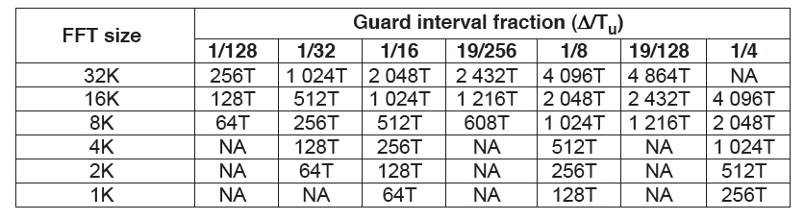
Table 1-1 Duration of the guard interval in terms of the elementary period T

For 8MHz channels, Table 1-2 shows the guard interval durations considering each allowed combination of FFT size an guard interval fraction.

 | Guard-interval fraction
FFT size | 1/128 | 1/32 | 1/16 | 19/256 | 1/8 | 19/128 | 1/4
32 K | 28 | 112 | 224 | 266 | 448 | 532 | N/A
16 K | 14 | 56 | 112 | 133 | 224 | 266 | 448
8 K | 7 | 28 | 56 | 66.5 | 112 | 133 | 224
4 K | N/A | 14 | 28 | N/A | 56 | N/A | 112
2 K | N/A | 7 | 14 | N/A | 28 | N/A | 56
1 K | N/A | N/A | 7 | N/A | 14 | N/A | 28

Table 1-2 Guard-interval duration in μs for 8MHz channels

The set of tests for guard-interval consists in the extreme cases of guard interval durations for each allowed combination of FFT size and guard interval fraction, as shown in
Table 1-3. The cases marked with blue colour in the following table are the set of tests for guard-interval parameter (Test 3-1, Test 3-2, Test 3-3, Test 3-4, Test 3-5, Test 3-6, Test 3-7, Test 3-8, Test 3-9, Test 3-10, Test 3-11, Test 3-12) and are presented in the next parameter tables.

 | Guard-interval fraction
FFT size | 1/128 | 1/32 | 1/16 | 19/256 | 1/8 | 19/128 | 1/4
32 K | 28 | 112 | 224 | 266 | 448 | 532 | N/A
16 K | 14 | 56 | 112 | 133 | 224 | 266 | 448
8 K | 7 | 28 | 56 | 66.5 | 112 | 133 | 224
4 K | N/A | 14 | 28 | N/A | 56 | N/A | 112
2 K | N/A | 7 | 14 | N/A | 28 | N/A | 56
1 K | N/A | N/A | 7 | N/A | 14 | N/A | 28

Table 1-3 Selected tests for guard-interval duration in μs for 8MHz channels (blue colour)

Test 3-1 and Test 3-2: FFT Size 32K

 | Test 3-1 | Test 3-2
PLP | Single | Single
FFTSIZE | 32K | 32K
GI | 1/128 | 19/128
Data Symbols | 59 | 59
SISO/MISO | SISO | SISO
PAPR | None | None
Null packet deletion | None | None
Frames per superframe | 2 | 2
Bandwidth | 8MHz | 8MHz
Extended Carrier Mode | Yes | Yes
Pilot Pattern | PP7 | PP7
L1 Modulation | 64QAM | 64QAM
Sub Slices per Frame | 1 | 1
FEF | None | None
L1 Repetition | 0 | 0
Number of PLPs | 1 | 1
Number of RFs | 1 | 1
Number of AUXs | 0 | 0
T2 system ID | 0x8001 | 0x8001
Network ID | 0x3085 | 0x3085
Cell ID | 0x0000 | 0x0000
RF frequency (Hz) | 729833333 | 729833333

 | Test 3-1 | Test 3-2
PLP 1
PLP_ID | 0 | 0
Type | 1 | 1
Modulation | 256QAM | 256QAM
Rate | 2/3 | 2/3
FEC Type | 64800 | 64800
Rotated QAM | Yes | Yes
FEC blocks per interleaving frame | 202 | 187
Max FEC blocks per interleaving frame | 202 | 187
Frame Interval (I_JUMP) | 1 | 1
Type of time-interleaving | 0 | 0
Time Interleaving Length | 3 | 3
Input stage
Mode | HEM | HEM
ISSY | No | No
BUFS
BUFS unit
Design delay (samples)
Null packet deletion | No | No
In Band Signalling | No | No
Number of other PLPs in-band signalling
Number of NULL packets inserted each time (p)
Frequency of NULL packets insertion in packets (q)
Input TS rate (bits/s) | 40.214.645 | 32.673.959

Test 3-3 and Test 3-4: FFT Size 16K

 | Test 3-3 | Test 3-4
PLP | Single | Single
FFTSIZE | 16K | 16K
GI | 1/128 | 1/4
Data Symbols | 59 | 59
SISO/MISO | SISO | SISO
PAPR | None | None
Null packet deletion | None | None
Frames per superframe | 2 | 2
Bandwidth | 8MHz | 8MHz
Extended Carrier Mode | Yes | Yes
Pilot Pattern | PP7 | PP7
L1 Modulation | 64QAM | 64QAM
Sub Slices per Frame | 1 | 1
FEF | None | None
L1 Repetition | 0 | 0
Number of PLPs | 1 | 1
Number of RFs | 1 | 1
Number of AUXs | 0 | 0
T2 system ID | 0x8001 | 0x8001
Network ID | 0x3085 | 0x3085
Cell ID | 0x0000 | 0x0000
RF frequency (Hz) | 729833333 | 729833333

 | Test 3-3 | Test 3-4
PLP 1
PLP_ID | 0 | 0
Type | 1 | 1
Modulation | 256QAM | 256QAM
Rate | 2/3 | 2/3
FEC Type | 64800 | 64800
Rotated QAM | Yes | Yes
FEC blocks per interleaving frame | 100 | 92
Max FEC blocks per interleaving frame | 100 | 92
Frame Interval (I_JUMP) | 1 | 1
Type of time-interleaving | 0 | 0
Time Interleaving Length | 3 | 3
Input stage
Mode | HEM | HEM
ISSY | No | No
BUFS
BUFS unit
Design delay (samples)
Null packet deletion | No | No
In Band Signalling | No | No
Number of other PLPs in-band signalling
Number of NULL packets inserted each time (p)
Frequency of NULL packets insertion in packets (q)
Input TS rate (bits/s) | 39.775.411 | 29.515.208

Test 3-5 and Test 3-6: FFT Size 8K

 | Test 3-5 | Test 3-6
PLP | Single | Single
FFTSIZE | 8K | 8K
GI | 1/128 | 1/4
Data Symbols | 59 | 59
SISO/MISO | SISO | SISO
PAPR | None | None
Null packet deletion | None | None
Frames per superframe | 2 | 2
Bandwidth | 8MHz | 8MHz
Extended Carrier Mode | Yes | Yes
Pilot Pattern | PP7 | PP1
L1 Modulation | 64QAM | 64QAM
Sub Slices per Frame | 1 | 1
FEF | None | None
L1 Repetition | 0 | 0
Number of PLPs | 1 | 1
Number of RFs | 1 | 1
Number of AUXs | 0 | 0
T2 system ID | 0x8001 | 0x8001
Network ID | 0x3085 | 0x3085
Cell ID | 0x0000 | 0x0000
RF frequency (Hz) | 729833333 | 729833333

 | Test 3-5 | Test 3-6
PLP 1
PLP_ID | 0 | 0
Type | 1 | 1
Modulation | 256QAM | 256QAM
Rate | 2/3 | 2/3
FEC Type | 64800 | 64800
Rotated QAM | Yes | Yes
FEC blocks per interleaving frame | 50 | 46
Max FEC blocks per interleaving frame | 50 | 46
Frame Interval (I_JUMP) | 1 | 1
Type of time-interleaving | 0 | 0
Time Interleaving Length | 3 | 3
Input stage
Mode | HEM | HEM
ISSY | No | No
BUFS
BUFS unit
Design delay (samples)
Null packet deletion | No | No
In Band Signalling | No | No
Number of other PLPs in-band signalling
Number of NULL packets inserted each time (p)
Frequency of NULL packets insertion in packets (q)
Input TS rate (bits/s) | 39.045.448 | 28.984.706

Test 3-7 and Test 3-8: FFT Size 4K

 | Test 3-7 | Test 3-8
PLP | Single | Single
FFTSIZE | 4K | 4K
GI | 1/32 | 1/4
Data Symbols | 59 | 59
SISO/MISO | SISO | SISO
PAPR | None | None
Null packet deletion | None | None
Frames per superframe | 2 | 2
Bandwidth | 8MHz | 8MHz
Extended Carrier Mode | No | No
Pilot Pattern | PP7 | PP1
L1 Modulation | 64QAM | 64QAM
Sub Slices per Frame | 1 | 1
FEF | None | None
L1 Repetition | 0 | 0
Number of PLPs | 1 | 1
Number of RFs | 1 | 1
Number of AUXs | 0 | 0
T2 system ID | 0x8001 | 0x8001
Network ID | 0x3085 | 0x3085
Cell ID | 0x0000 | 0x0000
RF frequency (Hz) | 729833333 | 729833333

 | Test 3-7 | Test 3-8
PLP 1
PLP_ID | 0 | 0
Type | 1 | 1
Modulation | 256QAM | 256QAM
Rate | 2/3 | 2/3
FEC Type | 64800 | 64800
Rotated QAM | Yes | Yes
FEC blocks per interleaving frame | 25 | 23
Max FEC blocks per interleaving frame | 25 | 23
Frame Interval (I_JUMP) | 1 | 1
Type of time-interleaving | 0 | 0
Time Interleaving Length | 3 | 3
Input stage
Mode | HEM | HEM
ISSY | No | No
BUFS
BUFS unit
Design delay (samples)
Null packet deletion | No | No
In Band Signalling | No | No
Number of other PLPs in-band signalling
Number of NULL packets inserted each time (p)
Frequency of NULL packets insertion in packets (q)
Input TS rate (bits/s) | 36.813.614 | 27.978.927
Test 3-9 and Test 3-10: FFT Size 2K

 | Test 3-9 | Test 3-10
PLP | Single | Single
FFTSIZE | 2K | 2K
GI | 1/32 | 1/4
Data Symbols | 59 | 59
SISO/MISO | SISO | SISO
PAPR | None | None
Null packet deletion | None | None
Frames per superframe | 2 | 2
Bandwidth | 8MHz | 8MHz
Extended Carrier Mode | No | No
Pilot Pattern | PP7 | PP1
L1 Modulation | 64QAM | 64QAM
Sub Slices per Frame | 1 | 1
FEF | None | None
L1 Repetition | 0 | 0
Number of PLPs | 1 | 1
Number of RFs | 1 | 1
Number of AUXs | 0 | 0
T2 system ID | 0x8001 | 0x8001
Network ID | 0x3085 | 0x3085
Cell ID | 0x0000 | 0x0000
RF frequency (Hz) | 729833333 | 729833333

 | Test 3-9 | Test 3-10
PLP 1
PLP_ID | 0 | 0
Type | 1 | 1
Modulation | 256QAM | 256QAM
Rate | 2/3 | 2/3
FEC Type | 64800 | 64800
Rotated QAM | Yes | Yes
FEC blocks per interleaving frame | 12 | 11
Max FEC blocks per interleaving frame | 12 | 11
Frame Interval (I_JUMP) | 1 | 1
Type of time-interleaving | 0 | 0
Time Interleaving Length | 3 | 3
Input stage
Mode | HEM | HEM
ISSY | No | No
BUFS
BUFS unit
Design delay (samples)
Null packet deletion | No | No
In Band Signalling | No | No
Number of other PLPs in-band signalling
Number of NULL packets inserted each time (p)
Frequency of NULL packets insertion in packets (q)
Input TS rate (bits/s) | 33.009.158 | 25.025.656
Test 3-11 and Test 3-12: FFT Size 1K

 | Test 3-11 | Test 3-12
PLP | Single | Single
FFTSIZE | 1K | 1K
GI | 1/16 | 1/4
Data Symbols | 59 | 59
SISO/MISO | SISO | SISO
PAPR | None | None
Null packet deletion | None | None
Frames per superframe | 2 | 2
Bandwidth | 8MHz | 8MHz
Extended Carrier Mode | No | No
Pilot Pattern | PP4 | PP1
L1 Modulation | 64QAM | 64QAM
Sub Slices per Frame | 1 | 1
FEF | None | None
L1 Repetition | 0 | 0
Number of PLPs | 1 | 1
Number of RFs | 1 | 1
Number of AUXs | 0 | 0
T2 system ID | 0x8001 | 0x8001
Network ID | 0x3085 | 0x3085
Cell ID | 0x0000 | 0x0000
RF frequency (Hz) | 729833333 | 729833333

 | Test 3-11 | Test 3-12
PLP 1
PLP_ID | 0 | 0
Type | 1 | 1
Modulation | 256QAM | 256QAM
Rate | 2/3 | 2/3
FEC Type | 64800 | 64800
Rotated QAM | Yes | Yes
FEC blocks per interleaving frame | 6 | 6
Max FEC blocks per interleaving frame | 6 | 6
Frame Interval (I_JUMP) | 1 | 1
Type of time-interleaving | 0 | 0
Time Interleaving Length | 3 | 3
Input stage
Mode | HEM | HEM
ISSY | No | No
BUFS
BUFS unit
Design delay (samples)
Null packet deletion | No | No
In Band Signalling | No | No
Number of other PLPs in-band signalling
Number of NULL packets inserted each time (p)
Frequency of NULL packets insertion in packets (q)
Input TS rate (bits/s) | 28.324.231 | 24.164.341

Test 4 - Frame Length

The T2-frame length (the number of symbols in a T2-frame) is a configurable parameter that can be chosen as required by the broadcaster or network operator. The DVB-T2 specifications impose three constraints:
- 250ms as the maximum T2-frame duration.
- Specifications of the minimum number of symbols allowed.
- An even number of symbols for 32 K mode.

The choice of the frame length depends on the selections made of the other parameters, including:
- FFT size
- Guard interval
- The use of extended-carrier mode.
- The combinations of different types of PLPs.

Test 4-1, Max Frame Length.
Test 4-2, Min Frame Length.

Test 4-1 Maximum possible FL = 245,840 ms

PLP | Single
FFTSIZE | 32K
GI | 1/128
Data Symbols | 67
SISO/MISO | SISO
PAPR | None
Null packet deletion | None
Frames per superframe | 2
Bandwidth | 8MHz
Extended Carrier Mode | Yes
Pilot Pattern | PP7
L1 Modulation | 64QAM
Sub Slices per Frame | 1
FEF | None
L1 Repetition | 0
Number of PLPs | 1
Number of RFs | 1
Number of AUXs | 0
T2 system ID | 0x8001
Network ID | 0x3085
Cell ID | 0x0000
RF frequency (Hz) | 729833333

PLP 1
PLP_ID | 0
Type | 1
Modulation | 256QAM
Rate | 2/3
FEC Type | 64800
Rotated QAM | Yes
FEC blocks per interleaving frame | 202
Max FEC blocks per interleaving frame | 202
Frame Interval (I_JUMP) | 1
Type of time-interleaving | 0
Time Interleaving Length | 3
Input stage
Mode | HEM
ISSY | No
BUFS
BUFS unit
Design delay (samples)
Null packet deletion | No
In Band Signalling | No
Number of other PLPs in-band signalling
Number of NULL packets inserted each time (p)
Frequency of NULL packets insertion in packets (q)
Input TS rate (bits/s) | 35.487.821

Test 4-2 Minimum possible FL = 14,672 ms

PLP | Single
FFTSIZE | 32K
GI | 1/128
Data Symbols | 3
SISO/MISO | SISO
PAPR | None
Null packet deletion | None
Frames per superframe | 2
Bandwidth | 8MHz
Extended Carrier Mode | No
Pilot Pattern | PP7
L1 Modulation | 64QAM
Sub Slices per Frame | 1
FEF | None
L1 Repetition | 0
Number of PLPs | 1
Number of RFs | 1
Number of AUXs | 0
T2 system ID | 0x8001
Network ID | 0x3085
Cell ID | 0x0000
RF frequency (Hz) | 729833333

PLP 1
PLP_ID | 0
Type | 1
Modulation | 256QAM
Rate | 2/3
FEC Type | 64800
Rotated QAM | Yes
FEC blocks per interleaving frame | 12
Max FEC blocks per interleaving frame | 12
Frame Interval (I_JUMP) | 1
Type of time-interleaving | 0
Time Interleaving Length | 3
Input stage
Mode | HEM
ISSY | No
BUFS
BUFS unit
Design delay (samples)
Null packet deletion | No
In Band Signalling | No
Number of other PLPs in-band signalling
Number of NULL packets inserted each time (p)
Frequency of NULL packets insertion in packets (q)
Input TS rate (bits/s) | 31.745.741

Test 5 – Super-frame Length

A super-frame can carry T2-frames and may also have FEF parts, as seen in Figure 1-1.

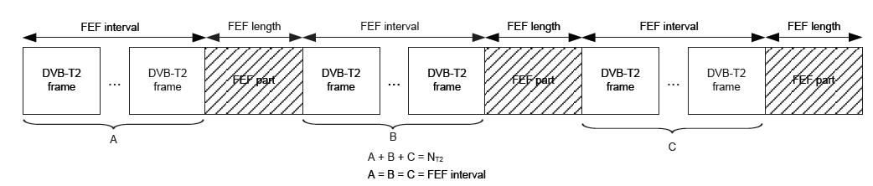
Figure 1-1 The super-frame, including T2-frames and FEF parts

N_{T2} represents the number of T2-frames in a super-frame. It is a configurable parameter that is signalled in L1-pre signalling. The maximum value for the super-frame length T_{SF} is 64s if FEFs are not used (equivalent to 255 frames of 250 ms) and 128s if FEFs are used.

The main goal of the set of parameters of Test 5-1 is to obtain the nearest super-frame length to the maximum value (T_{SF}=64s). A frame length of 245,840 ms is achieved and 255 frames are configured in order to set the maximum possible value of super-frame length.

Test 5-1 Super frame length

PLP | Single
FFTSIZE | 32K
GI | 1/128
Data Symbols | 67
SISO/MISO | SISO
PAPR | None
Null packet deletion | None
Frames per superframe | 255
Bandwidth | 8MHz
Extended Carrier Mode | Yes
Pilot Pattern | PP7
L1 Modulation | 64QAM
Sub Slices per Frame | 1
FEF | None
L1 Repetition | 0
Number of PLPs | 1
Number of RFs | 1
Number of AUXs | 0
T2 system ID | 0x8001
Network ID | 0x3085
Cell ID | 0x0000
RF frequency (Hz) | 729833333

PLP 1
PLP_ID | 0
Type | 1
Modulation | 256QAM
Rate | 2/3
FEC Type | 64800
Rotated QAM | Yes
FEC blocks per interleaving frame | 202
Max FEC blocks per interleaving frame | 202
Frame Interval (I_JUMP) | 1
Type of time-interleaving | 0
Time Interleaving Length | 3
Input stage
Mode | HEM
ISSY | No
BUFS
BUFS unit
Design delay (samples)
Null packet deletion | No
In Band Signalling | No
Number of other PLPs in-band signalling
Number of NULL packets inserted each time (p)
Frequency of NULL packets insertion in packets (q)
Input TS rate (bits/s) | 35.487.821

Test 6 – Time Interleaving parameters

Each Interleaving Frame is either mapped directly onto one T2-frame or spread out over several T2-frames. Furthermore, each Interleaving Frame is also divided into one or more (N_{TI}) TI-blocks. A TI-block corresponds to one usage of the time interleaver memory.

Therefore, there are three options for time interleaving for each PLP:
- Each Interleaving Frame contains one TI-block and is mapped directly to one T2-frame. This option is signalled by ’Type of time-interleaving’=0 and ’Time Interleaving Length’=1.
- Each Interleaving Frame contains one TI-block and is mapped to more than one T2-frame. This option is signalled by ’Type of time-interleaving’=1.
- Each Interleaving Frame is mapped directly to one T2-frame and the Interleaving Frame is divided into several TI-blocks. Each of the TI-blocks may use up to the full TI memory, thus increasing the maximum bit-rate for a PLP. This option is signalled by ’Type of time-interleaving’=0.

The number of T2-frames in one Interleaving Frame, defined as P_{I}, is signalled in the L1 configurable by ’Time Interleaving Length’ in conjunction with ’Type of time-interleaving’. The duration of one super-frame must not be exceded by the length of the time interleaving period (T_{P}). The calculation of the time interleaving period is the following:

T_{P} = T_{F} · P_{I}(i) · I_{JUMP}(i),

where T_{F} is the T2-frame length in time and I_{JUMP}(i) is the interval of T2-frames for PLP_{i}. For each PLP, described as PLP_{i}, the value of P_{I} is identified by P_{I}(i).

Test 6-1 is an example of the use of Time Interleaver where each Interleaving Frame contains one TI-block and is mapped to more than one T2-frame (’Type of time-interleaving’=1). This test checks a high value time of interleaving period (’Time Interleaving Length’=255). The duration of the super-frame is not exceed by the length of the time interleaving period.

Test 5-1 Super frame length

PLP | Single
FFTSIZE | 32K
GI | 1/128
Data Symbols | 59
SISO/MISO | SISO
PAPR | None
Null packet deletion | None
Frames per superframe | 255
Bandwidth | 8MHz
Extended Carrier Mode | Yes
Pilot Pattern | PP7
L1 Modulation | 64QAM
Sub Slices per Frame | 1
FEF | None
L1 Repetition | 0
Number of PLPs | 1
Number of RFs | 1
Number of AUXs | 0
T2 system ID | 0x8001
Network ID | 0x3085
Cell ID | 0x0000
RF frequency (Hz) | 729833333

PLP 1
PLP_ID | 0
Type | 1
Modulation | 256QAM
Rate | 2/3
FEC Type | 64800
Rotated QAM | Yes
FEC blocks per interleaving frame | 202
Max FEC blocks per interleaving frame | 202
Frame Interval (I_JUMP) | 1
Type of time-interleaving | 0
Time Interleaving Length | 255
Input stage
Mode | HEM
ISSY | No
BUFS
BUFS unit
Design delay (samples)
Null packet deletion | No
In Band Signalling | No
Number of other PLPs in-band signalling
Number of NULL packets inserted each time (p)
Frequency of NULL packets insertion in packets (q)
Input TS rate (bits/s) | 40.214.645

Test 7 - Maximum Total Bitrate

Test 7-1 consists of a set of configuration parameters to obtain the highest data rate. A channel of 8MHz has been selected with 32K mode, a guard interval of 1/128, extended-carrier mode and no tone reservation. The pilot-pattern used is PP7.
Table 1-4 shows the maximum achievable bit rate for each combination of constellation and code-rate, also with the corresponding frame length (L_{F}) and the total number of FEC blocks per frame. It is recommended a slightly shorter frame length which offers a slightly lower bit-rate but longer time interleaving. Figure 1-2 shows that the difference between absolute maximum bitrate and recommended configuration bitrate is clearly insignificant.

Modulation | Code rate | Absolute maximum bit-rate |  |  | Recommended configuration
Modulation | Code rate | Bitrate Mbit/s | Frame length LF | FEC blocks per frame | Bitrate Mbit/s | Frame length LF | FEC blocks per frame
QPSK | 1/2 | 7,49255 | 62 | 52 | 7,4442731 | 60 | 50
QPSK | 3/5 | 9,003747 | 62 | 52 | 8,9457325 | 60 | 50
QPSK | 2/3 | 10,01867 | 62 | 52 | 9,9541201 | 60 | 50
QPSK | 3/4 | 11,27054 | 62 | 52 | 11,197922 | 60 | 50
QPSK | 4/5 | 12,02614 | 62 | 52 | 11,948651 | 60 | 50
QPSK | 5/6 | 12,53733 | 62 | 52 | 12,456553 | 60 | 50
16-QAM | 1/2 | 15,03743 | 60 | 101 | 15,037432 | 60 | 101
16-QAM | 3/5 | 18,07038 | 60 | 101 | 18,07038 | 60 | 101
16-QAM | 2/3 | 20,10732 | 60 | 101 | 20,107323 | 60 | 101
16-QAM | 3/4 | 22,6198 | 60 | 101 | 22,619802 | 60 | 101
16-QAM | 4/5 | 24,13628 | 60 | 101 | 24,136276 | 60 | 101
16-QAM | 5/6 | 25,16224 | 60 | 101 | 25,162236 | 60 | 101
64-QAM | 1/2 | 22,51994 | 46 | 116 | 22,481705 | 60 | 151
64-QAM | 3/5 | 27,06206 | 46 | 116 | 27,016112 | 60 | 151
64-QAM | 2/3 | 30,11257 | 46 | 116 | 30,061443 | 60 | 151
64-QAM | 3/4 | 33,87524 | 46 | 116 | 33,817724 | 60 | 151
64-QAM | 4/5 | 36,1463 | 46 | 116 | 36,084927 | 60 | 151
64-QAM | 5/6 | 37,68277 | 46 | 116 | 37,618789 | 60 | 151
256-QAM | 1/2 | 30,08728 | 68 | 229 | 30,074863 | 60 | 202
256-QAM | 3/5 | 36,15568 | 68 | 229 | 36,140759 | 60 | 202
256-QAM | 2/3 | 40,23124 | 68 | 229 | 40,214645 | 60 | 202
256-QAM | 3/4 | 45,25828 | 68 | 229 | 45,239604 | 60 | 202
256-QAM | 4/5 | 48,29248 | 68 | 229 | 48,272552 | 60 | 202
256-QAM | 5/6 | 50,34524 | 68 | 229 | 50,324472 | 60 | 202

Table 1-4 Maximum bit-rate and recommended configurations for 8 MHz, 32 K 1/128, PP7 – Maximum bitrate recommended configuration (gray)
Figure 1-2 Maximum bitrate and bitrate for recommended configuration
with 8 MHz bandwidth and 32 K PP7

Test 7-1 Maximum Total Bitrate

PLP | Single
FFTSIZE | 32K
GI | 1/128
Data Symbols | 59
SISO/MISO | SISO
PAPR | None
Null packet deletion | None
Frames per superframe | 2
Bandwidth | 8MHz
Extended Carrier Mode | Yes
Pilot Pattern | PP7
L1 Modulation | 64QAM
Sub Slices per Frame | 1
FEF | None
L1 Repetition | 0
Number of PLPs | 1
Number of RFs | 1
Number of AUXs | 0
T2 system ID | 0x8001
Network ID | 0x3085
Cell ID | 0x0000
RF frequency (Hz) | 729833333

PLP 1
PLP_ID | 0
Type | 1
Modulation | 256QAM
Rate | 5/6
FEC Type | 64800
Rotated QAM | Yes
FEC blocks per interleaving frame | 202
Max FEC blocks per interleaving frame | 202
Frame Interval (I_JUMP) | 1
Type of time-interleaving | 0
Time Interleaving Length | 3
Input stage
Mode | HEM
ISSY | No
BUFS
BUFS unit
Design delay (samples)
Null packet deletion | No
In Band Signalling | No
Number of other PLPs in-band signalling
Number of NULL packets inserted each time (p)
Frequency of NULL packets insertion in packets (q)
Input TS rate (bits/s) | 50.324.472

Test 8 - Maximum PLP protection

Test 8-1 consists of a set of configurations parameters to obtain the highest protection of a PLP in ‘Input Mode A’. The parameters are similar to Test 7-1: a channel of 8MHz, 32K mode, guard interval of 1/128, extended-carrier mode and no tone reservation. The pilot-pattern used is PP7.
Table 1-4 shows the maximum achievable bit rate for each combination of constellation and code-rate, also with the corresponding frame length (L_{F}) and the total number of FEC blocks per frame. The selected parameters from the table correspond to the maximum PLP protection.

Modulation | Code rate | Absolute maximum bit-rate |  |  | Recommended configuration
Modulation | Code rate | Bitrate Mbit/s | Frame length LF | FEC blocks per frame | Bitrate Mbit/s | Frame length LF | FEC blocks per frame
QPSK | 1/2 | 7,49255 | 62 | 52 | 7,4442731 | 60 | 50
QPSK | 3/5 | 9,003747 | 62 | 52 | 8,9457325 | 60 | 50
QPSK | 2/3 | 10,01867 | 62 | 52 | 9,9541201 | 60 | 50
QPSK | 3/4 | 11,27054 | 62 | 52 | 11,197922 | 60 | 50
QPSK | 4/5 | 12,02614 | 62 | 52 | 11,948651 | 60 | 50
QPSK | 5/6 | 12,53733 | 62 | 52 | 12,456553 | 60 | 50
16-QAM | 1/2 | 15,03743 | 60 | 101 | 15,037432 | 60 | 101
16-QAM | 3/5 | 18,07038 | 60 | 101 | 18,07038 | 60 | 101
16-QAM | 2/3 | 20,10732 | 60 | 101 | 20,107323 | 60 | 101
16-QAM | 3/4 | 22,6198 | 60 | 101 | 22,619802 | 60 | 101
16-QAM | 4/5 | 24,13628 | 60 | 101 | 24,136276 | 60 | 101
16-QAM | 5/6 | 25,16224 | 60 | 101 | 25,162236 | 60 | 101
64-QAM | 1/2 | 22,51994 | 46 | 116 | 22,481705 | 60 | 151
64-QAM | 3/5 | 27,06206 | 46 | 116 | 27,016112 | 60 | 151
64-QAM | 2/3 | 30,11257 | 46 | 116 | 30,061443 | 60 | 151
64-QAM | 3/4 | 33,87524 | 46 | 116 | 33,817724 | 60 | 151
64-QAM | 4/5 | 36,1463 | 46 | 116 | 36,084927 | 60 | 151
64-QAM | 5/6 | 37,68277 | 46 | 116 | 37,618789 | 60 | 151
256-QAM | 1/2 | 30,08728 | 68 | 229 | 30,074863 | 60 | 202
256-QAM | 3/5 | 36,15568 | 68 | 229 | 36,140759 | 60 | 202
256-QAM | 2/3 | 40,23124 | 68 | 229 | 40,214645 | 60 | 202
256-QAM | 3/4 | 45,25828 | 68 | 229 | 45,239604 | 60 | 202
256-QAM | 4/5 | 48,29248 | 68 | 229 | 48,272552 | 60 | 202
256-QAM | 5/6 | 50,34524 | 68 | 229 | 50,324472 | 60 | 202

Table 1-5 Maximum bit-rate and recommended configurations for 8 MHz, 32 K 1/128, PP7 – Maximum protection for recommended configurations (gray)

Test 8-1 Maximum PLP protection

PLP | Single
FFTSIZE | 32K
GI | 1/128
Data Symbols | 59
SISO/MISO | SISO
PAPR | None
Null packet deletion | None
Frames per superframe | 2
Bandwidth | 8MHz
Extended Carrier Mode | Yes
Pilot Pattern | PP7
L1 Modulation | 64QAM
Sub Slices per Frame | 1
FEF | None
L1 Repetition | 0
Number of PLPs | 1
Number of RFs | 1
Number of AUXs | 0
T2 system ID | 0x8001
Network ID | 0x3085
Cell ID | 0x0000
RF frequency (Hz) | 729833333

PLP 1
PLP_ID | 0
Type | 1
Modulation | QPSK
Rate | 1/2
FEC Type | 64800
Rotated QAM | Yes
FEC blocks per interleaving frame | 50
Max FEC blocks per interleaving frame | 50
Frame Interval (I_JUMP) | 1
Type of time-interleaving | 0
Time Interleaving Length | 3
Input stage
Mode | HEM
ISSY | No
BUFS
BUFS unit
Design delay (samples)
Null packet deletion | No
In Band Signalling | No
Number of other PLPs in-band signalling
Number of NULL packets inserted each time (p)
Frequency of NULL packets insertion in packets (q)
Input TS rate (bits/s) | 7.444.273

Input Mode B

The second set of tests are configured using the Input Mode B. In this type of input mode, the T2 system carries more than one input stream, which may include both Transport and Generic Streams. Each stream is carried by a separate PLP. There may be statistical multiplexing between the PLPs so that the bit rate of an individual PLP is variable, and there may be one or more common PLPs, each shared by a group of PLPs.
The set of test included in this chapter for Input Mode B have been designed for static scheduling. Each configuration includes multiple PLPs without any Common PLP. As for the group of tests for Input Mode A, tests have been configured to check extreme parameter values, that is, maximum total bit rate, number of subslices or maximum PLP protection. This group of tests shall be used to check a DVB-T2 receiver interoperability.

The list of test for Input Mode B are:

- Test 1 – FFT Size parameter
- Test 2 – Extended Carrier Mode
- Test 3 – Guard Interval
- Test 4 – Frame Length
- Test 5 – Super Frame Length
- Test 6 – Number of subslices
- Test 7 – Maximum Total Bitrate
- Test 8 – Maximum PLP protection
- Test 9 – Number of PLPs

Test 1 - FFT Size parameter

A brief description of FFT size parameter can be found in 1.1.1.

Valid FFT sizes for DVB-T2 are 1K, 2K, 4K, 8K, 16K and 32K.

Test 1-1 and Test 1-2 perform the extreme cases fo FFT size values, this is 32K and 1K mode respectively.

Test 1-1 FFT Size: 32K mode

PLP | Multiple
FFTSIZE | 32K
GI | 1/128
Data Symbols | 59
SISO/MISO | SISO
PAPR | P2-TR & L1-ACE only
Frames per superframe | 2
Bandwidth | 8MHz
Extended Carrier Mode | Yes
Pilot Pattern | PP7
L1 Modulation | 16QAM
Sub Slices per Frame | 270
FEF | None
L1 Repetition | 0
Number of PLPs | 2
Number of RFs | 1
Number of AUXs | 0
T2 system ID | 0x8001
Network ID | 0x3085
Cell ID | 0x0000
RF frequency (Hz) | 729833333
Spec version | 1.2.1
Vclip | infinity
L1 Extension Present | No
L1 Bias balancing | No
L1_ACE_MAX | 0
Bitrate (bits/s) (Frame) | 19.619.653

PLP | PLP1 | PLP2
PLP_ID | 0 | 1
PLP_GROUP_ID | 0 | 1
Type | 2 | 2
Modulation | 256QAM | 16QAM
Rate | 2/3 | 3/5
FEC Type | 64800 | 64800
Rotated QAM | No | No
FEC blocks per interleaving frame | 68 | 34
Max FEC blocks per interleaving frame | 68 | 34
TI blocks per frame (N_TI) | 1 | 1
T2 frames per Interleaving Frame (P_I) | 1 | 1
Frame Interval (I_JUMP) | 1 | 1
Type of time-interleaving | 0 | 0
Time Interleaving Length | 1 | 1
Input stage
Mode | HEM | HEM
ISSY | Yes | Yes
BUFS | 2097152 | 2097152
Design delay (samples) | 1143097 | 1143269
Null packet deletion | No | No
In Band Signalling | Type A | Type A
Number of other PLPs in-band signalling | 0 | 0
Number of NULL packets inserted each time (p)
Frequency of NULL packets insertion in packets (q)

Test 1-2 FFT Size: 1K mode

PLP | Multiple
FFTSIZE | 1K
GI | 1/16
Data Symbols | 59
SISO/MISO | SISO
PAPR | P2-TR & L1-ACE only
Frames per superframe | 2
Bandwidth | 1,7MHz
Extended Carrier Mode | No
Pilot Pattern | PP4
L1 Modulation | QPSK
Sub Slices per Frame | 270
FEF | None
L1 Repetition | 0
Number of PLPs | 2
Number of RFs | 1
Number of AUXs | 0
T2 system ID | 0x8001
Network ID | 0x3085
Cell ID | 0x0000
RF frequency (Hz) | 729833333
Spec version | 1.2.1
Vclip | infinity
L1 Extension Present | No
L1 Bias balancing | No
L1_ACE_MAX | 0
Bitrate (bits/s) (Frame) | 3.612.612

PLP | PLP1 | PLP2
PLP_ID | 0 | 1
PLP_GROUP_ID | 0 | 1
Type | 2 | 2
Modulation | 256QAM | 16QAM
Rate | 2/3 | 3/5
FEC Type | 64800 | 64800
Rotated QAM | No | No
FEC blocks per interleaving frame | 2 | 2
Max FEC blocks per interleaving frame | 2 | 2
TI blocks per frame (N_TI) | 1 | 1
T2 frames per Interleaving Frame (P_I) | 1 | 1
Frame Interval (I_JUMP) | 1 | 1
Type of time-interleaving | 0 | 0
Time Interleaving Length | 1 | 1
Input stage
Mode | HEM | HEM
ISSY | Yes | Yes
BUFS | 2097152 | 2097152
Design delay (samples) | 1143097 | 1143269
Null packet deletion | No | No
In Band Signalling | Type A | Type A
Number of other PLPs in-band signalling | 0 | 0
Number of NULL packets inserted each time (p)
Frequency of NULL packets insertion in packets (q)

Test 2 - Extended Carrier Mode

A brief description of Extended Carrier Mode can be found in 1.1.2.

Test 2-1 represents the use of Extended Carrier Mode. Test 2-2 represents the case where Extended Carrier Mode is not used. In this case, the Frame duration is slightly shorter than in Test 2-1.
Test 2-1 Extended Carrier Mode

PLP | Multiple
FFTSIZE | 16K
GI | 19/128
Data Symbols | 59
SISO/MISO | SISO
PAPR | P2-TR & L1-ACE only
Frames per superframe | 2
Bandwidth | 8MHz
Extended Carrier Mode | Yes
Pilot Pattern | PP3
L1 Modulation | QPSK
Sub Slices per Frame | 270
FEF | None
L1 Repetition | 0
Number of PLPs | 2
Number of RFs | 1
Number of AUXs | 0
T2 system ID | 0x8001
Network ID | 0x3085
Cell ID | 0x0000
RF frequency (Hz) | 729833333
Spec version | 1.2.1
Vclip | infinity
L1 Extension Present | No
L1 Bias balancing | No
L1_ACE_MAX | 0
Bitrate (bits/s) (Frame) | 20.163.759

PLP | PLP1 | PLP2
PLP_ID | 0 | 1
PLP_GROUP_ID | 0 | 1
Type | 2 | 2
Modulation | 256QAM | 16QAM
Rate | 2/3 | 3/5
FEC Type | 64800 | 64800
Rotated QAM | No | No
FEC blocks per interleaving frame | 29 | 32
Max FEC blocks per interleaving frame | 29 | 32
TI blocks per frame (N_TI) | 1 | 1
T2 frames per Interleaving Frame (P_I) | 1 | 1
Frame Interval (I_JUMP) | 1 | 1
Type of time-interleaving | 0 | 0
Time Interleaving Length | 1 | 1
Input stage
Mode | HEM | HEM
ISSY | Yes | Yes
BUFS | 2097152 | 2097152
Design delay (samples) | 1143097 | 1143269
Null packet deletion | No | No
In Band Signalling | Type A | Type A
Number of other PLPs in-band signalling | 0 | 0
Number of NULL packets inserted each time (p)
Frequency of NULL packets insertion in packets (q)

Test 2-2 No Extended Carrier Mode

PLP | Multiple
FFTSIZE | 16K
GI | 19/128
Data Symbols | 59
SISO/MISO | SISO
PAPR | P2-TR & L1-ACE only
Frames per superframe | 2
Bandwidth | 8MHz
Extended Carrier Mode | No
Pilot Pattern | PP3
L1 Modulation | QPSK
Sub Slices per Frame | 270
FEF | None
L1 Repetition | 0
Number of PLPs | 2
Number of RFs | 1
Number of AUXs | 0
T2 system ID | 0x8001
Network ID | 0x3085
Cell ID | 0x0000
RF frequency (Hz) | 729833333
Spec version | 1.2.1
Vclip | infinity
L1 Extension Present | No
L1 Bias balancing | No
L1_ACE_MAX | 0
Bitrate (bits/s) (Frame) | 20.163.759

PLP | PLP1 | PLP2
PLP_ID | 0 | 1
PLP_GROUP_ID | 0 | 1
Type | 2 | 2
Modulation | 256QAM | 16QAM
Rate | 2/3 | 3/5
FEC Type | 64800 | 64800
Rotated QAM | No | No
FEC blocks per interleaving frame | 29 | 32
Max FEC blocks per interleaving frame | 29 | 32
TI blocks per frame (N_TI) | 1 | 1
T2 frames per Interleaving Frame (P_I) | 1 | 1
Frame Interval (I_JUMP) | 1 | 1
Type of time-interleaving | 0 | 0
Time Interleaving Length | 1 | 1
Input stage
Mode | HEM | HEM
ISSY | Yes | Yes
BUFS | 2097152 | 2097152
Design delay (samples) | 1143097 | 1143269
Null packet deletion | No | No
In Band Signalling | Type A | Type A
Number of other PLPs in-band signalling | 0 | 0
Number of NULL packets inserted each time (p)
Frequency of NULL packets insertion in packets (q)

Test 3 - Guard Interval

A brief description of Guard Interval parameter can be found in 1.1.3.

For 8MHz channels, Table 1-6 shows the guard interval durations considering each allowed combination of FFT size an guard interval fraction.

 | Guard-interval fraction
FFT size | 1/128 | 1/32 | 1/16 | 19/256 | 1/8 | 19/128 | 1/4
32 K | 28 | 112 | 224 | 266 | 448 | 532 | N/A
16 K | 14 | 56 | 112 | 133 | 224 | 266 | 448
8 K | 7 | 28 | 56 | 66.5 | 112 | 133 | 224
4 K | N/A | 14 | 28 | N/A | 56 | N/A | 112
2 K | N/A | 7 | 14 | N/A | 28 | N/A | 56
1 K | N/A | N/A | 7 | N/A | 14 | N/A | 28

Table 1-6 Guard-interval duration in μs for 8MHz channels

The set of tests for guard-interval consists in the extreme cases of guard interval durations for each allowed combination of FFT size and guard interval fraction, as shown in Table 1-7.

 | Guard-interval fraction
FFT size | 1/128 | 1/32 | 1/16 | 19/256 | 1/8 | 19/128 | 1/4
32 K | 28 | 112 | 224 | 266 | 448 | 532 | N/A
16 K | 14 | 56 | 112 | 133 | 224 | 266 | 448
8 K | 7 | 28 | 56 | 66.5 | 112 | 133 | 224
4 K | N/A | 14 | 28 | N/A | 56 | N/A | 112
2 K | N/A | 7 | 14 | N/A | 28 | N/A | 56
1 K | N/A | N/A | 7 | N/A | 14 | N/A | 28

Table 1-7 Selected tests for guard-interval duration in μs for 8MHz channels (blue colour)

As for Input Mode A, a set of test, from Test 3-1 to Test 3-12, have been defined for the use cases maked in blue color in the Table 1-7. The group of specification parameters are presented in the following tables.
Test 3-1 and Test 3-2 – FFT Size 32K

 | Test 3-1 | Test 3-2
PLP | Multiple | Multiple
FFTSIZE | 32K | 32K
GI | 1/128 | 19/128
Data Symbols | 59 | 59
SISO/MISO | SISO | SISO
PAPR | P2-TR & L1-ACE only | P2-TR & L1-ACE only
Frames per superframe | 2 | 2
Bandwidth | 8MHz | 8MHz
Extended Carrier Mode | Yes | Yes
Pilot Pattern | PP7 | PP2
L1 Modulation | 16QAM | 16QAM
Sub Slices per Frame | 270 | 270
FEF | None | None
L1 Repetition | 0 | 0
Number of PLPs | 2 | 2
Number of RFs | 1 | 1
Number of AUXs | 0 | 0
T2 system ID | 0x8001 | 0x8001
Network ID | 0x3085 | 0x3085
Cell ID | 0x0000 | 0x0000
RF frequency (Hz) | 729833333 | 729833333
Spec version | 1.2.1 | 1.2.1
Vclip | infinity | infinity
L1 Extension Present | No | No
L1 Bias balancing | No | No
L1_ACE_MAX | 0 | 0
Bitrate (bits/s) (Frame) | 19.619.653 | 17.219.424

 | Test 3-1 |  | Test 3-2
PLP | PLP1 | PLP2 | PLP1 | PLP2
PLP_ID | 0 | 1 | 0 | 1
PLP_GROUP_ID | 0 | 1 | 0 | 1
Type | 2 | 2 | 2 | 2
Modulation | 256QAM | 16QAM | 256QAM | 16QAM
Rate | 2/3 | 3/5 | 2/3 | 3/5
FEC Type | 64800 | 64800 | 64800 | 64800
Rotated QAM | No | No | No | No
FEC blocks per interleaving frame | 68 | 34 | 68 | 34
Max FEC blocks per interleaving frame | 68 | 34 | 68 | 34
TI blocks per frame (N_TI) | 1 | 1 | 1 | 1
T2 frames per Interleaving Frame (P_I) | 1 | 1 | 1 | 1
Frame Interval (I_JUMP) | 1 | 1 | 1 | 1
Type of time-interleaving | 0 | 0 | 0 | 0
Time Interleaving Length | 1 | 1 | 1 | 1
Input stage
Mode | HEM | HEM | HEM | HEM
ISSY | Yes | Yes | Yes | Yes
BUFS | 2097152 | 2097152 | 2097152 | 2097152
Design delay (samples) | 1143097 | 1143269 | 1143097 | 1143269
Null packet deletion | No | No | No | No
In Band Signalling | Type A | Type A | Type A | Type A
Number of other PLPs in-band signalling | 0 | 0 | 0 | 0
Number of NULL packets inserted each time (p)
Frequency of NULL packets insertion in packets (q)

Test 3-3 and Test 3-4 FFT Size 16K

 | Test 3-3 | Test 3-4
PLP | Multiple | Multiple
FFTSIZE | 16K | 16K
GI | 1/128 | 1/4
Data Symbols | 59 | 59
SISO/MISO | SISO | SISO
PAPR | P2-TR & L1-ACE only | P2-TR & L1-ACE only
Frames per superframe | 2 | 2
Bandwidth | 8MHz | 8MHz
Extended Carrier Mode | Yes | Yes
Pilot Pattern | PP7 | PP1
L1 Modulation | 16QAM | 16QAM
Sub Slices per Frame | 270 | 270
FEF | None | None
L1 Repetition | 0 | 0
Number of PLPs | 2 | 2
Number of RFs | 1 | 1
Number of AUXs | 0 | 0
T2 system ID | 0x8001 | 0x8001
Network ID | 0x3085 | 0x3085
Cell ID | 0x0000 | 0x0000
RF frequency (Hz) | 729833333 | 729833333
Spec version | 1.2.1 | 1.2.1
Vclip | infinity | infinity
L1 Extension Present | No | No
L1 Bias balancing | No | No
L1_ACE_MAX | 0 | 0
Bitrate (bits/s) (Frame) | 26.234.124 | 18.239.862

 | Test 3-3 |  | Test 3-4
PLP | PLP1 | PLP2 | PLP1 | PLP2
PLP_ID | 0 | 1 | 0 | 1
PLP_GROUP_ID | 0 | 1 | 0 | 1
Type | 2 | 2 | 2 | 2
Modulation | 256QAM | 16QAM | 256QAM | 16QAM
Rate | 2/3 | 3/5 | 2/3 | 3/5
FEC Type | 64800 | 64800 | 64800 | 64800
Rotated QAM | No | No | No | No
FEC blocks per interleaving frame | 39 | 30 | 29 | 31
Max FEC blocks per interleaving frame | 39 | 30 | 29 | 31
TI blocks per frame (N_TI) | 1 | 1 | 1 | 1
T2 frames per Interleaving Frame (P_I) | 1 | 1 | 1 | 1
Frame Interval (I_JUMP) | 1 | 1 | 1 | 1
Type of time-interleaving | 0 | 0 | 0 | 0
Time Interleaving Length | 1 | 1 | 1 | 1
Input stage
Mode | HEM | HEM | HEM | HEM
ISSY | Yes | Yes | Yes | Yes
BUFS | 2097152 | 2097152 | 2097152 | 2097152
Design delay (samples) | 1143097 | 1143269 | 1143097 | 1143269
Null packet deletion | No | No | No | No
In Band Signalling | Type A | Type A | Type A | Type A
Number of other PLPs in-band signalling | 0 | 0 | 0 | 0
Number of NULL packets inserted each time (p)
Frequency of NULL packets insertion in packets (q)

Test 3-5 and Test 3-6 – FFT Size 8K

 | Test 3-5 | Test 3-6
PLP | Multiple | Multiple
FFTSIZE | 8K | 8K
GI | 1/128 | 1/4
Data Symbols | 59 | 59
SISO/MISO | SISO | SISO
PAPR | P2-TR & L1-ACE only | P2-TR & L1-ACE only
Frames per superframe | 2 | 2
Bandwidth | 8MHz | 8MHz
Extended Carrier Mode | Yes | Yes
Pilot Pattern | PP7 | PP1
L1 Modulation | 16QAM | 16QAM
Sub Slices per Frame | 270 | 270
FEF | None | None
L1 Repetition | 0 | 0
Number of PLPs | 2 | 2
Number of RFs | 1 | 1
Number of AUXs | 0 | 0
T2 system ID | 0x8001 | 0x8001
Network ID | 0x3085 | 0x3085
Cell ID | 0x0000 | 0x0000
RF frequency (Hz) | 729833333 | 729833333
Spec version | 1.2.1 | 1.2.1
Vclip | infinity | infinity
L1 Extension Present | No | No
L1 Bias balancing | No | No
L1_ACE_MAX | 0 | 0
Bitrate (bits/s) (Frame) | 24.579.254 | 25.360.163

 | Test 3-5 |  | Test 3-6
PLP | PLP1 | PLP2 | PLP1 | PLP2
PLP_ID | 0 | 1 | 0 | 1
PLP_GROUP_ID | 0 | 1 | 0 | 1
Type | 2 | 2 | 2 | 2
Modulation | 256QAM | 16QAM | 256QAM | 16QAM
Rate | 2/3 | 3/5 | 2/3 | 3/5
FEC Type | 64800 | 64800 | 64800 | 64800
Rotated QAM | No | No | No | No
FEC blocks per interleaving frame | 18 | 15 | 19 | 15
Max FEC blocks per interleaving frame | 18 | 15 | 19 | 15
TI blocks per frame (N_TI) | 1 | 1 | 1 | 1
T2 frames per Interleaving Frame (P_I) | 1 | 1 | 1 | 1
Frame Interval (I_JUMP) | 1 | 1 | 1 | 1
Type of time-interleaving | 0 | 0 | 0 | 0
Time Interleaving Length | 1 | 1 | 1 | 1
Input stage
Mode | HEM | HEM | HEM | HEM
ISSY | Yes | Yes | Yes | Yes
BUFS | 2097152 | 2097152 | 2097152 | 2097152
Design delay (samples) | 1143097 | 1143269 | 1143097 | 1143269
Null packet deletion | No | No | No | No
In Band Signalling | Type A | Type A | Type A | Type A
Number of other PLPs in-band signalling | 0 | 0 | 0 | 0
Number of NULL packets inserted each time (p)
Frequency of NULL packets insertion in packets (q)

Test 3-7 and Test 3-8 – FFT Size 4K

 | Test 3-7 | Test 3-8
PLP | Multiple | Multiple
FFTSIZE | 4K | 4K
GI | 1/32 | 1/4
Data Symbols | 59 | 59
SISO/MISO | SISO | SISO
PAPR | P2-TR & L1-ACE only | P2-TR & L1-ACE only
Frames per superframe | 2 | 2
Bandwidth | 8MHz | 8MHz
Extended Carrier Mode | No | No
Pilot Pattern | PP7 | PP1
L1 Modulation | 16QAM | 16QAM
Sub Slices per Frame | 270 | 270
FEF | None | None
L1 Repetition | 0 | 0
Number of PLPs | 2 | 2
Number of RFs | 1 | 1
Number of AUXs | 0 | 0
T2 system ID | 0x8001 | 0x8001
Network ID | 0x3085 | 0x3085
Cell ID | 0x0000 | 0x0000
RF frequency (Hz) | 729833333 | 729833333
Spec version | 1.2.1 | 1.2.1
Vclip | infinity | infinity
L1 Extension Present | No | No
L1 Bias balancing | No | No
L1_ACE_MAX | 0 | 0
Bitrate (bits/s) (Frame) | 23.981.292 | 17.501.327

 | Test 3-7 |  | Test 3-8
PLP | PLP1 | PLP2 | PLP1 | PLP2
PLP_ID | 0 | 1 | 0 | 1
PLP_GROUP_ID | 0 | 1 | 0 | 1
Type | 2 | 2 | 2 | 2
Modulation | 256QAM | 16QAM | 256QAM | 16QAM
Rate | 2/3 | 3/5 | 2/3 | 3/5
FEC Type | 64800 | 64800 | 64800 | 64800
Rotated QAM | No | No | No | No
FEC blocks per interleaving frame | 10 | 7 | 9 | 6
Max FEC blocks per interleaving frame | 10 | 7 | 9 | 6
TI blocks per frame (N_TI) | 1 | 1 | 1 | 1
T2 frames per Interleaving Frame (P_I) | 1 | 1 | 1 | 1
Frame Interval (I_JUMP) | 1 | 1 | 1 | 1
Type of time-interleaving | 0 | 0 | 0 | 0
Time Interleaving Length | 1 | 1 | 1 | 1
Input stage
Mode | HEM | HEM | HEM | HEM
ISSY | Yes | Yes | Yes | Yes
BUFS | 2097152 | 2097152 | 2097152 | 2097152
Design delay (samples) | 1143097 | 1143269 | 1143097 | 1143269
Null packet deletion | No | No | No | No
In Band Signalling | Type A | Type A | Type A | Type A
Number of other PLPs in-band signalling | 0 | 0 | 0 | 0
Number of NULL packets inserted each time (p)
Frequency of NULL packets insertion in packets (q)

Test 3-9 and Test 3-10 – FFT Size 2K

 | Test 3-9 | Test 3-10
PLP | Multiple | Multiple
FFTSIZE | 2K | 2K
GI | 1/32 | 1/4
Data Symbols | 59 | 59
SISO/MISO | SISO | SISO
PAPR | P2-TR & L1-ACE only | P2-TR & L1-ACE only
Frames per superframe | 2 | 2
Bandwidth | 8MHz | 8MHz
Extended Carrier Mode | No | No
Pilot Pattern | PP7 | PP1
L1 Modulation | 16QAM | 16QAM
Sub Slices per Frame | 270 | 270
FEF | None | None
L1 Repetition | 0 | 0
Number of PLPs | 2 | 2
Number of RFs | 1 | 1
Number of AUXs | 0 | 0
T2 system ID | 0x8001 | 0x8001
Network ID | 0x3085 | 0x3085
Cell ID | 0x0000 | 0x0000
RF frequency (Hz) | 729833333 | 729833333
Spec version | 1.2.1 | 1.2.1
Vclip | infinity | infinity
L1 Extension Present | No | No
L1 Bias balancing | No | No
L1_ACE_MAX | 0 | 0
Bitrate (bits/s) (Frame) | 23.906.410 | 17.497.093

 | Test 3-9 |  | Test 3-10
PLP | PLP1 | PLP2 | PLP1 | PLP2
PLP_ID | 0 | 1 | 0 | 1
PLP_GROUP_ID | 0 | 1 | 0 | 1
Type | 2 | 2 | 2 | 2
Modulation | 256QAM | 16QAM | 256QAM | 16QAM
Rate | 2/3 | 3/5 | 2/3 | 3/5
FEC Type | 64800 | 64800 | 64800 | 64800
Rotated QAM | No | No | No | No
FEC blocks per interleaving frame | 6 | 3 | 5 | 3
Max FEC blocks per interleaving frame | 6 | 3 | 5 | 3
TI blocks per frame (N_TI) | 1 | 1 | 1 | 1
T2 frames per Interleaving Frame (P_I) | 1 | 1 | 1 | 1
Frame Interval (I_JUMP) | 1 | 1 | 1 | 1
Type of time-interleaving | 0 | 0 | 0 | 0
Time Interleaving Length | 1 | 1 | 1 | 1
Input stage
Mode | HEM | HEM | HEM | HEM
ISSY | Yes | Yes | Yes | Yes
BUFS | 2097152 | 2097152 | 2097152 | 2097152
Design delay (samples) | 1143097 | 1143269 | 1143097 | 1143269
Null packet deletion | No | No | No | No
In Band Signalling | Type A | Type A | Type A | Type A
Number of other PLPs in-band signalling | 0 | 0 | 0 | 0
Number of NULL packets inserted each time (p)
Frequency of NULL packets insertion in packets (q)

Test 3-11 and Test 3-12 - FFT Size 1K

 | Test 3-11 | Test 3-12
PLP | Multiple | Multiple
FFTSIZE | 1K | 2K
GI | 1/16 | 1/4
Data Symbols | 59 | 59
SISO/MISO | SISO | SISO
PAPR | P2-TR & L1-ACE only | P2-TR & L1-ACE only
Frames per superframe | 2 | 2
Bandwidth | 8MHz | 8MHz
Extended Carrier Mode | No | No
Pilot Pattern | PP4 | PP1
L1 Modulation | 16QAM | 16QAM
Sub Slices per Frame | 270 | 270
FEF | None | None
L1 Repetition | 0 | 0
Number of PLPs | 2 | 2
Number of RFs | 1 | 1
Number of AUXs | 0 | 0
T2 system ID | 0x8001 | 0x8001
Network ID | 0x3085 | 0x3085
Cell ID | 0x0000 | 0x0000
RF frequency (Hz) | 729833333 | 729833333
Spec version | 1.2.1 | 1.2.1
Vclip | infinity | infinity
L1 Extension Present | No | No
L1 Bias balancing | No | No
L1_ACE_MAX | 0 | 0
Bitrate (bits/s) (Frame) | 23.100.468 | 19.707.774

 | Test 3-11 |  | Test 3-12
PLP | PLP1 | PLP2 | PLP1 | PLP2
PLP_ID | 0 | 1 | 0 | 1
PLP_GROUP_ID | 0 | 1 | 0 | 1
Type | 2 | 2 | 2 | 2
Modulation | 256QAM | 16QAM | 256QAM | 16QAM
Rate | 2/3 | 3/5 | 2/3 | 3/5
FEC Type | 64800 | 64800 | 64800 | 64800
Rotated QAM | No | No | No | No
FEC blocks per interleaving frame | 4 | 1 | 4 | 1
Max FEC blocks per interleaving frame | 4 | 1 | 4 | 1
TI blocks per frame (N_TI) | 1 | 1 | 1 | 1
T2 frames per Interleaving Frame (P_I) | 1 | 1 | 1 | 1
Frame Interval (I_JUMP) | 1 | 1 | 1 | 1
Type of time-interleaving | 0 | 0 | 0 | 0
Time Interleaving Length | 1 | 1 | 1 | 1
Input stage
Mode | HEM | HEM | HEM | HEM
ISSY | Yes | Yes | Yes | Yes
BUFS | 2097152 | 2097152 | 2097152 | 2097152
Design delay (samples) | 1143097 | 1143269 | 1143097 | 1143269
Null packet deletion | No | No | No | No
In Band Signalling | Type A | Type A | Type A | Type A
Number of other PLPs in-band signalling | 0 | 0 | 0 | 0
Number of NULL packets inserted each time (p)
Frequency of NULL packets insertion in packets (q)

Test 4 - Frame Length

A brief descrtipcion of Frame Length particularities can be found in 1.1.4.

Test 4-1, Maximum Frame Length.
Test 4-2, Minimum Frame Length.

Test 4-1 Max Frame Length = 249,242 ms

PLP | Multiple
FFTSIZE | 16K
GI | 19/128
Data Symbols | 120
SISO/MISO | SISO
PAPR | P2-TR & L1-ACE only
Frames per superframe | 2
Bandwidth | 8MHz
Extended Carrier Mode | Yes
Pilot Pattern | PP3
L1 Modulation | QPSK
Sub Slices per Frame | 270
FEF | None
L1 Repetition | 0
Number of PLPs | 2
Number of RFs | 1
Number of AUXs | 0
T2 system ID | 0x8001
Network ID | 0x3085
Cell ID | 0x0000
RF frequency (Hz) | 729833333
Spec version | 1.2.1
Vclip | infinity
L1 Extension Present | No
L1 Bias balancing | No
L1_ACE_MAX | 0
Bitrate (bits/s) (Frame) | 10.180.978

PLP | PLP1 | PLP2
PLP_ID | 0 | 1
PLP_GROUP_ID | 0 | 1
Type | 2 | 2
Modulation | 256QAM | 16QAM
Rate | 2/3 | 3/5
FEC Type | 64800 | 64800
Rotated QAM | No | No
FEC blocks per interleaving frame | 29 | 32
Max FEC blocks per interleaving frame | 29 | 32
TI blocks per frame (N_TI) | 1 | 1
T2 frames per Interleaving Frame (P_I) | 1 | 1
Frame Interval (I_JUMP) | 1 | 1
Type of time-interleaving | 0 | 0
Time Interleaving Length | 1 | 1
Input stage
Mode | HEM | HEM
ISSY | Yes | Yes
BUFS | 2097152 | 2097152
Design delay (samples) | 1143097 | 1143269
Null packet deletion | No | No
In Band Signalling | Type A | Type A
Number of other PLPs in-band signalling | 0 | 0
Number of NULL packets inserted each time (p)
Frequency of NULL packets insertion in packets (q)

Test 4-2 Minimum Frame Length = 16,688 ms

PLP | Multiple
FFTSIZE | 16K
GI | 19/128
Data Symbols | 7
SISO/MISO | SISO
PAPR | P2-TR & L1-ACE only
Frames per superframe | 2
Bandwidth | 8MHz
Extended Carrier Mode | Yes
Pilot Pattern | PP3
L1 Modulation | QPSK
Sub Slices per Frame | 270
FEF | None
L1 Repetition | 0
Number of PLPs | 2
Number of RFs | 1
Number of AUXs | 0
T2 system ID | 0x8001
Network ID | 0x3085
Cell ID | 0x0000
RF frequency (Hz) | 729833333
Spec version | 1.2.1
Vclip | infinity
L1 Extension Present | No
L1 Bias balancing | No
L1_ACE_MAX | 0
Bitrate (bits/s) (Frame) | 17.054.160

PLP | PLP1 | PLP2
PLP_ID | 0 | 1
PLP_GROUP_ID | 0 | 1
Type | 2 | 2
Modulation | 256QAM | 16QAM
Rate | 2/3 | 3/5
FEC Type | 64800 | 64800
Rotated QAM | No | No
FEC blocks per interleaving frame | 3 | 4
Max FEC blocks per interleaving frame | 3 | 4
TI blocks per frame (N_TI) | 1 | 1
T2 frames per Interleaving Frame (P_I) | 1 | 1
Frame Interval (I_JUMP) | 1 | 1
Type of time-interleaving | 0 | 0
Time Interleaving Length | 1 | 1
Input stage
Mode | HEM | HEM
ISSY | Yes | Yes
BUFS | 2097152 | 2097152
Design delay (samples) | 1143097 | 1143269
Null packet deletion | No | No
In Band Signalling | Type A | Type A
Number of other PLPs in-band signalling | 0 | 0
Number of NULL packets inserted each time (p)
Frequency of NULL packets insertion in packets (q)

Test 5 – Super-frame Length

A brief description of Super-frame Length particularities can be found in 1.1.5.

The set of parameters of Test 5-1 obtain the nearest super-frame length to the maximum value (T_{SF}=64s). A frame length of 249,242 ms is achieved and 255 frames are configured in order to set the maximum possible value of super-frame length. T_{SF}=63,56s

Test 5-1 Super Frame Length

PLP | Multiple
FFTSIZE | 16K
GI | 19/128
Data Symbols | 120
SISO/MISO | SISO
PAPR | P2-TR & L1-ACE only
Frames per superframe | 255
Bandwidth | 8MHz
Extended Carrier Mode | Yes
Pilot Pattern | PP3
L1 Modulation | QPSK
Sub Slices per Frame | 270
FEF | None
L1 Repetition | 0
Number of PLPs | 2
Number of RFs | 1
Number of AUXs | 0
T2 system ID | 0x8001
Network ID | 0x3085
Cell ID | 0x0000
RF frequency (Hz) | 729833333
Spec version | 1.2.1
Vclip | infinity
L1 Extension Present | No
L1 Bias balancing | No
L1_ACE_MAX | 0
Bitrate (bits/s) (Frame) | 10.180.978

PLP | PLP1 | PLP2
PLP_ID | 0 | 1
PLP_GROUP_ID | 0 | 1
Type | 2 | 2
Modulation | 256QAM | 16QAM
Rate | 2/3 | 3/5
FEC Type | 64800 | 64800
Rotated QAM | No | No
FEC blocks per interleaving frame | 30 | 32
Max FEC blocks per interleaving frame | 30 | 32
TI blocks per frame (N_TI) | 1 | 1
T2 frames per Interleaving Frame (P_I) | 1 | 1
Frame Interval (I_JUMP) | 1 | 1
Type of time-interleaving | 0 | 0
Time Interleaving Length | 1 | 1
Input stage
Mode | HEM | HEM
ISSY | Yes | Yes
BUFS | 2097152 | 2097152
Design delay (samples) | 1143097 | 1143269
Null packet deletion | No | No
In Band Signalling | Type A | Type A
Number of other PLPs in-band signalling | 0 | 0
Number of NULL packets inserted each time (p)
Frequency of NULL packets insertion in packets (q)

Test 6 – Number of subslices

An increment of time diversity of each PLP is obtained by increasing the number os sub-slices. Thus, a large number of sub-slices also results in a more even delivery of data throughout the T2 frame. This fact makes the management of the de-jitter buffer and time-de-interleaver memory easier. Generally, if receiver power saving is not an issue, the number of sub-slices should be as large as possible.

Figure 1-3 represents a diagram of divisors for valid numbers of sub-slices.

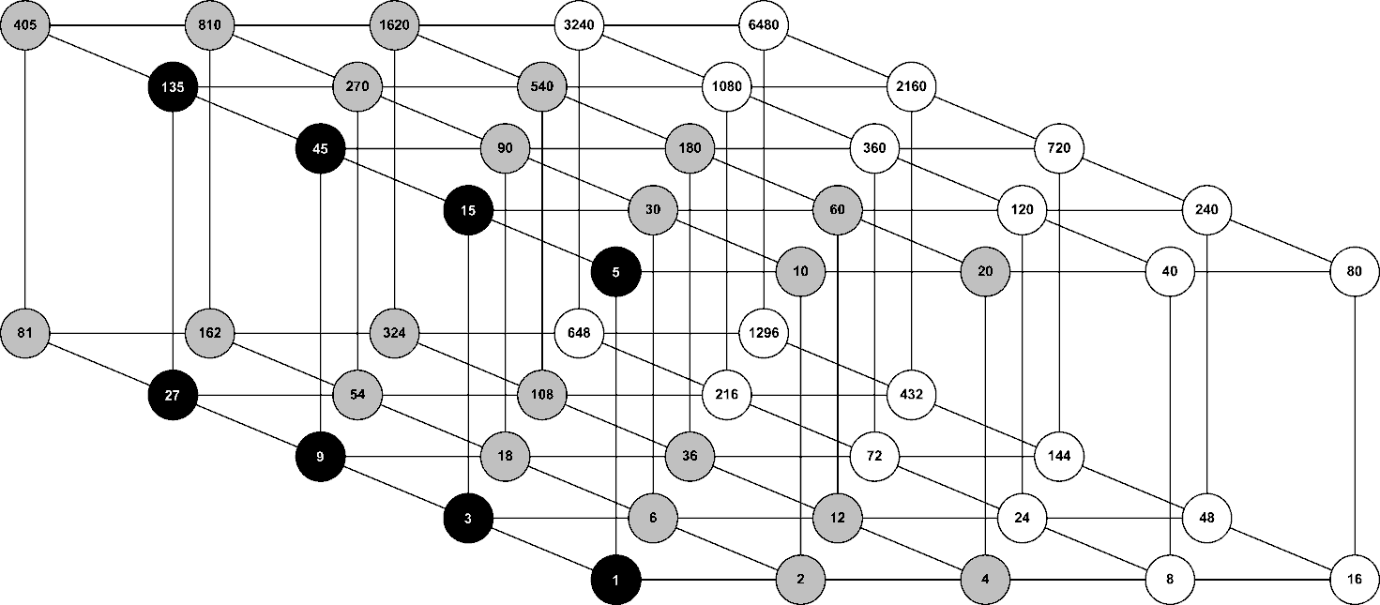

Figure 1-3 Source diagram of divisors for valid numbers of sub-slices

In Table 1-8 the allowed values for the total number of sub-lices N_{subslices_total} = N_{RF} · N_{subslices} at the output of each time interleaver block of each PLP can be seen. The value selected from the table msut be available for all modulation types and FEC block sizes currenty in use due to the same value must be used for all PLPs.

The table of short FEC block size with a ’Y’ in all four columns shows the safest possible option because this will always be suitable for all PLPs, listed in the Table 1-9. In the case that only long FEC blocks are used, the values from Table 1-10 can be used.

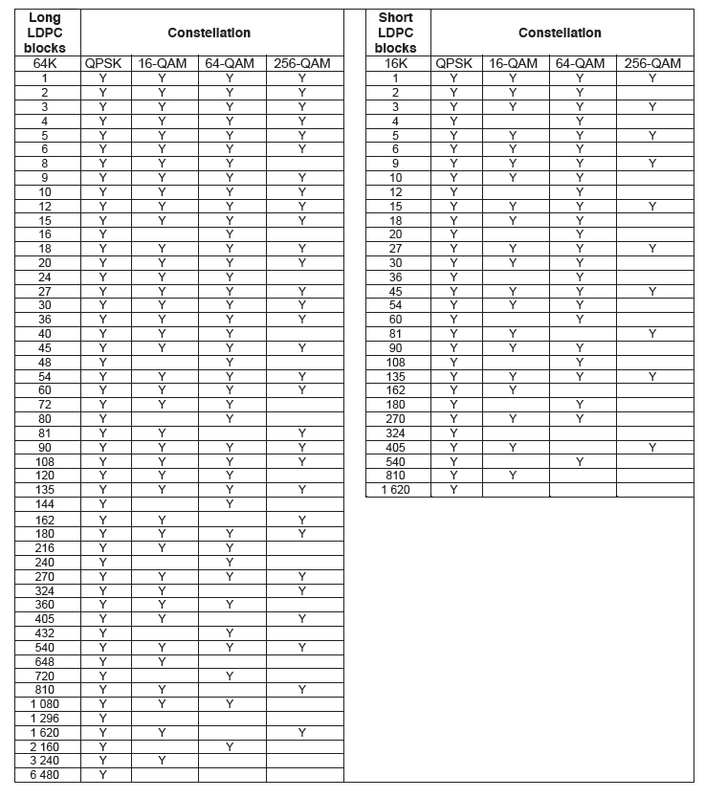
Table 1-8 List of available number of sub-slices for different constellations and FEC blocks sizes

1 | 3 | 5 | 9 | 15 | 27 | 45 | 135

Table 1-9 List of values for number of sub-slices which may be used with any combination of PLPs (short of long FEC blocks)

1 | 2 | 3 | 4 | 5 | 6 | 9 | 10
12 | 15 | 18 | 20 | 27 | 30 | 36 | 45
54 | 60 | 90 | 108 | 135 | 180 | 270 | 540

Table 1-10 List of values for number of sub-slices which may be used with any combination of PLPs (long FEC blocks only)
A group of tests have been defined. Test 6-1, Test 6-2 and Test 6-3 are configured with Long LDPC Blocks parameter and check the different possibilities of number of subslices (minimum, medium and maximum).
The set of tests (Test 6-4, Test 6-5 and Test 6-6) are configured with Short LDPC Blocks parameter and also check the differents values of number os subslices (minimum, medium and maximum).
Test 6-1, Test 6-2 and Test 6-3 Number of subslices – Long LDPC Blocks

 | Test 6-1 | Test 6-2 | Test 6-3
PLP | Multiple
FFTSIZE | 16K
GI | 19/128
Data Symbols | 59
SISO/MISO | SISO
PAPR | P2-TR & L1-ACE only
Frames per superframe | 2
Bandwidth | 8MHz
Extended Carrier Mode | Yes
Pilot Pattern | PP3
L1 Modulation | QPSK
Sub Slices per Frame | 270 | 1620 | 1
FEF | None
L1 Repetition | 0
Number of PLPs | 2
Number of RFs | 1
Number of AUXs | 0
T2 system ID | 0x8001
Network ID | 0x3085
Cell ID | 0x0000
RF frequency (Hz) | 729833333
Spec version | 1.2.1
Vclip | infinity
L1 Extension Present | No
L1 Bias balancing | No
L1_ACE_MAX | 0
Bitrate (bits/s) (Frame) | 20.512.897

 | Test 6-1, Test 6-2, Test 6-3
PLP | PLP1 | PLP2
PLP_ID | 0 | 1
PLP_GROUP_ID | 0 | 1
Type | 2 | 2
Modulation | 256QAM | 16QAM
Rate | 2/3 | 3/5
FEC Type | 64800 | 64800
Rotated QAM | No | No
FEC blocks per interleaving frame | 30 | 32
Max FEC blocks per interleaving frame | 30 | 32
TI blocks per frame (N_TI) | 1 | 1
T2 frames per Interleaving Frame (P_I) | 1 | 1
Frame Interval (I_JUMP) | 1 | 1
Type of time-interleaving | 0 | 0
Time Interleaving Length | 1 | 1
Input stage
Mode | HEM | HEM
ISSY | Yes | Yes
BUFS | 2097152 | 2097152
Design delay (samples) | 1143097 | 1143269
Null packet deletion | No | No
In Band Signalling | Type A | Type A
Number of other PLPs in-band signalling | 0 | 0
Number of NULL packets inserted each time (p)
Frequency of NULL packets insertion in packets (q)

Test 6-4, Test 6-5 and Test 6-6 Number of subslices – Short LDPC Blocks

 | Test 6-4 | Test 6-5 | Test 6-6
PLP | Multiple
FFTSIZE | 16K
GI | 19/128
Data Symbols | 59
SISO/MISO | SISO
PAPR | P2-TR & L1-ACE only
Frames per superframe | 2
Bandwidth | 8MHz
Extended Carrier Mode | Yes
Pilot Pattern | PP3
L1 Modulation | QPSK
Sub Slices per Frame | 135 | 405 | 1
FEF | None
L1 Repetition | 0
Number of PLPs | 2
Number of RFs | 1
Number of AUXs | 0
T2 system ID | 0x8001
Network ID | 0x3085
Cell ID | 0x0000
RF frequency (Hz) | 729833333
Spec version | 1.2.1
Vclip | infinity
L1 Extension Present | No
L1 Bias balancing | No
L1_ACE_MAX | 0
Bitrate (bits/s) (Frame) | 20.512.897

 | Test 6-1, Test 6-2, Test 6-3
PLP | PLP1 | PLP2
PLP_ID | 0 | 1
PLP_GROUP_ID | 0 | 1
Type | 2 | 2
Modulation | 256QAM | 16QAM
Rate | 2/3 | 3/5
FEC Type | 16200 | 16200
Rotated QAM | No | No
FEC blocks per interleaving frame | 30 | 32
Max FEC blocks per interleaving frame | 30 | 32
TI blocks per frame (N_TI) | 1 | 1
T2 frames per Interleaving Frame (P_I) | 1 | 1
Frame Interval (I_JUMP) | 1 | 1
Type of time-interleaving | 0 | 0
Time Interleaving Length | 1 | 1
Input stage
Mode | HEM | HEM
ISSY | Yes | Yes
BUFS | 2097152 | 2097152
Design delay (samples) | 1143097 | 1143269
Null packet deletion | No | No
In Band Signalling | Type A | Type A
Number of other PLPs in-band signalling | 0 | 0
Number of NULL packets inserted each time (p)
Frequency of NULL packets insertion in packets (q)

Test 7 - Maximum Total Bitrate

A brief description of particularities of total bitrate in DVB-T2 configurations can be found in 0.

Test 7-1 consists of a set of configuration parameters to obtain the highest data rate. A channel of 8MHz has been selected with 32K mode, a guard interval of 1/128, extended-carrier mode and no tone reservation. The pilot-pattern used is PP7.
Test 7-1 Maximum Total Bitrate

PLP | Multiple
FFTSIZE | 32K
GI | 1/128
Data Symbols | 41
SISO/MISO | SISO
PAPR | P2-TR & L1-ACE only
Frames per superframe | 2
Bandwidth | 8MHz
Extended Carrier Mode | Yes
Pilot Pattern | PP7
L1 Modulation | 64QAM
Sub Slices per Frame | 270
FEF | None
L1 Repetition | 0
Number of PLPs | 2
Number of RFs | 1
Number of AUXs | 0
T2 system ID | 0x8001
Network ID | 0x3085
Cell ID | 0x0000
RF frequency (Hz) | 729833333
Spec version | 1.2.1
Vclip | infinity
L1 Extension Present | No
L1 Bias balancing | No
L1_ACE_MAX | 0
Bitrate (bits/s) (Frame) | 48.379.698

PLP | PLP1 | PLP2
PLP_ID | 0 | 1
PLP_GROUP_ID | 0 | 1
Type | 2 | 2
Modulation | 256QAM | 256QAM
Rate | 5/6 | 5/6
FEC Type | 64800 | 64800
Rotated QAM | No | No
FEC blocks per interleaving frame | 68 | 68
Max FEC blocks per interleaving frame | 68 | 68
TI blocks per frame (N_TI) | 1 | 1
T2 frames per Interleaving Frame (P_I) | 1 | 1
Frame Interval (I_JUMP) | 1 | 1
Type of time-interleaving | 0 | 0
Time Interleaving Length | 1 | 1
Input stage
Mode | HEM | HEM
ISSY | Yes | Yes
BUFS | 2097152 | 2097152
Design delay (samples) | 1143097 | 1143269
Null packet deletion | No | No
In Band Signalling | Type A | Type A
Number of other PLPs in-band signalling | 0 | 0
Number of NULL packets inserted each time (p)
Frequency of NULL packets insertion in packets (q)

Test 8 - Maximum PLP protection

A brief description of PLP protection possibilities is presented in 1.1.8.

Test 8-1 consists of a set of configurations parameters to obtain the highest protection of PLP in ‘Input Mode B’. The parameters are similar to Test 7-1: a channel of 8MHz, 32K mode, guard interval of 1/128, extended-carrier mode, no tone reservation, pilot-pattern PP7. For each PLP a QPSK modulation is used and a code-rate of 1/2 have been configured.

Test 8-1 Maximum PLP Protection

PLP | Multiple
FFTSIZE | 32K
GI | 1/128
Data Symbols | 41
SISO/MISO | SISO
PAPR | P2-TR & L1-ACE only
Frames per superframe | 2
Bandwidth | 8MHz
Extended Carrier Mode | Yes
Pilot Pattern | PP7
L1 Modulation | 64QAM
Sub Slices per Frame | 270
FEF | None
L1 Repetition | 0
Number of PLPs | 2
Number of RFs | 1
Number of AUXs | 0
T2 system ID | 0x8001
Network ID | 0x3085
Cell ID | 0x0000
RF frequency (Hz) | 729833333
Spec version | 1.2.1
Vclip | infinity
L1 Extension Present | No
L1 Bias balancing | No
L1_ACE_MAX | 0
Bitrate (bits/s) (Frame) | 7.226.884

PLP | PLP1 | PLP2
PLP_ID | 0 | 1
PLP_GROUP_ID | 0 | 1
Type | 2 | 2
Modulation | QPSK | QPSK
Rate | 1/2 | 1/2
FEC Type | 64800 | 64800
Rotated QAM | No | No
FEC blocks per interleaving frame | 17 | 17
Max FEC blocks per interleaving frame | 17 | 17
TI blocks per frame (N_TI) | 1 | 1
T2 frames per Interleaving Frame (P_I) | 1 | 1
Frame Interval (I_JUMP) | 1 | 1
Type of time-interleaving | 0 | 0
Time Interleaving Length | 1 | 1
Input stage
Mode | HEM | HEM
ISSY | Yes | Yes
BUFS | 2097152 | 2097152
Design delay (samples) | 1143097 | 1143269
Null packet deletion | No | No
In Band Signalling | Type A | Type A
Number of other PLPs in-band signalling | 0 | 0
Number of NULL packets inserted each time (p)
Frequency of NULL packets insertion in packets (q)

Test 9 – Number of PLPs

The number of PLPs that can be carried by the T2 system is limited by the modulation used for L1-post signalling and the number of signalling bits. The maximum number of PLPs that can be carried by a T2 system, assuming that neither FEFs nor auxiliary streams are used, is given in Table 1-11.

 |  | BPSK | QPSK | 16-QAM | 64-QAM
Repetition not used | 32 K | 61 | 127 | 255 | 255
Repetition not used | others | 19 | 43 | 87 | 132
Repetition used | 32 K | 45 | 94 | 190 | 255
Repetition used | others | 14 | 31 | 64 | 97

Table 1-11 Maximum number of PLPs for different configurations

Test 9-1 is an example of the limitation of number of PLPs in T2 system. The set of parameters selected for test consists of the use of ‘L1 Repetition’, a FFT size of 16K and a BPSK modulation for L1-post signalling. A total number of 14 PLPs have been configured in the test.
Test 9-1 Number of PLPs

PLP | Multiple
FFTSIZE | 16K
GI | 19/128
Data Symbols | 59
SISO/MISO | SISO
PAPR | P2-TR & L1-ACE only
Frames per superframe | 2
Bandwidth | 8MHz
Extended Carrier Mode | Yes
Pilot Pattern | PP3
L1 Modulation | BPSK
Sub Slices per Frame | 270
FEF | None
L1 Repetition | 0
Number of PLPs | 2
Number of RFs | 1
Number of AUXs | 0
T2 system ID | 0x8001
Network ID | 0x3085
Cell ID | 0x0000
RF frequency (Hz) | 729833333
Spec version | 1.2.1
Vclip | infinity
L1 Extension Present | No
L1 Bias balancing | No
L1_ACE_MAX | 0
Bitrate (bits/s) (Frame) | 32.806.078

PLP | PLP1 .. PLP10 | PLP11 .. PLP14
PLP_ID | 0 .. 9 | 10 .. 13
PLP_GROUP_ID | 0 .. 9 | 10 .. 13
Type | 2 | 2
Modulation | 256QAM | 256QAM
Rate | 2/3 | 2/3
FEC Type | 64800 | 64800
Rotated QAM | No | No
FEC blocks per interleaving frame | 7 | 6
Max FEC blocks per interleaving frame | 7 | 6
TI blocks per frame (N_TI) | 1 | 1
T2 frames per Interleaving Frame (P_I) | 1 | 1
Frame Interval (I_JUMP) | 1 | 1
Type of time-interleaving | 0 | 0
Time Interleaving Length | 1 | 1
Input stage
Mode | HEM | HEM
ISSY | Yes | Yes
BUFS | 0 | 0
Design delay (samples) | Auto | Auto
Null packet deletion | No | No
In Band Signalling | Type A | Type A
Number of other PLPs in-band signalling | 0 | 0
Number of NULL packets inserted each time (p)
Frequency of NULL packets insertion in packets (q)

Generation of T2-MI test files

DVB-T2 system allow a large number of configurations. As described in the previous section, a plan test has been designed in order to check the extreme cases for the main configurable parameters.
Document is organized in the following way. A brief explanation of equipment configuration is presented in a diagram block scheme. Then, a reference of the two group of interoperability set of tests, corresponding to ’Input Mode A’ and ’Input Mode B’ with static scheduling, are indicated. Specific generated files are presented. Finally, a description of tools and equipment used to generate the test files is presented.

Block Diagram Scheme

Figure ‎1-1 shows the block diagram used to generate test files interoperable DVB-T2.

DVB-T2 Gateway Manager is a web manager that allows a user to create configurations for DVB-T2 Gateway and remotely control the T2-Gateway via the network. Using this manager, different configurations associated with each interoperability tests have been created to generate test files.

The DVB-T2 Gateway is able to save a file of the output signal corresponding to the T2MI Packets protocol file for to interoperability test.

Figure ‎1-1 Block Diagram Scheme for test file generation

Input Mode A

Input Mode A configurations form the first group of test. The specific values ​​of parameters for each test configuration can be found in the previous deliverable "Interoperability Plan Test for DVB-T2" for Engines project.

As a reminder, below are the 8 tests defined.

- Test 1 – FFT Size parameter
- Test 2 – Extended Carrier Mode
- Test 3 – Guard Interval
- Test 4 – Frame Length
- Test 5 – Super Frame Length
- Test 6 – Time Interleaving parameters
- Test 7 – Maximum Total Bitrate
- Test 8 – Maximum PLP protection

Table ‎1-1 lists the files generated for each of the interoperability test.

Test |  | Test file
Test 1 | FFT Size parameter
Test 1-1 | Extreme case 32K | InputModeA_Test1.1.ts
Test 1-2 | Extreme case 1K | InputModeA_Test1.2.ts
Test 2 | Extended Carrier Mode
Test 2-1 | Extended Carrier Mode used | InputModeA_Test2.1.ts
Test 2-2 | Extended Carrier Mode not used | InputModeA_Test2.2.ts
Test 3 | Guard Interval
Test 3-1, 3-2 | FFT Size 32K | InputModeA_Test3.2.ts  InputModeA_Test3.3.ts
Test 3-3, 3-4 | FFT Size 16K | InputModeA_Test3.3.ts  InputModeA_Test3.4.ts
Test 3-5, 3-6 | FFT Size 8K | InputModeA_Test3.5.ts  InputModeA_Test3.6.ts
Test 3-7, 3-8 | FFT Size 4K | InputModeA_Test3.7.ts  InputModeA_Test3.8.ts
Test 3-9, 3-10 | FFT Size 2K | InputModeA_Test3.9.ts  InputModeA_Test3.10.ts
Test 3-11, 3-12 | FFT Size 1K | InputModeA_Test3.11.ts  InputModeA_Test3.12.ts
Test 4 | Frame Length
Test 4-1 | Maximum Frame Length | InputModeA_Test4.1.ts
Test 4-2 | Minimum Frame Length | InputModeA_Test4.2.ts
Test 5 | Super Frame Length
Test 5-1 | Super Frame Length | InputModeA_Test5.1.ts
Test 6 | Time Interleaving parameters
Test 6-1 | Time Interleaving parameters | InputModeA_Test6.1.ts
Test 7 | Maximum Total Bitrate
Test 7-1 | Maximum Total Bitrate | InputModeA_Test7.1.ts
Test 8 | Maximum PLP protection
Test 8-1 | Maximum PLP protection | InputModeA_Test8.1.ts

Table ‎1-1 Table of Input Mode A interoperability tests

Input Mode B

Input Mode B configurations form the second group of test. The specific values ​​of parameters for each test configuration can be found in the previous deliverable "Interoperability Plan Test for DVB-T2" for Engines project.

The test group of Input Mode B are designed for static scheduling. All the configurations contain multiple PLPs without any Common PLP.

The following are the tests defined for Input Mode B:

- Test 1 – FFT Size parameter
- Test 2 – Extended Carrier Mode
- Test 3 – Guard Interval
- Test 4 – Frame Length
- Test 5 – Super Frame Length
- Test 6 – Number of subslices
- Test 7 – Maximum Total Bitrate
- Test 8 – Maximum PLP protection
- Test 9 – Number of PLPs

Table ‎1-2 lists the files generated for each of the interoperability test.

Test |  | Test file
Test 1 | FFT Size parameter
Test 1-1 | Extreme case 32K | InputModeB_Test1.1.ts
Test 1-2 | Extreme case 1K | InputModeB_Test1.2.ts
Test 2 | Extended Carrier Mode
Test 2-1 | Extended Carrier Mode used | InputModeB_Test2.1.ts
Test 2-2 | Extended Carrier Mode not used | InputModeB_Test2.2.ts
Test 3 | Guard Interval
Test 3-1, 3-2 | FFT Size 32K | InputModeB_Test3.2.ts  InputModeB_Test3.3.ts
Test 3-3, 3-4 | FFT Size 16K | InputModeB_Test3.3.ts  InputModeB_Test3.4.ts
Test 3-5, 3-6 | FFT Size 8K | InputModeB_Test3.5.ts  InputModeB_Test3.6.ts
Test 3-7, 3-8 | FFT Size 4K | InputModeB_Test3.7.ts  InputModeB_Test3.8.ts
Test 3-9, 3-10 | FFT Size 2K | InputModeB_Test3.9.ts  InputModeB_Test3.10.ts
Test 3-11, 3-12 | FFT Size 1K | InputModeB_Test3.11.ts  InputModeB_Test3.12.ts
Test 4 | Frame Length
Test 4-1 | Maximum Frame Length | InputModeB_Test4.1.ts
Test 4-2 | Minimum Frame Length | InputModeB_Test4.2.ts
Test 5 | Super Frame Length
Test 5-1 | Super Frame Length | InputModeB_Test5.1.ts
Test 6 | Number of Subslices
Test 6-1 | Long LDPC Blocks | InputModeB_Test6.1.ts
Test 6-2 | Long LDPC Blocks | InputModeB_Test6.2.ts
Test 6-3 | Long LDPC Blocks | InputModeB_Test6.3.ts
Test 6-4 | Short LDPC Blocks | InputModeB_Test6.4.ts
Test 6-5 | Short LDPC Blocks | InputModeB_Test6.5.ts
Test 6-6 | Short LDPC Blocks | InputModeB_Test6.6.ts
Test 7 | Maximum Total Bitrate
Test 7-1 | Maximum Total Bitrate | InputModeB_Test7.1.ts
Test 8 | Maximum PLP protection
Test 8-1 | Maximum PLP protection | InputModeB_Test8.1.ts
Test 9 | Number of PLPs
Test 9-1 | Number of PLPs | InputModeB_Test9.1.ts

Table ‎1-2 Table of Input Mode B interoperability tests

Tools and equipment to generate test files

DVB-T2 Gateway Manager

DVB-T2 Gateway Manager is a web tool to control one or more DVB-T2 Gateways through the network. Figure ‎2-1 shows a screenshot where a list of DVB-T2 Gateways can be seen. All these equipment can be controlled remotely using the DVB-T2 Gateway Manager.

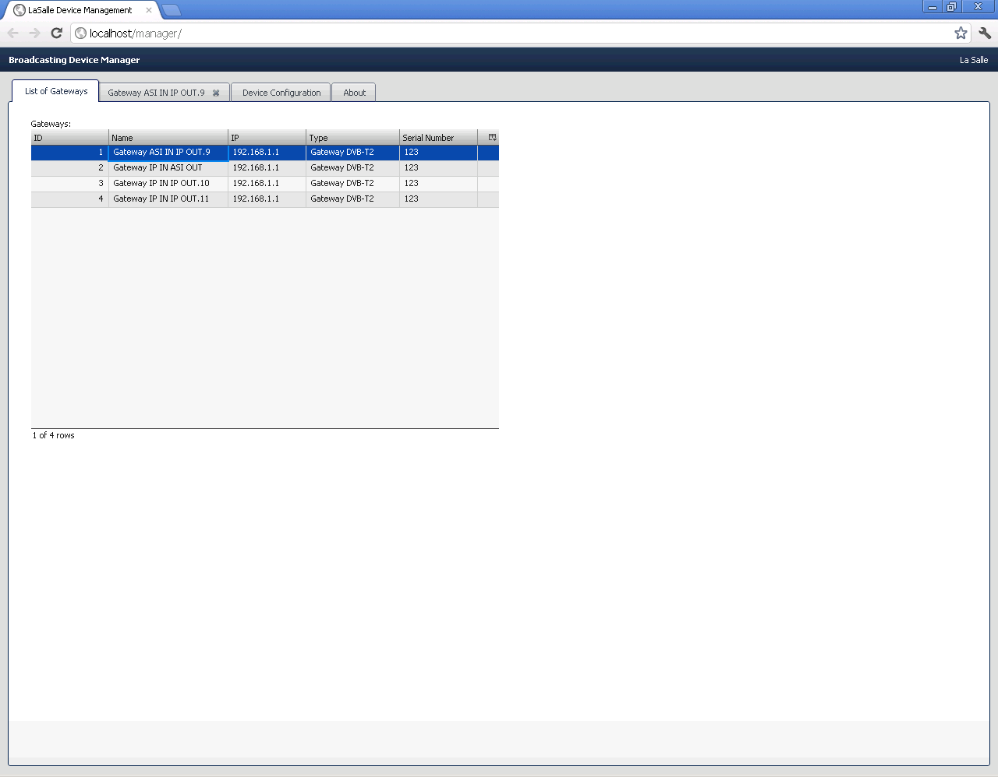
Figure ‎2-1 DVB-T2 Gateway Manager – List of Gateways

Next, Figure ‎2-2 shows the Overall configuration parameters, such as the modulation T2 parameters, the frequency or the input type (ASI or IP).
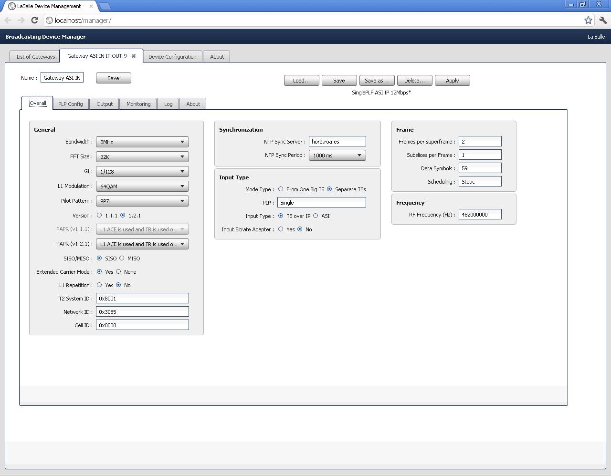
Figure ‎2-2 DVB-T2 Gateway Manager – Overall Gateway configuration

Figure ‎2-3 shows the PLP specific parameters.

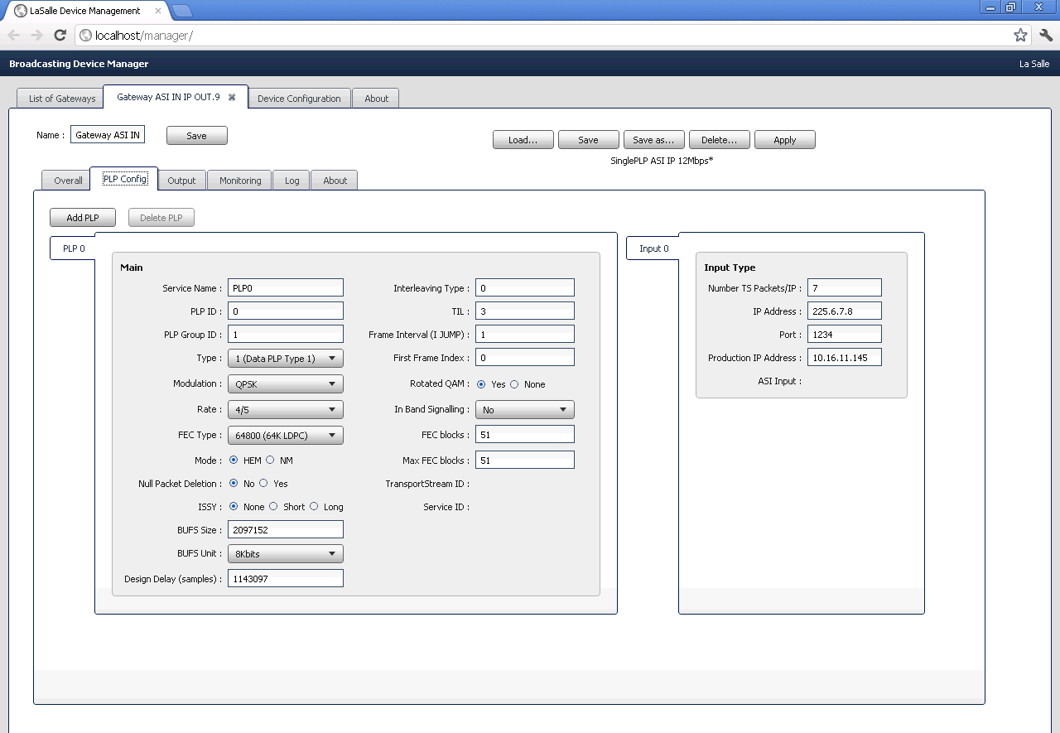
Figure ‎2-3 DVB-T2 Gateway Manager – PLP configuration
Finally, Figure ‎2-4 shows the configuration parameters of the output signal of the DVB-T2 Gateway.

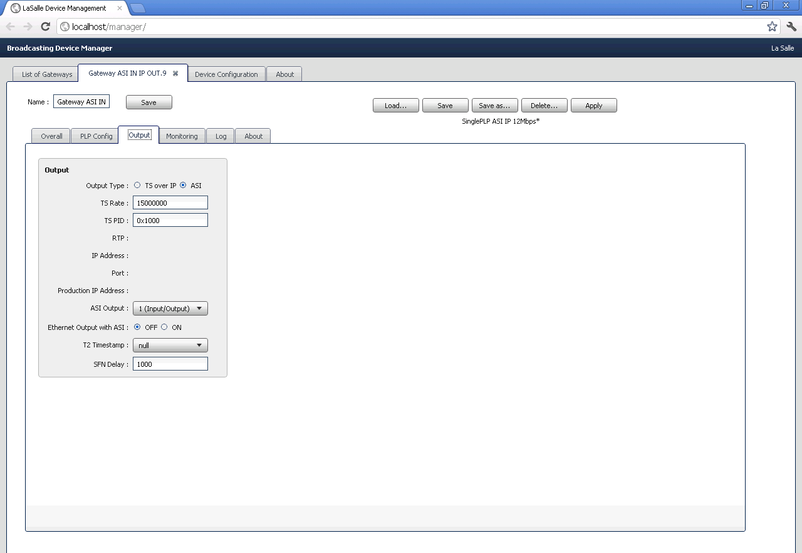
Figure ‎2-4 DVB-T2 Gateway Manager – Output configuration
DVB-T2 Gateway Manager allows to create and manage different configurations and apply them individually to each of the DVB-T2 Gateway.

DVB-T2 Gateway

The DVB-T2 Gateway equipment is configured and controlled by the DVB-T2 Gateway Manager. This equipment generates the output signal (T2MI protocol) that is sent to the T2 modulator.
The DVB-T2 Gateway may have two input signal types: IP and ASI. The output signal can also be in IP and ASI. It also has the option of recording the ASI output to a file. This option is the one used to generate the files for interoperability testing.

Test Files

The test files are available in the La Salle ftp site. For more information, please contact alexl@salle.url.edu.

Time Frequency Slicing

Introduction

DVB-T2 offers a new approach called Time Frequency Slicing (TFS). This approach combine multiple RF channels into a coherent high-capacity system enabling statistical multiplexing across several HD services as well as providing frequency diversity advantages. Significant efficiency advantages can be achieved by statistical multiplexing of several services. The capacity of the fixed frequency TDM frame is dynamically divided between the physical channels. This division gives statistical multiplexing gain, i.e. the bit rate variations are averaged over all the services resulting in decreased overall bit rate variation and lower amount of wasted capacity. The idea of time-frequency slicing is to utilize several RF channels to increase the capacity, i.e., the size of the frame, and to multiplex services over all the RF channels. The number of services is increased proportionally to the number of RF channels in an increased statistitical multplexing gain. The timing of the services transmitted within the different RF channels is arranged so that a service can be received using a single tuner front end.

Time Frequency Slicing allows a potentially far more efficient statistical multiplexing than when the multiplexing is restricted to a capacity of a single RF frequency. Using statistical multiplexing across several RF frequencies allows very high Transport Stream bit rates and therefore an efficiency asymptotically approaching that of ideal statmuxing. The potential increase in number of services due to this, compared to fixed bit rate coding using the same number of RF channels, is difficult to estimate exactly, but is likely to be in the order of 30-40%. The increase in number of services, compared with statmuxing of services within each RF channel separately, is difficult to estimate exactly, but is likely to be in the order of 20-30%.

Another related advantage of the higher TS bit rate provided by Time Frequency Slicing is that it allows for a far better granularity in selection of average service bit rate for a service. With transmission over a single RF channel the total bit rate is quite limited so only a course granularity can be achieved regarding service bit rates. This leads to large differences in service bit rates when adding or reducing one service and it is in most cases impossible to select the service bit rate that otherwise would be the optimum one. Alternatively the services will not fill the capacity and there would be some remaining capacity, which is insufficient for an additional service. This problem is accentuated when lower RF bandwidths than 8 MHz are used, where Time Frequency Slicing would provide even larger benefits.

TFS architecture allows error correction process to each individual service within a multiplex rather than applying the error correction to the multiplex as a whole. If it is required to apply particular protection to different sevices this means an advantge. TFS system leads to the use of regular pilot symbols to identify the TFS framing structure. These pilot symbols can then be used to provide a mechanism for signaling, a method for fast synchronization and a method for fast identification of T2 transmissions.

Time Frequency Slicing also leads to network planning gain. TFS offers frequency diversity. This diversity is achieved by extending the channel coding and interleaving of a service over all the RF channels in a frame. Another advantage is a coverage gain for static reception. TFS provides improved robustness against channel time variations (similar to RX diversity), especially important for portable/mobile reception. Besides, it provides improved robustness against static and time varying interference from other transmitters (one frequency could e.g. be completely lost due to temporary interference).

TFS in DVB-T2 allows a more efficient statistical multiplexing using several RF channels. An increment of aproximately 20-30% in number of services can be achieved.

The multiple PLP and time-slicing approaches implemented by DVB-T2 allow for different levels of coding, modulation and time interleaving depth to be applied to different PLPs, to provide variable robustness on a service-by-service basis. The receiver can also concentrate its decoding resources on the one PLP containing the required data, which means power saving. Receivers may save power by switching off some of the circuitry while signals for the PLP of interest are not being transmitted. In particular the fixed amount of memory in the receiver dedicated to time de-interleaving (for robustness against impulsive interference) can be used for a greater interleaving depth, compared with the single PLP mode, since the de-interleaver is only processing data for the required PLP. With a single PLP, the time-interleaving depth is around 70ms, whereas with multiple PLPs this can be extended to the full frame duration (150 ms to 250 ms), or for lower data-rate services it can be extended over multiple frames.

DVB-T2 Gateway

Introduction

The T2-Gateway generates a T2-MI stream, consisting of a sequence of T2-MI packets, from the input streams (every one correspondes to a PLP (Physical Layer Pipe)). Each T2-MI packet contains a Baseband Frame, a IQ vector data for each auxiliary stream or signalling information (L1 or SFN).
The T2-MI stream contains all the needed information to describe the content and the time of emission of the T2-frames. A single T2-MI signal feeds one or more modulators of the network. Optionally, a T2 Gateway may perform additional tasks, such as a Remultiplexing process.

The T2-Gateway makes operations according to the specification of the physical layer that are not completely normative such as scheduling and allocation. In an SFN network, these processes must be done in a central point to assure that all the modulators are receiving the same signal.

Figura ‎2-1 Block diagram for DVB-T2 chain

DVB-T2 Gateway modules

The functionalities of the DVB-T2 Gateway are divided into different interfaces and modules as in the next diagram.

Figura ‎3-1 Interfaces and modules of the prototype of the DVB-T2 Gateway
The following sections describe each module.

Input Interface

The input interface may receive incoming streams in two different ways: “One Big TS” and “Separate TS”.
The first mode is “One big TS”, this mode receives a single stream as input. This stream contains multiple services that will be splitted afterwards in the DVB-T2 Gateway into multiple PLPs.
The second mode is “Separate TS”, this mode receive each stream to be associated to a PLP independently.

Input Bitrate Adapter Module

The module Input Bitrate Adapter, optionally remultiplexes a TS to adjust to the bitrate expected for that PLP according to the modulation parameters and the clock signal coming from a stable source for instance a GPS signal.

One Big TS Adapter Bitrate Module

In the mode ”One big TS”, this module generates N streams from the input stream that will correspond to the total of PLPs (except for the PLP common). To do that, it performs the clonning of the input stream into N output streams. Each of these will only contain useful packets for the corresponding PLP, the rest will be replaced by TS NULL packets. Moreover, the PSI/SI will be modified accordingly for a correct signalling of the services in each of the PLPs.

Annex D Splitting Module

The Annex D Splitting module receives N streams TS with the same bitrate and in a synchronized way at TS packet level. This module performs a task of identification of everything what is common in the N input streams. This redundant information is sent into a new stream named PLP common that replaces the common packets in each PLP by TS NULL packets and moves them to the common PLP. In this process, SDT and EIT tables are also processed and remultiplexed.

Mode Adaptation Module

The Mode Adaptation Module generates the Baseband Frames (BBFrames) from the TS for each of the PLPs. A Baseband Header is inserted for each BBFrame. Depending on the mode used HEM (High Efficiency Mode) or NM (Normal Mode), different tasks are performed such as ISSY (Input Stream Synchronizer), DNP (Deletion of NULL Packets), removal of the sync byte of the TS packets, calculation of SYNCD and CRC-8.

Scheduler Module

The Scheduler module has two main functions: distribute sections of the input streams into Baseband Frames in Interleaving Frames and distribute the slices and sub-slices of each PLP into cells of the T2-frame.
This module generates a stream of T2-MI packets that, apart from the BBFrames, include packets L1-current and L1-future that contain information about the pre/post signalling inserted in the P2 symbols of a T2-frame. It also includes packets DVB-T2 timestamp used to synchronize the output of the DVB-T2 modulators.

Data Piping Module

The Data Piping Module is responsible for the generation of the stream according to Data Piping protocol with the T2-MI packets as payload.

Output Interface

Finally, the Output Interface Module will put into the output stream (TS/UDP/IP, ASI or file) the T2-MI signal.

TFS in DVB-T2 Gateway

This section describes a first analysis on the specification about TFS. This section identifies the modules of the DVB-T2 Gateway affected directly by TFS in each point described by the standard in Annex E: T2-frame structure for Time-Frequency Slicing.

DVB-T2 Gateway modules affected by TFS is the Scheduler. It is affected because the T2-frames are generated inside the Scheduler. Indirectly it affects the rest of modules because of the duration and capacity of the T2-frame. Many of the points where TFS affects are in the L1 signalling and it is generated in the Scheduler. The following table details the points that need to be taken into account for TFS in T2. It is a summary of the informative annex E: T2-frame structure for Time-Frequency Slicing.

Concept | Changes/implication in T2-GW
Duration and capacity of the T2-frame | T_{F} as in single RF. C_{tot} affected by N_{RF}
Overall structure of the T2-frame | D_{data} affected by N_{RF}
Structure of the Type-2 part of the T2-frame | structure of the TF-sliced part type 2
Restrictions on frame structure to allow tuner switching time | The time between two sub-slices  The minimum frequency hopping time  minimum tuning time is 5 ms  (number of symbols needed for tuning,
Signalling of the dynamic parameters in a TFS configuration | L1-post dynamic signalling transmitted in P2 will refer to the next T2-frame  in-band signalling for the current PLP will refer to the next-but-one Interleaving Frame
Indexing of RF channels | RF indexing scheme FIRST_RF_IDX
Mapping the Common and Type 1 PLPs | PLP_channel calculation
Mapping the Type 2 PLPs | The Type 2 PLPs start from the same active cell address in every RF
Size of the sub-slices | Calculation of N_{subslices_total}
Allocation of cell addresses to the sub-slices on RFstart | RF_{start} Sub Slice Start value
Allocation of cell addresses to the sub-slices on the other RF channels | RF_{shift}
Mapping the PLP cells to the allocated cell addresses | PLP_NUM_BLOCKS_MAX < D_{type2}/N_{RF}
Auxiliary streams and dummy cells | the data PLPs of both types, auxiliary streams and dummy cells < total capacity

Interoperability Testing advanced T2-MI tests

//Jerome

References

- ETSI TR 102 831 v.0.10.04 (2010-03), ”Digital Video Broadcasting (DVB); Implementation guidelines for a second generation digital terrestrial television broadcasting system (DVB-T2)”, DVB (Digital Video Broadcasting)
- DVB Document A122, “Digital Video Broadcasting (DVB); Frame structure channel coding and modulation for a second generation digital terrestrial television broadcasting system (DVB-T2)”, June 2010, DVB (Digital Video Broadcasting)

